

The Queen’s Net Worth, Savings, & Pensions

From The Desk Of Her Royal Majesty

Queen Laura L. Gardner

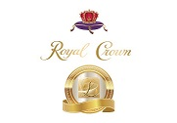

**Net Worth, Savings, & Pensions 💰**



**Queen Laura L. Gardner’s Net Worth 💰:** 960 Trillion 899 Billion 740 Million GSP 💵 Verified By All Banks 🏦

**Queen Laura L. Gardner’s Savings:** 50 Million USD 💵 Verified By All Banks 🏦

**Queen Laura L. Gardner’s Pension:** 103 Thousand, 938 Dollars/per month 💵 Verified By All Banks 🏦