The Queen’s Tiny Pampering House

Type: Personal Residence
Owner: Queen Laura L. Gardner
Value: $110,000.00
Location: Sweet, Timbers
House Elevation:
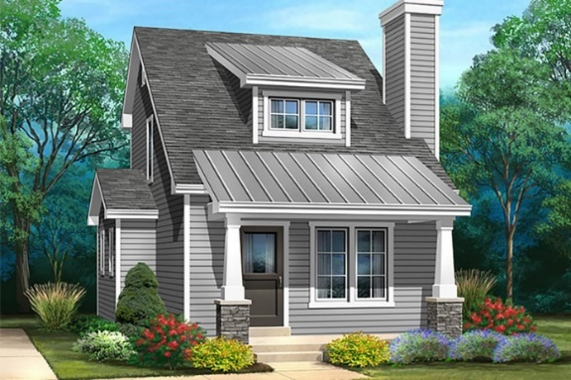
[Blue, Grey & White Color Scheme]

House Floorplan Downstairs
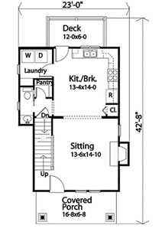

Interior & Furnishings

Sitting Room

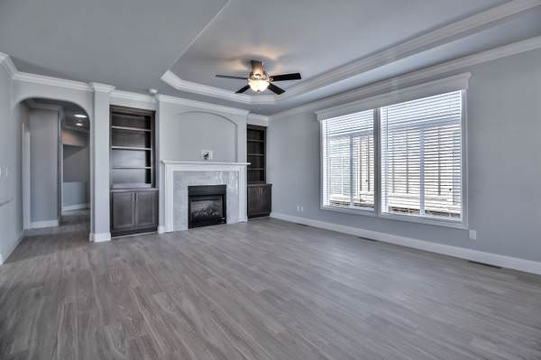

SAMSUNG 40” Class The Frame 4K Ultra HD QLED Smart TV – QN50LS03ADFXZA Item # 99000208

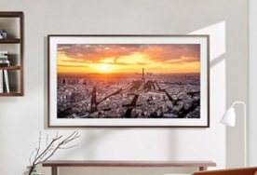

Couch Set

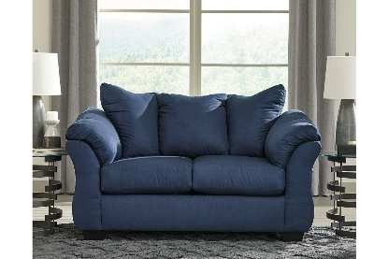
Darcy Loveseat - [Ashley Furniture]

Sitting Room Floor, Foyer & Other Untiled Areas

SMARTCORE Pro Twilight 12-in x 24-in Waterproof Interlocking Luxury Flooring (15.83-sq ft) - In Grey

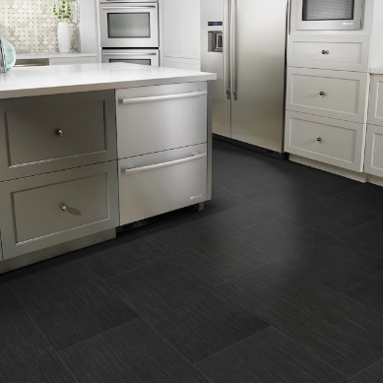

Living Room Appliances

Blinds

Luxe Modern Blackout Roller Shades

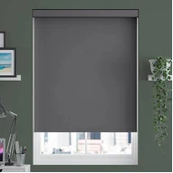

Thermostat

Nest Learning Thermostat (3rd Generation)
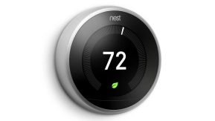

Fans

Dyson Purifier Cool TPO7
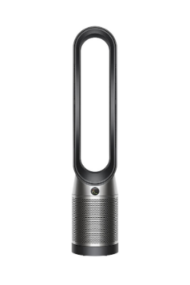

Wyze Plugs & Bulbs
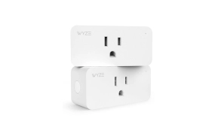

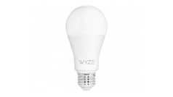

Kitchen/Breakfast Room

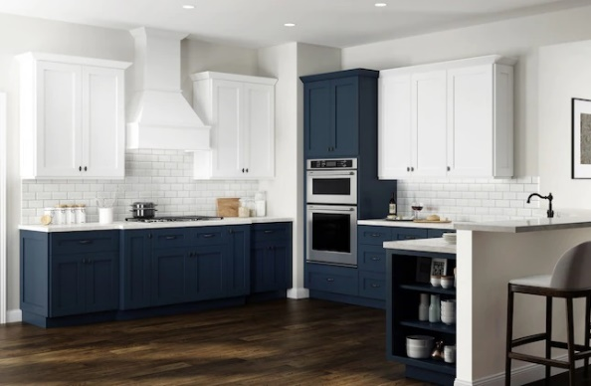

[The Samsung Refrigerator With Hidden Beverage Compartment, GE Smooth Top Stove & Kitchen Aid Oven, Cabinetry In Navy, Backsplash Glossy White & White Granite Sparkle Counter Tops At Lowes]

Kitchen Cabinetry [Blue & White Contrast, Microwave & Oven Within The Cabinetry]

Luxe Cabinetry Nevada 36-in W x 24-in H x 12-in D Mythic Blue Painted Door Wall Fully Assembled Semi-custom Cabinet

Kitchen Countertop

allen + roth A+R Solid Surface Mendenhall Solid Surface White Kitchen Countertop Sample (4-in x 4-in)

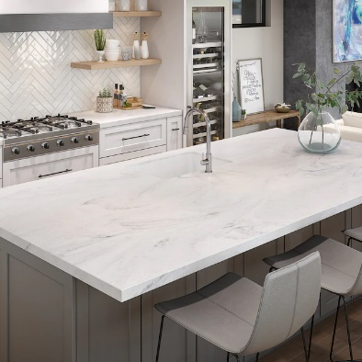

Kitchen Appliances

General Electric Stove

GE 30-in 4 Elements Smooth Surface (Radiant) Black Electric Cooktop

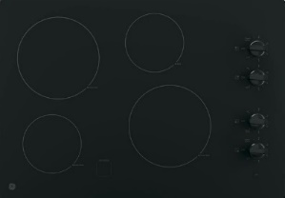

Kitchen Aid Oven

Kitchen Aid 30-in Self-Cleaning Convection Single Electric Wall Oven (Stainless Steel)

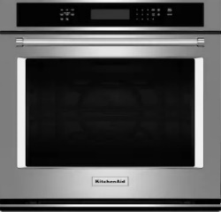

General Electric Whirlpool Microwave

Whirlpool 1.7-cu ft Over-the-Range Microwave with Electronic Touch Controls - Fingerprint Resistant Stainless Steel

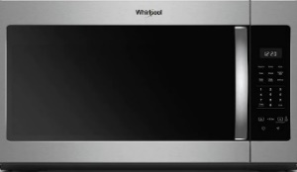

Frigidaire Refrigerator [Walmart]
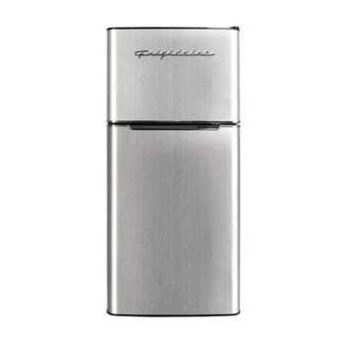

Kitchen Backsplash

Elida Ceramica White 12-in x 12-in Glossy Glass Brick Subway Wall Tile

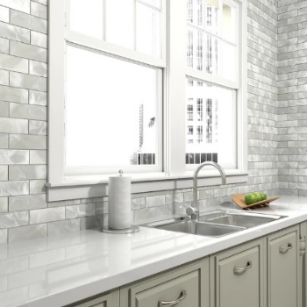

Kitchen Floor

Colorado Grey 18-in x 18-in Glazed Ceramic Stone Look Floor Tile
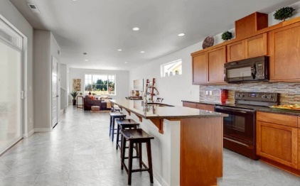

Google Nest Hub Max

Google Nest In Grey Smart Home Display With Google Assistant
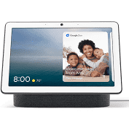

The U By Moen Smart Faucet
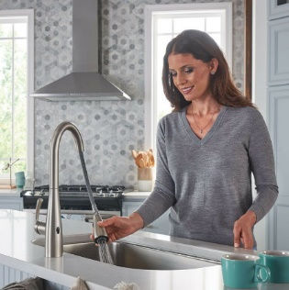

Pantry Barn Door [In Blue, Where The Floorplan Indicates]
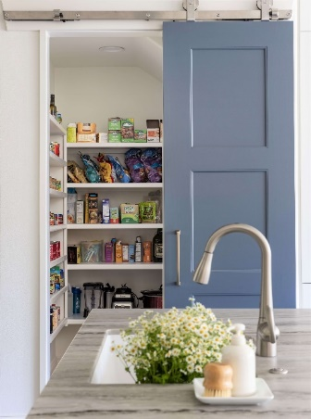

Half Bath [Blue & White]

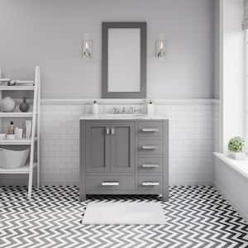

Bathroom Barn Door [Bathroom Written On The Door]
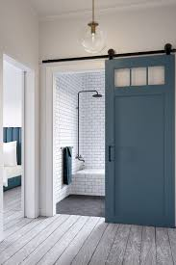

Laundry [Navy From Lowes]

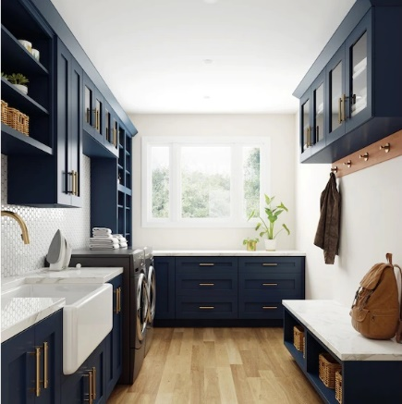

[Washer & Dryer Combo Danby In White]

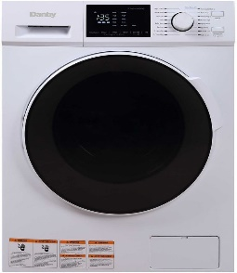

Deck
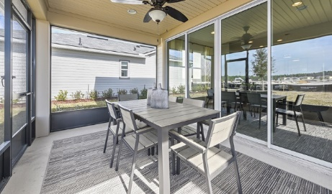

House Floorplan Upstairs

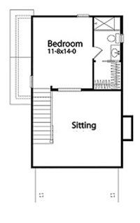

Sitting Room & Entertaining Bar

[Television, Fireplace, Tiled Area & Shelf]

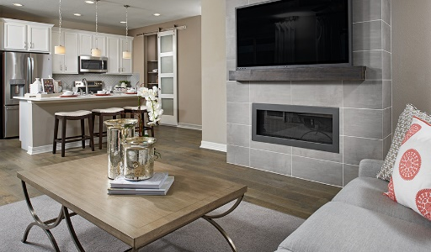

Philips 40" Class LED 1080p FHD 4000 Series Smart TV



JASIWAY Modern Convertible Sleeper Sofa Chair Bed - Blue and White

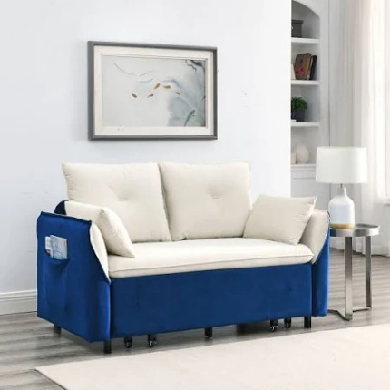

Entertaining Bar
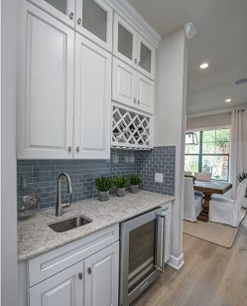

Queen Laura’s Master Suite

French Barn Double Doors [In White]
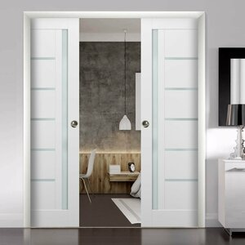

Full Size Bed & Furniture Pieces - [Aarons Furniture]
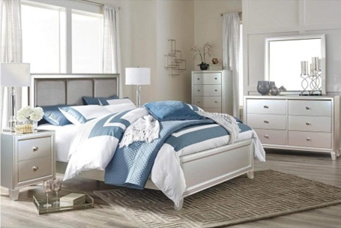

Additional Bedroom Furniture Pieces

Queen Size Bed Sleep Easy Cool Gel - [Furniture Distribution Center]

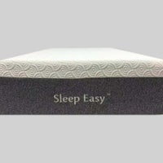

Bedroom Floor Carpet

Daytar Midnight Plush Carpet Sample (Interior/Exterior)


Google Nest (2nd Generation)
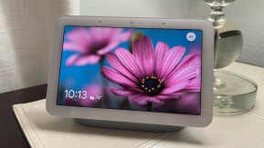

Charcoal Recliner with heat and massage - [Rent A Center]



Bathroom Barn Doors [In Grey]

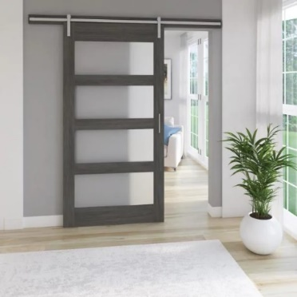

Shower Tiles [Lowes]

Giorbello 11.75x11.75 Mesh-Sheet 11-Pack Dark Blue 11-in x 12-in Multi-finish Glass; Metal Patterned Wall Tile
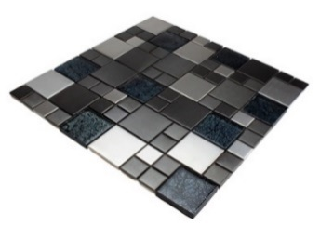

Bathtub [Blue, Grey & White Like The Picture Safe Step Tub]

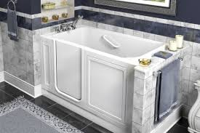



Bathroom Floor Tile
Artmore Tile Terrawood Blue 4 in. x 8 in. Matte Porcelain Floor and Wall Tile Sample


Elida Ceramica Blue 12-in x 12-in Glossy Glass Brick Subway Wall Tile
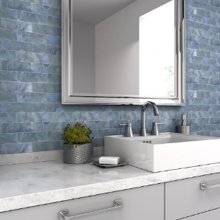

Bathroom Sink

Style Selections Del Rose 18-in Navy Blue Single Sink Bathroom Vanity with White Engineered Stone Top
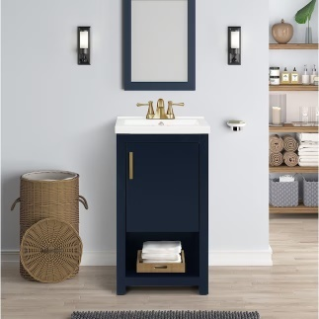

Closet Door [In White]

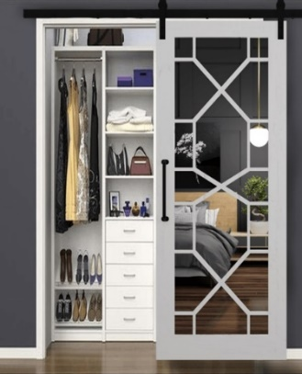

Bathroom Appliances

U By Moen Shower


U By Moen Faucet


Spa

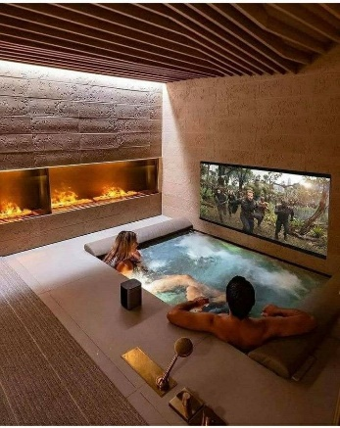

Single Car Garage & Storage

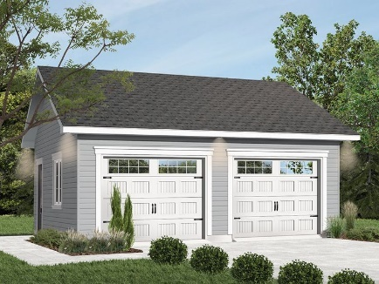

BMW Mini Coupe Convertible In Blue


Award:

Custom Guild Award



Queen Laura’s Custom Guild Award Winning Vacation House

[A Mastry Of The Household & 26 Years Of Household Immaculacy]


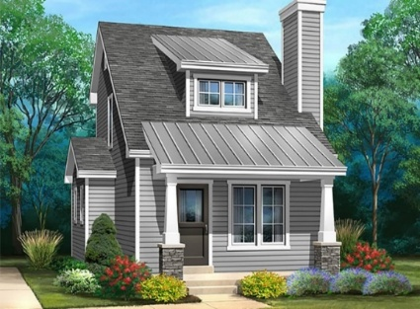

Personal Vacation Specifics:

Queen Laura based out of the Ultimate Kingdom & The Territories has enjoyed her countries and private islands for 25 Years. She is in the Guinness book of records for travel. The most cruises at 3,228 cruises, the second most drives at 6.5 million drives, and the fifth most flights at 1 million and 46 flights. Queen having visited all the various states and territories of North America for 45 Years, prefer to have travel by land, air, and sea, be safe, sensibly, and go smooth and seamlessly. Queen Laura is The Ultimate Kingdom Citizenship Diplomatic Status, for 24 years.

