The Royal Family’s Beach House

Type: Family Residence
Value: $60,000.00
Owners: The Royal Family Of The Ultimate Kingdom & The Territories
Location: Blue, Waters
House Elevation:
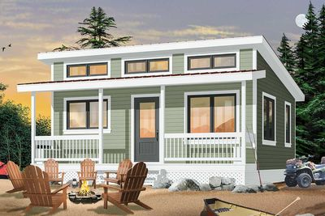
[Blue, White & Dark Grey]

Floorplan:
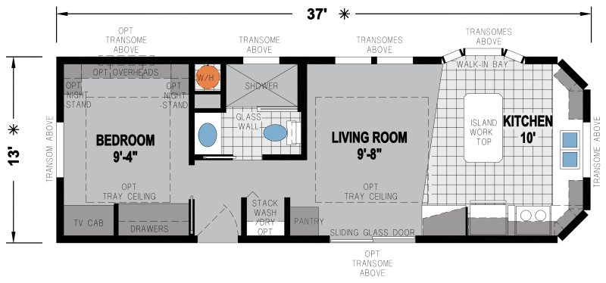

Rear Evaluation:
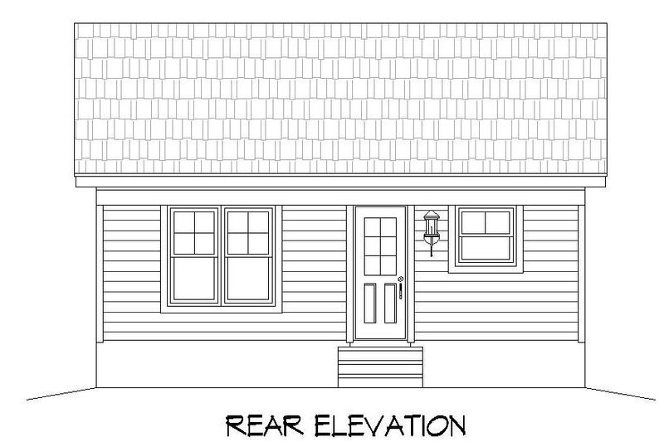

The Foyer
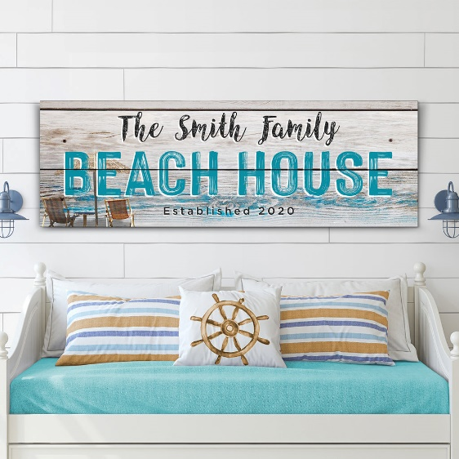
[The Sign Should Read The Royal Family Beach House Established 2023]

Foyer Mat
[The Sign Should Read The Royal Family]
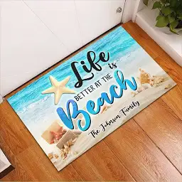

Kitchen
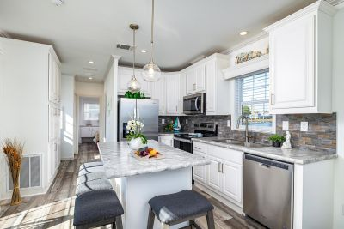

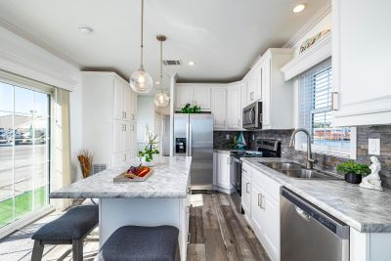

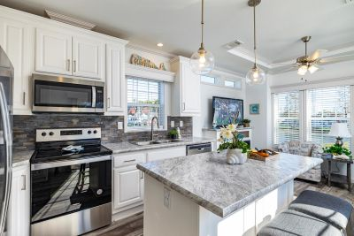

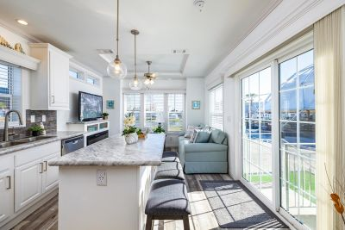

Kitchen Accessories

Mats
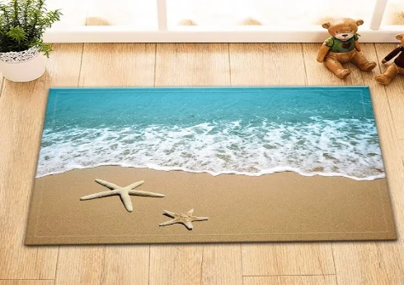
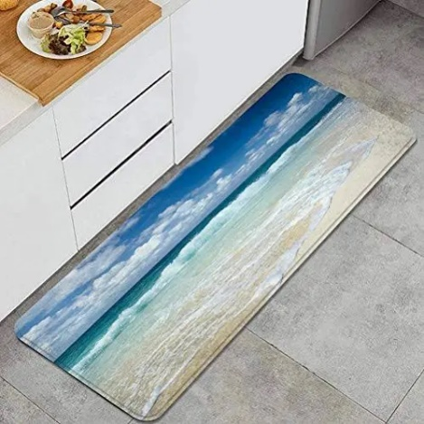

Living Room
[The Overall Look And Feel, Furniture Set, Table, Pictures, Curtains, Mat And Flooring]
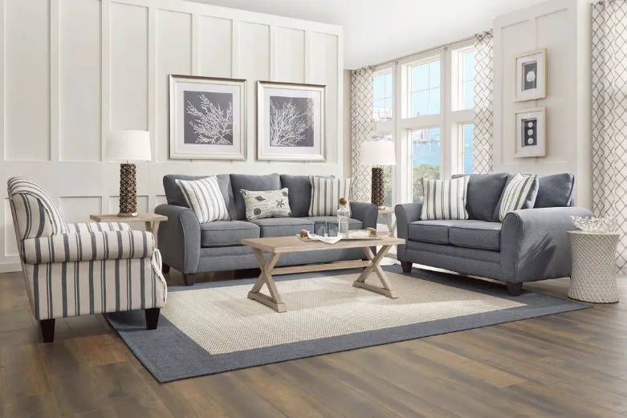

[The Television, Fireplace, And Boat]
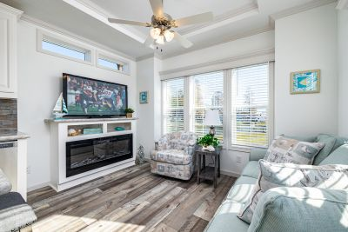

Bedroom [CEO Harry T. Ford]
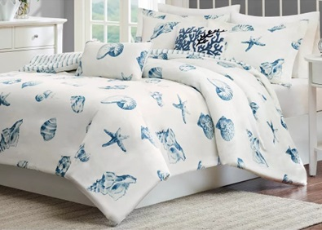

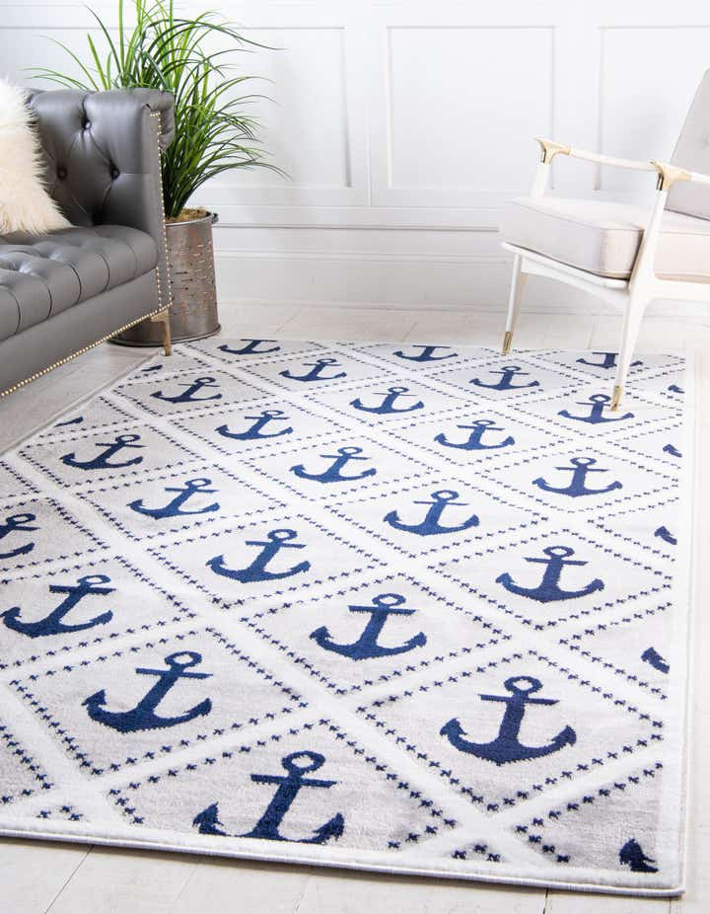

Bathroom
Shower [Grey & White Safe Step Shower]

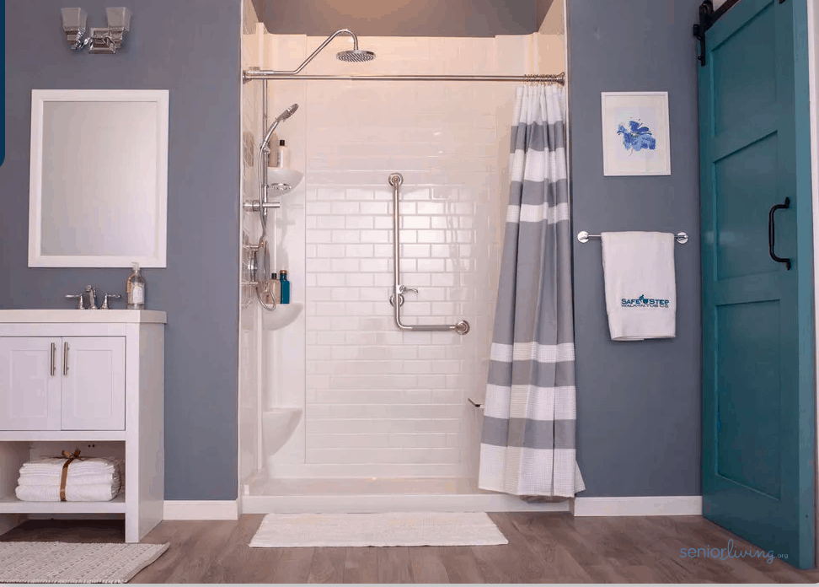

Bathtub [Grey & White Like The Picture Safe Step Tub]

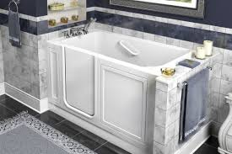



Bathroom Floor
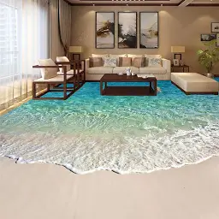

Private Yacht Dock
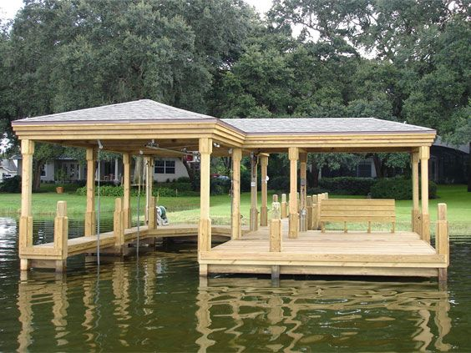

Queen’s Sea Ray Yacht
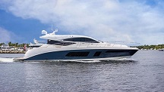

- Drs. Laura L. Gardner Alexander (Queen) [white & blue master suite]
- Dr. Landon D. Alexander (Queen’s Husband) [white & blue master suite]
- Drs. Lance D. Alexander (Queen’s Father-In-Law) [blue master suite]
- Dr. Laurie M. James Alexander (Queen’s Mother-In-Law) [blue master suite]
- Dr. Casey L. Smith Gardner (Queen’s Mother) [grey room]
- Drs. John R. Smith (Queen’s Grandfather) [brown room]
- Secretary Cindy A. Andrews Smith (Queen’s Grandmother) [brown room]
- Dr. Jennifer L. Smith Magnamere (Queen’s Aunt) [white room]
- Drs. Matthew A. Magnamere (Queen’s Uncle) [white room]
- RN. Jessica A. Smith (Queen’s Grandaunt) [black & white room]
- Dame Julie N. Andrews (Queen’s Grandaunt) [black & white room]
- General John R. Houston (Queen’s Granduncle) [black room]

The Queen’s Beach House

Type: Personal Beach Residence
Value: $60,000.00
Owner: Queen Laura L. Gardner Alexander
Location: Blue, Waters
House Elevation:
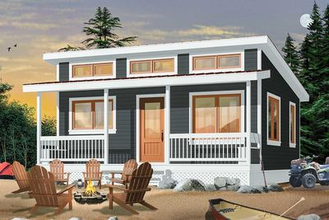

Floorplan:

Rear Evaluation:

Front Door Mat
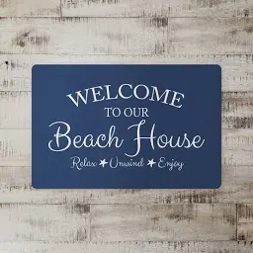

Inside Door Mat
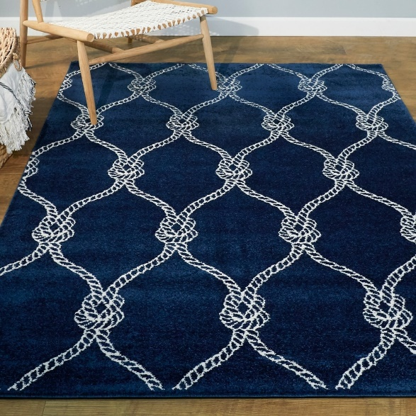

Interior & Furnishings

Kitchen

[Island Counter Throughout The Kitchen, The Microwave, The Stove & Hood Vent, The Refrigerator, The Sink, The Lights, Hardwood Floors Throughout, Blue Backsplash & Beach Logo]

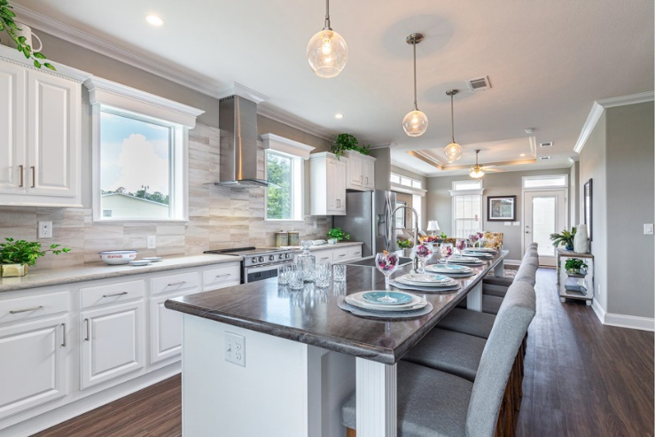

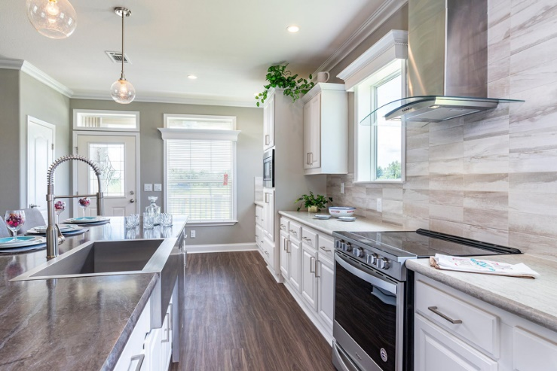

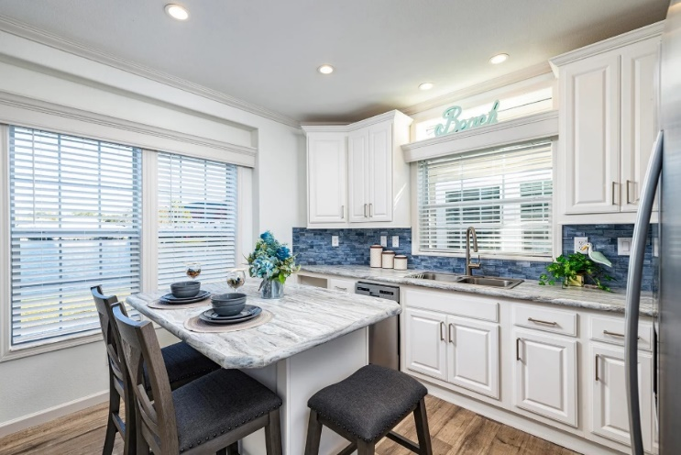

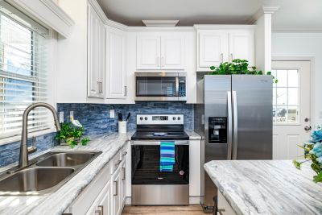

Cuisinart ICE-45 Mix It In Soft Serve 1-1/2-Quart Ice Cream Maker, White

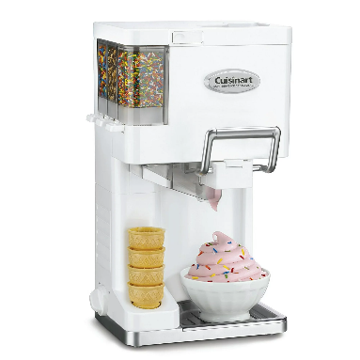

Nostalgia Extra Large Diner-Style Steamer 20 Hot Dogs and 6 Bun Capacity

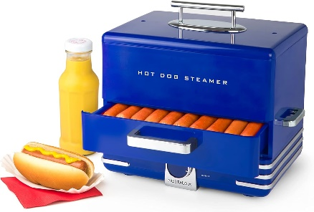

Capacity 0.7-Cu. Ft. Capacity Multi-Functioning Retro Convection Toaster Oven, Fits 12 Slices of Bread and Two 12-Inch Pizzas

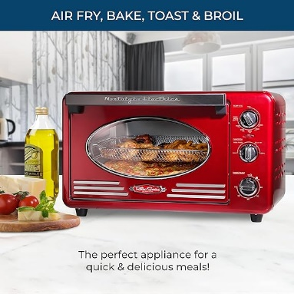

Nostalgia 600 Watts 8 oz. Navy Blue Vintage Professional Popcorn Machine Cart

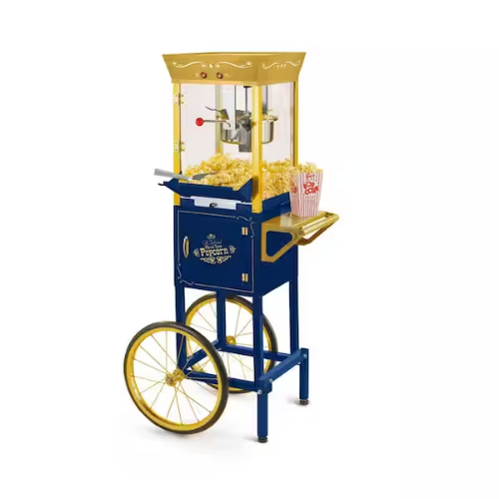

Arcade1Up Countercade NBA Jam & Teenage Mutant Ninja Turtles

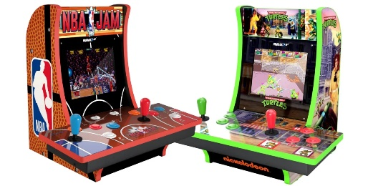

Living Room

[Layout & Kitchen Hardwood Floor Throughout]
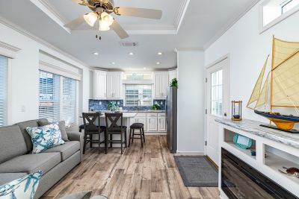

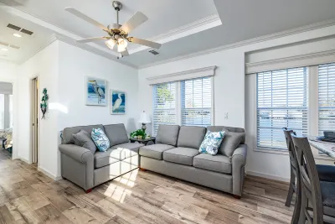

[Stripped Beach Couch]

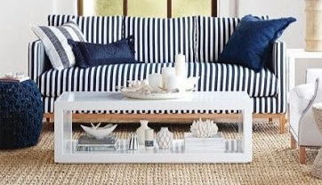

[Blue & White Sleeper Couch]

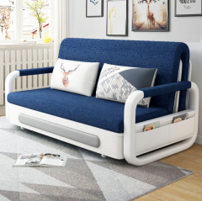

[Curtains & Rug]

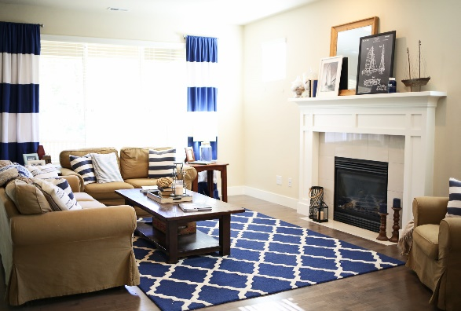

[Beach Posters]





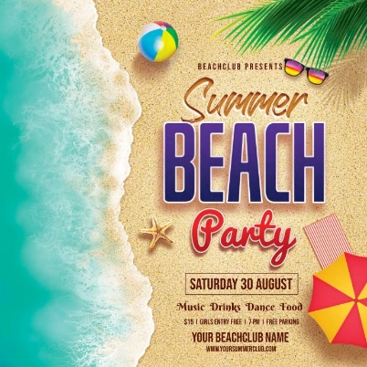

[Movie Beach Posters]

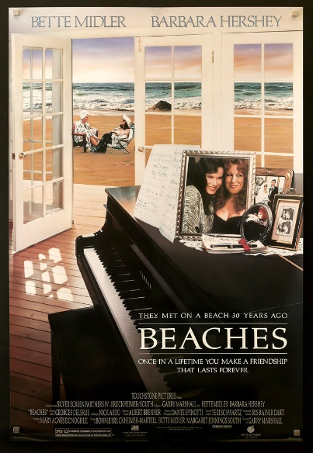



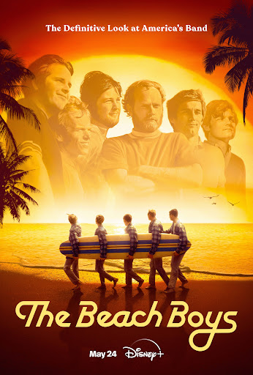

Bathroom

[Layout, Without Glass Door, Curtain, Mats & Bathroom Floor Decal Throughout]

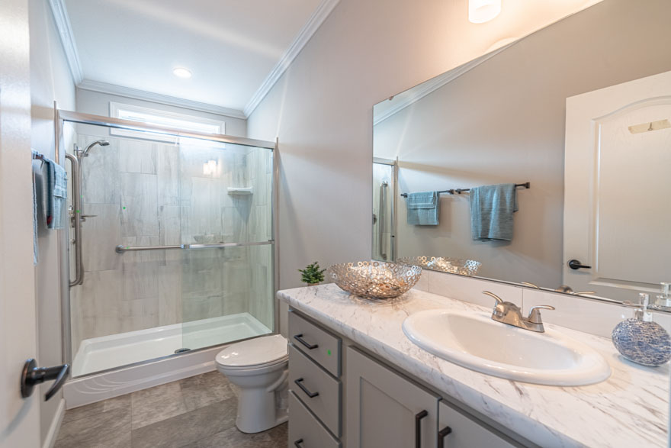

Bathtub [Blue, Grey & White Like The Picture Safe Step Tub]

Bedroom

[Layout & Kitchen Hardwood Floor Throughout]
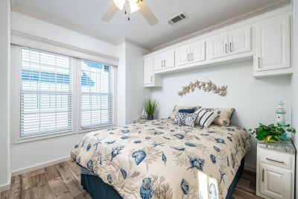

Car Garage
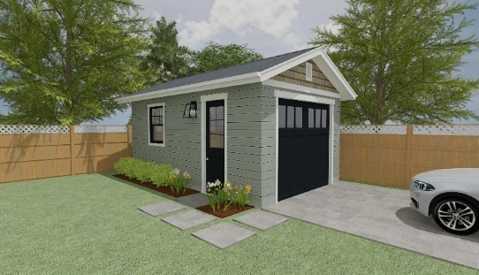

Queen’s Infinity QX30

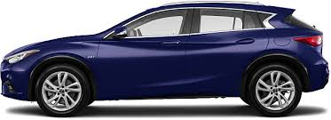

Custom Guild Award


