March 7th, 2026


The Social Security Survivors Pension

Name: Laura L. Gardner
DOB: 07/26/1981
Social Security Number: 559-67-1605

Fact Findings: Bronze American Indian of the American Indian Tribe Of Houston Of South Dakota. Great, Great Granddaughter Of American Indian Chief Adam T. Houston, Great Granddaughter Of Anjelica A. Houston Ford, Grandniece Of General John R. Houston & CEO Harry T. Ford. Filed As Dependent By Her Father Drs. Leroy L. Gardner To Inherit His Social Security Pension With Him Passing Away At 57 From Heart Failure.

Current SSDI Survivors Amount: $1,938.00/per month

Late Father’s Program


Baby Picture
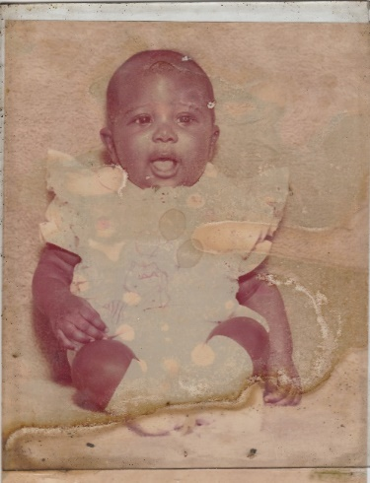

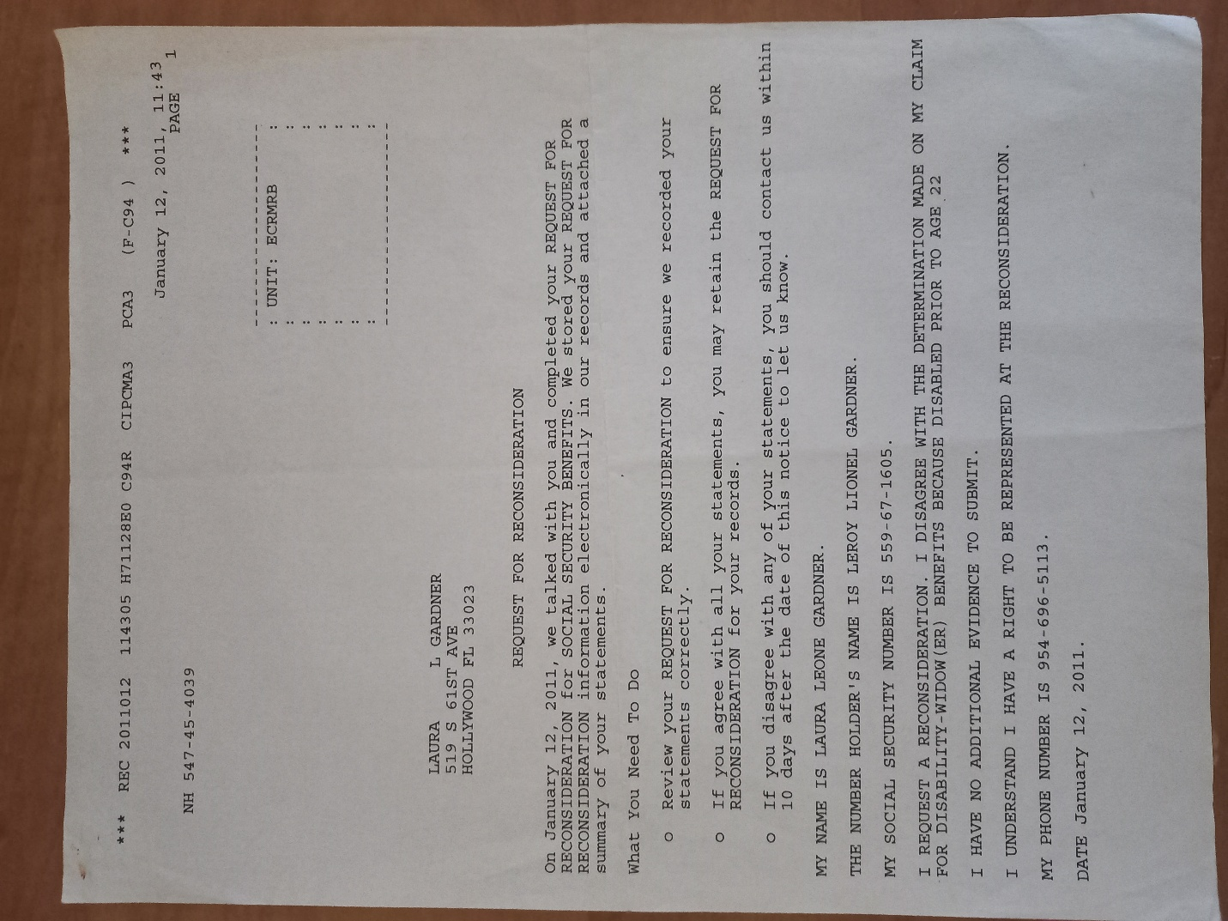

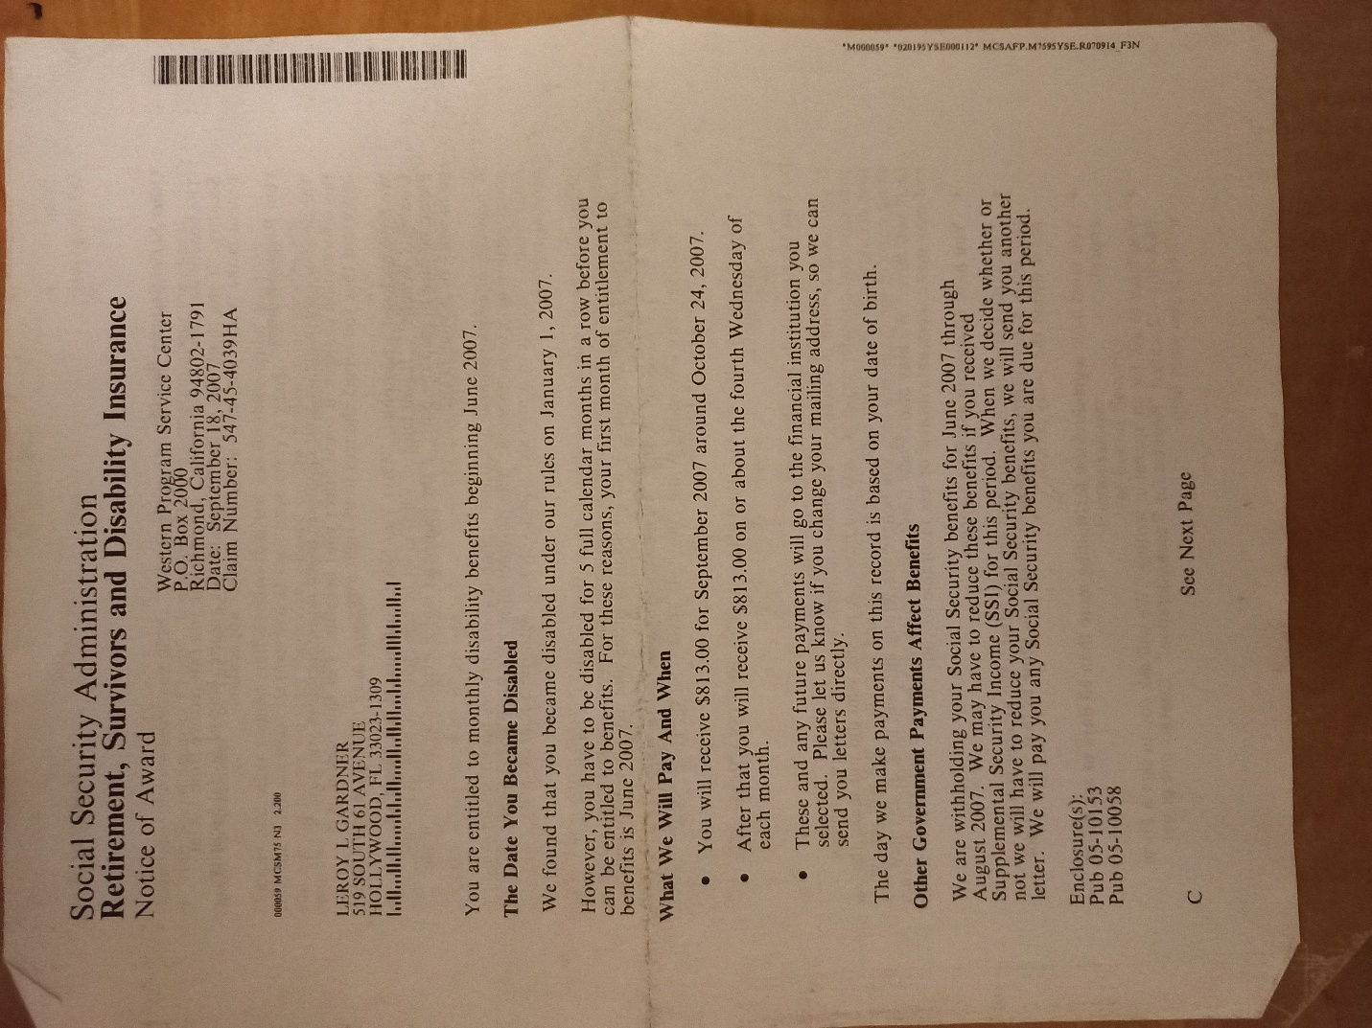

Social Security Administration Board: San Bernardino
605 N Arrowhead Ave Suite 101
San Bernardino, CA 92401

Direct Deposit Information For Survivor’s Pension

Bank: Wells Fargo

Type: Way2Save Savings Account

Account #: 6392901648

Routing #: 091400046

Total Amount: $1,938.00/per month [Every 7th Of The Month]

Mailing Address:

Laura Gardner
5013 S Louise Ave
Unit # 531
Sioux Falls, SD 57108


Laura Gardner

