**Dr. Jennifer & Drs. Matthew’s House**

**Type:** The Main Residence [680 Million]

**Location:** Serenity City, Queen Laura’s Heaven Access

**Value:** $510,000.00

**Owners:** Dr. Jennifer L. Smith Magnamere & Drs. Matthew A. Magnamere

**House Elevation**

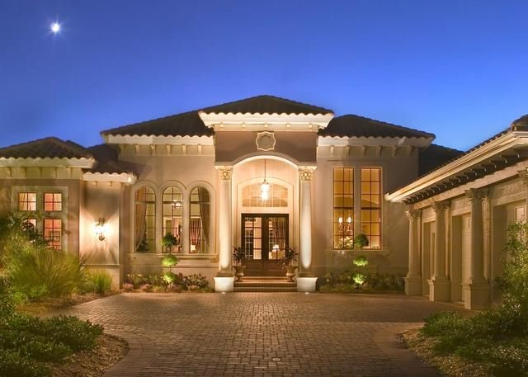

**Front Foyer**

[Remove The Staircase]



Luxury Staircase

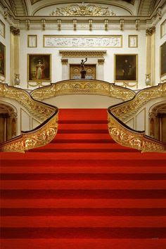

**Parlor**



**Dining Room**

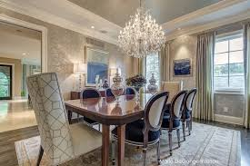

**Kitchen**

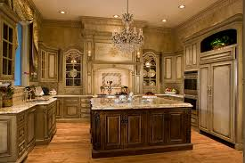

**Dinette**

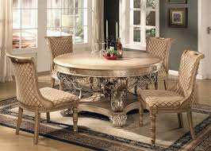

**Family Room**



**Exercise Room**



**Library**

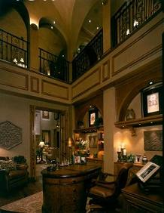

**Library Door**

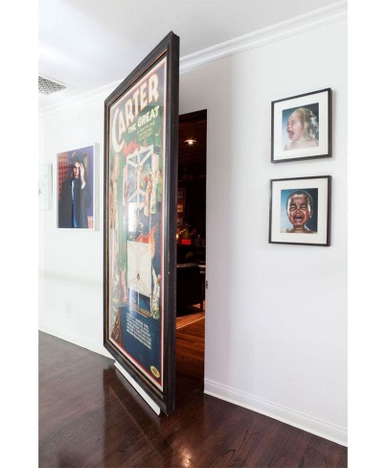

**Game Room**



**Theater Room**

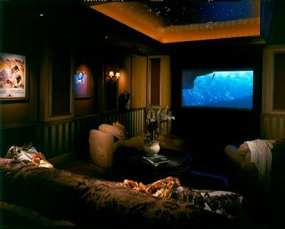

**Concession Stand**

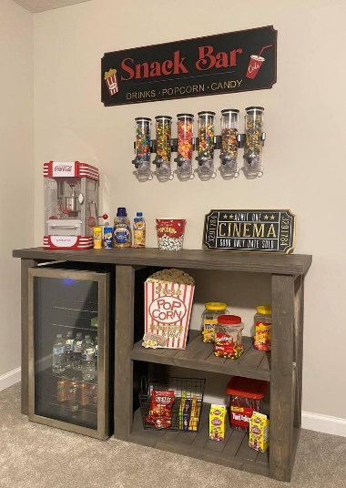

**Guest Rooms**

Guest Bedroom #1



Guest Bathroom #1

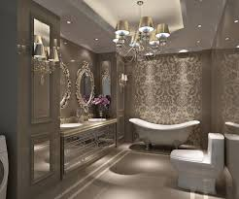

Guest Bedroom #2



Guest Bathroom #2

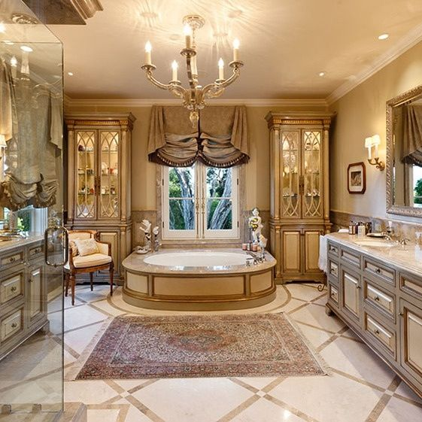

**Upstairs**

**Master Suite**

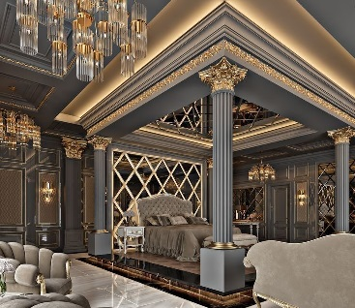

**Master Bathroom**

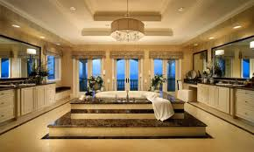

**Royal Nursery**

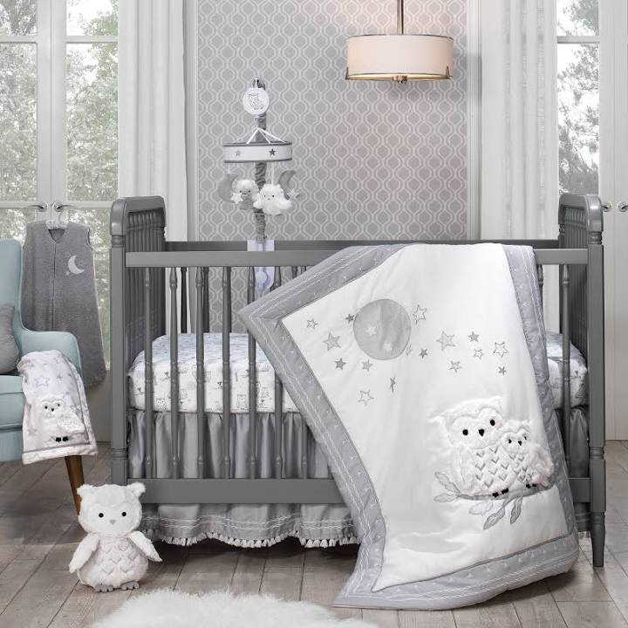

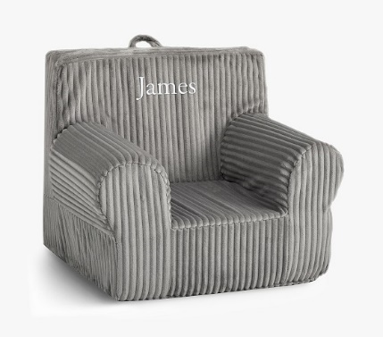

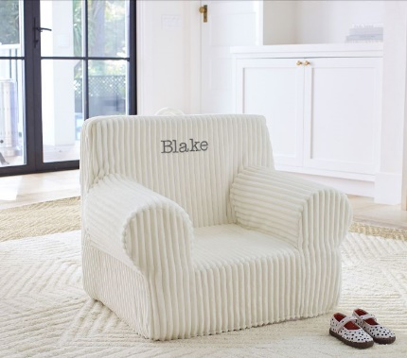

**Royal Cousin Madison, Royal Cousin Jordan & Royal Cousin Mathis Bedroom**

[Remove Chandelier, Nightstands & Lamps, Back Mirror, Chairs And Plant Stand]



**Laundry Room**

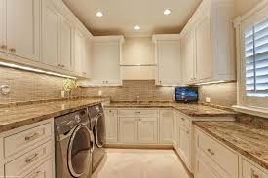

**Backyard**

Covered Lanai



Summer Kitchen

