The Criminal Physical & Pictures Of The Bodily Harm

**Pictures Of Bodily Harm**

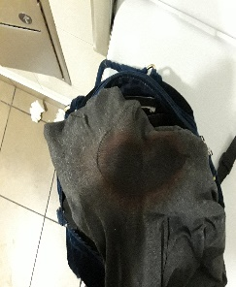

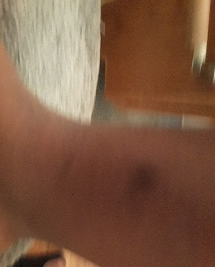

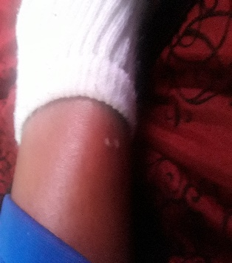

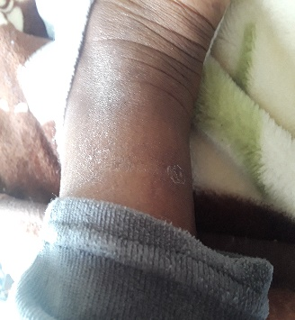

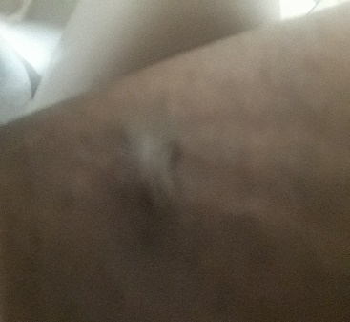

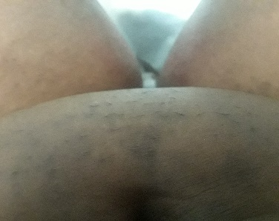

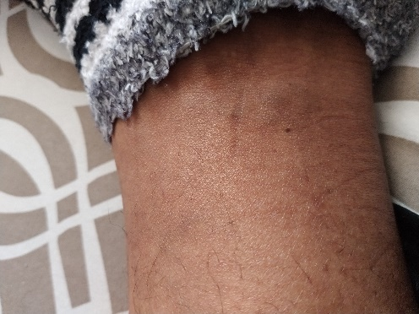

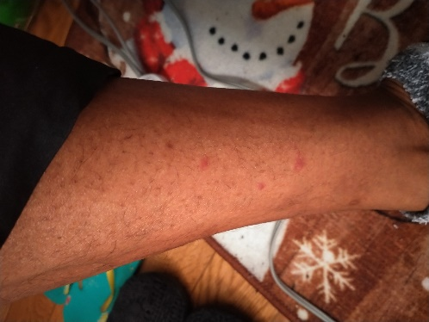

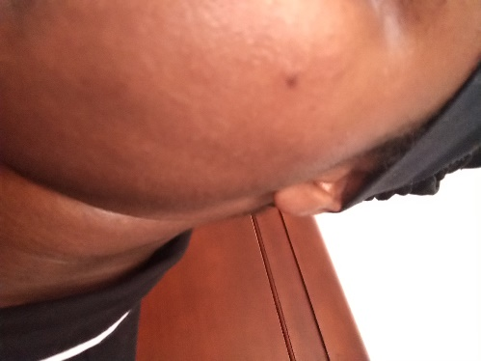

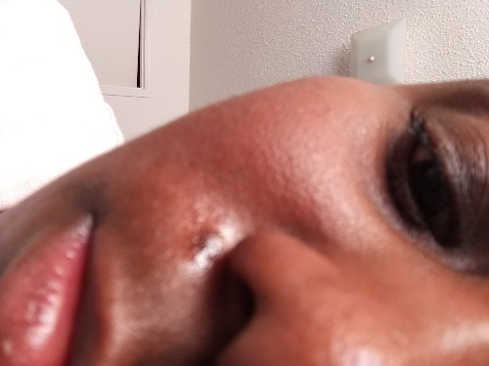



**Pictures Of Hostel** [Universal Symbol To Do Not Touch, Engaging The Universal Languages We All Understand Indeed Of See & Touch Respectively]

**More Graphic Pictures Of Criminal Harm**

