**Queen Laura & King Landon’s Heaven Royal Mansion**

**Type:** The Royal Main Residence

**Location:** Heaven City, Queen Laura’s Heaven Access

**Value:** $80 Million

**Owners:** Queen Laura L. Gardner Alexander & King Landon D. Alexander

**House Structure**

The columns for the entry, the patio rails and steps are ivory and the detailed trims in brown are made of pure gold with the exterior of satin beige. The tiles on the roof are made of brown clay and have a Mediterranean look. The color scheme looks like the one below.

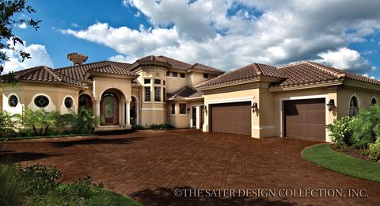

**House Elevation**

The 2 acres should be nicely landscaped and look like the elevation picture and the front and back of the yard should have very soft green grass with nicely kept lawn.

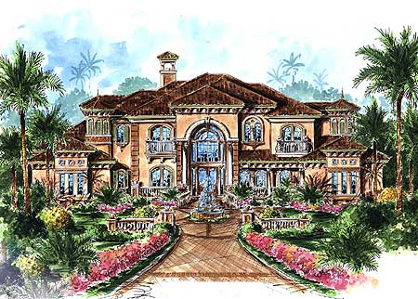

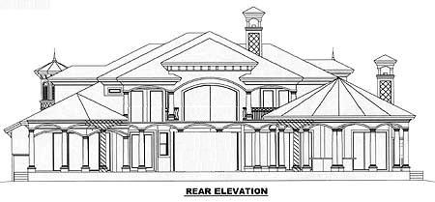

**Home Floor Plan First Floor**



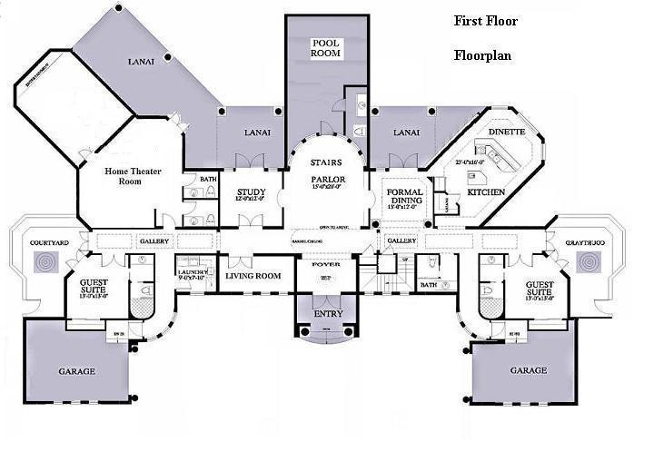

**The Entry**

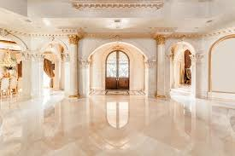

**The Foyer**

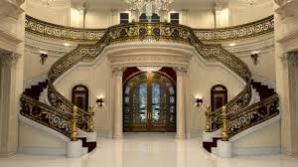

**The Dining Room**

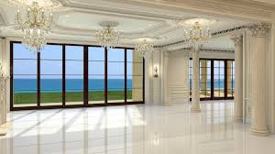

# The Kitchen

# 

**The Home Theater Room**

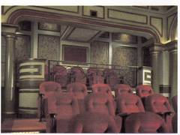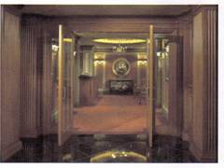

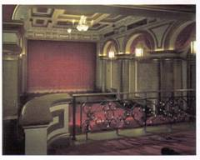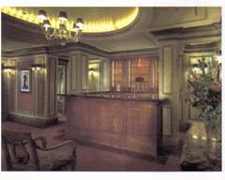

**The Bar And Aquarium**

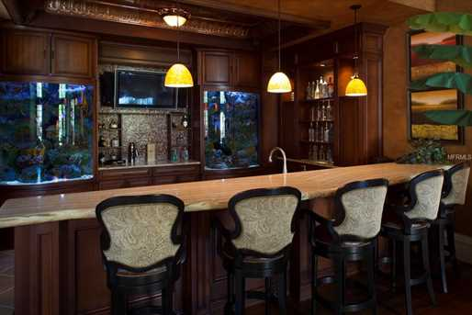

**The Guest Suites**

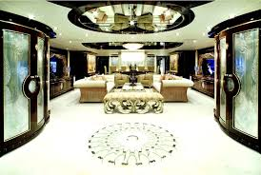

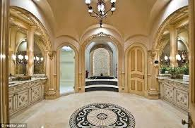

**The Office**

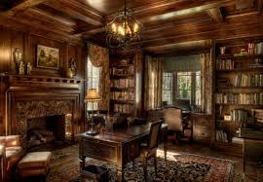

**The Laundry Room**

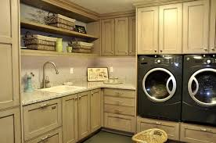

**The Game Room**



**The Educational Room**

Wall Decor

Floor

Game Table

Dice

**The Upstairs Hallway**

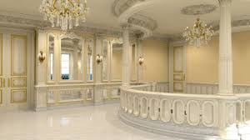

**Queen Laura & King Landon’s Master Suite Bedroom** [In Black, White & Gold]

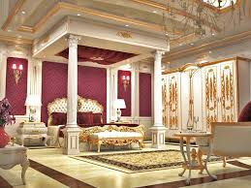

**Royal Nursery**

[Nursery Wallpaper On One Wall]

Waterproof Solid Black Wallpaper Self-Adhesive and Removable,17.7" x 393" Peel and Stick Wallpaper Wall Decoration From Amazon

[In Writing Royal Baby In White]

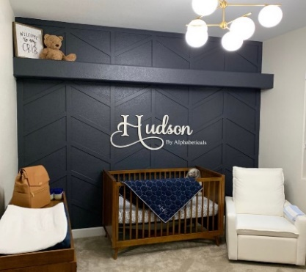

Nursery Furniture

Crown Piece & Valence In

Silver Crown With White Vale

Crib, Dresser, Diaper Bin [Pottery Barn] – In Black

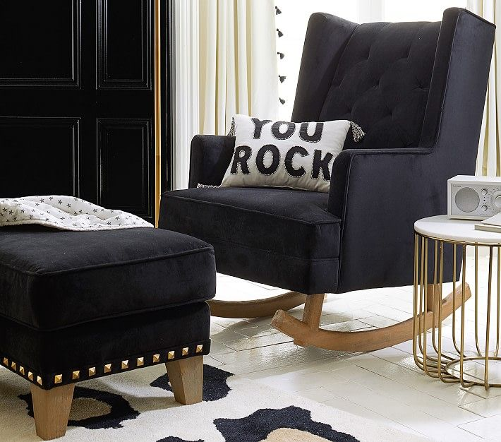Rocking Chair & Ottoman [Pottery Barn] - In Black

TWINNIS Super Soft Shaggy Rugs Fluffy Carpets, 4x5.9 Feet, Indoor Modern Plush Area Rugs From Amazon - In Black

**Prince Lancelot, Princess Lauren, & Prince Lord’s Rooms**

[Headboard, Bed, Bedding, Rug, Ottoman & Curtains, Remove Chandelarie, Nightstand & Lamps, Glass Back Insert]

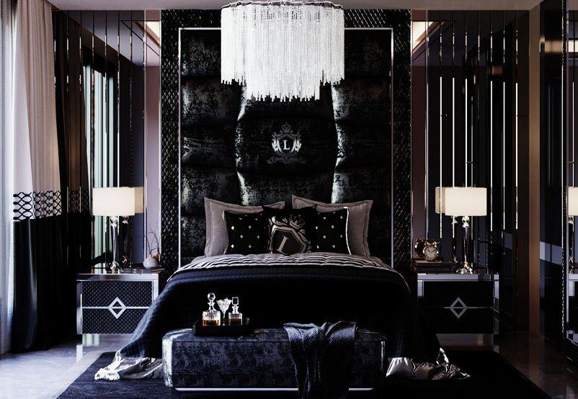

**The Garage**



**The Special Hall & Awards Room**

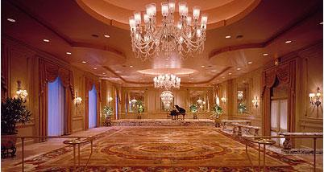

**The Awards**

The Nobel Peace Prize [20]

The Purple Heart [25]



The International Golden Heart [5]

Architectural Digest Awards [29]

James Beard Awards [335]

Costume Guild Awards [137]



Blockbuster Entertainment Awards [15]

I Heart Music Awards [14]



Readers Digest Awards [10]

Emmy Awards [67]

Grammy Awards [182]

Oscars [92]



Tonys [8]

Planned Parent Hood Award [3]



Gerber Award [1]

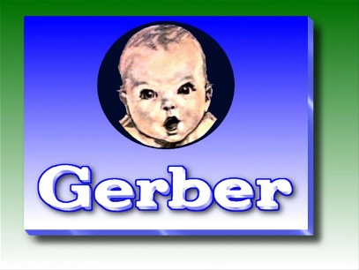

**Total Awards:** 938