The Queen’s Tiny Entertainment House

Type: Tiny Personal Residence
Owner: Queen Laura L. Gardner
Value: $120,000.00
Location: Valley, Splendor
House Elevation:
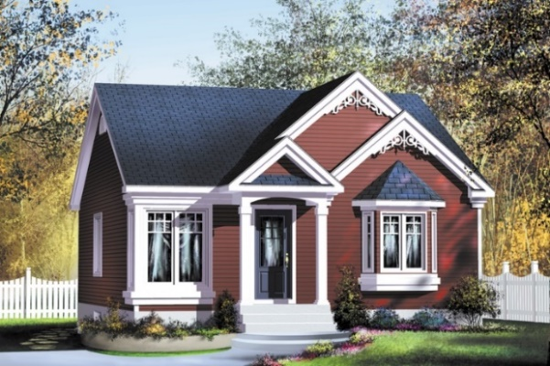
[Brown & Cream With Accents Of White]

Floor Plan:
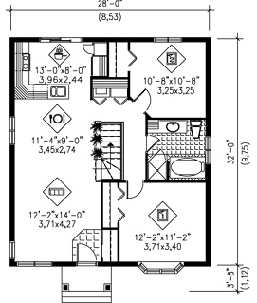

Interior & Furnishings

Living Room

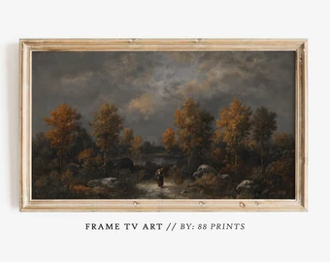
Samsung Frame TV 50”
Samsung Frame TV 50”

Wave Sound Touch Music System IV In Platinum Sliver


COWSAR 36.14-in W Free standing Infrared quartz Corner or flat wall Electric Fireplace

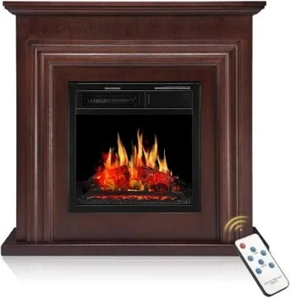
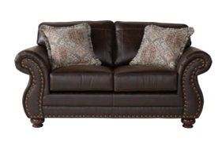
Conns Remington Love Seat

Living Room Floor, Foyer & Other Untiled Areas

SMARTCORE Pro Twilight 12-in x 24-in Waterproof Interlocking Luxury Flooring (15.83-sq ft) In Brown

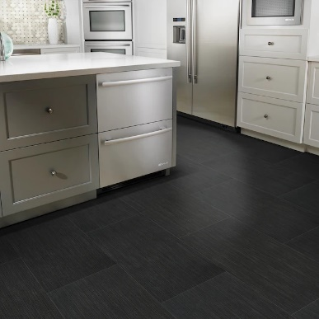

Dining Room

Irma 5-Piece Dark Brown and Espresso Brown Dining Set by Baxton Studio

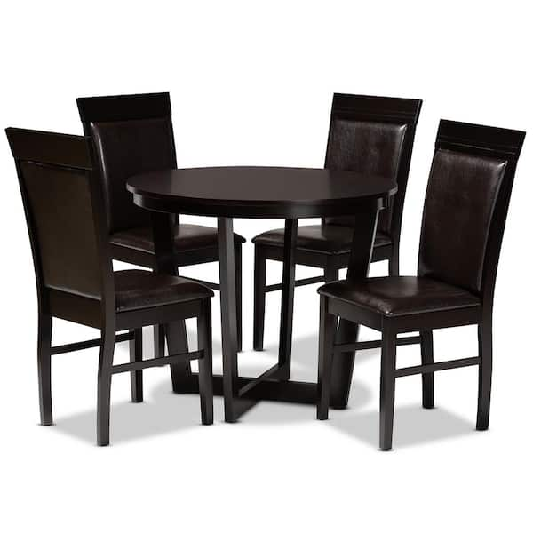

Kitchen
[Fully Functional Kitchen In Brown Color Scheme]
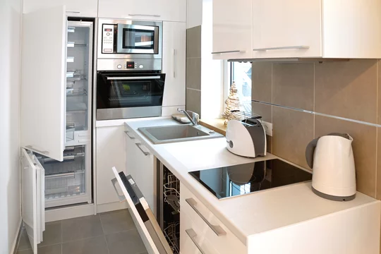

Kitchen Cabinetry

Espresso Shaker RTA Kitchen Great Buy Cabinets

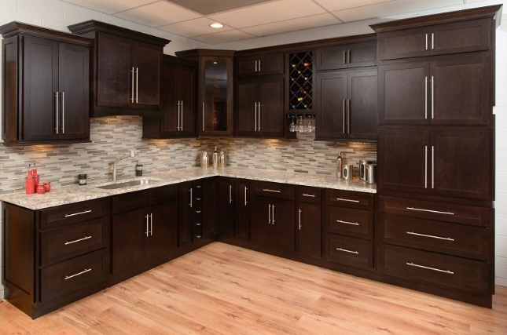

Backsplash For Bathroom & Kitchen

[Daltile Crystal Shores 1 X 2 12" X 13" Glass Mosaic]



Laura’s Master Bedroom
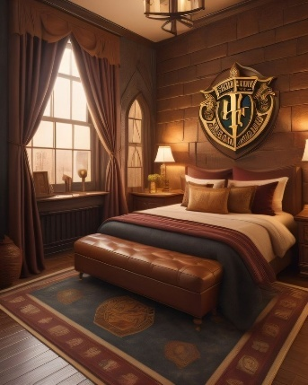

Bed
Full Size Bed Sleep Easy Cool Gel - [Furniture Distribution Center]

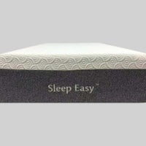

Pillows

Bodipedic Super Coolin Gel-Infused Gusseted Memory Foam Pillow

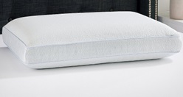

Closet [In Brown]

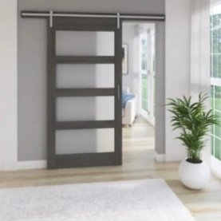

Bathroom

[In The Same Brown Color Scheme]

Bathroom Vanity

Signature Hardware Keller 24” Mahogany Bathroom Vanity Floor Tiles For Bathroom & Kitchen

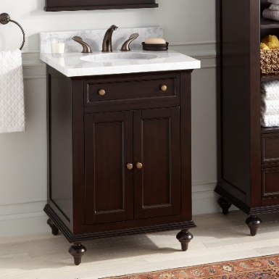

1.1/1.6 GPF Tornado Flush One-Piece Toilet Elongated, Siphonic S-trap 12", Soft Closing Seat, Button on Tank top, Powerful Dual Flush MAP 1000g, Comfort Chair Seat ADA Height 17", Matte black. By Lamanelle

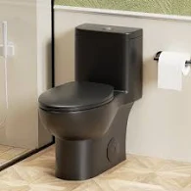

Skylight

Minimalist Light Filtering Skylights Chi White SC

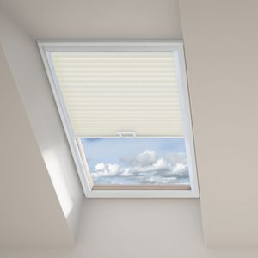

Shower [In Dark Brown & White]

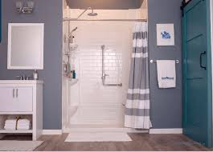

Bathtub [In Dark Brown & White]

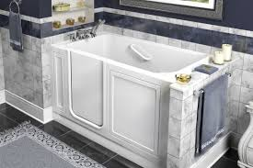



Entertainment Room

LG 55” smart flat screen tv



Bose Solo TV Sound System Home Cinema Choice

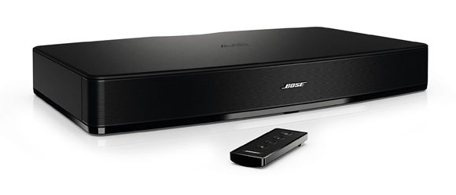

Sienna 34 in. Electric Fireplace Heater in Cherry with Mantel, Enhanced Log Display and Remote Control By Cambridge

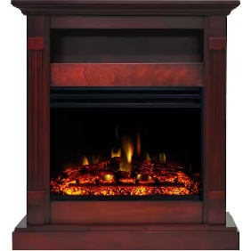

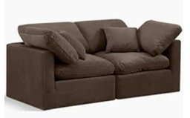
Meridian Furniture Indulge 70" Velvet Modular Sofa w/ Latch Underneath in Brown

Kadyn Morden Bench, Ottoman Bench, 43" Folding Storage Ottoman Bench Footrest Stool End of Bed Bench, Brown
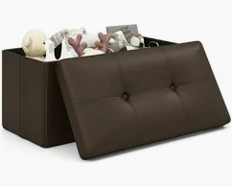

Movie Posters With Frame







Closet [In Brown]

Porch

Outdoor Infrared Lantern Heater - [Plow And Hearth]
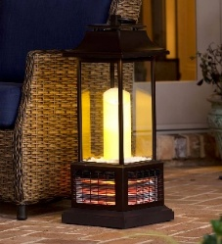

Single Car Garage

Single Car Garage That Looks Like The House To Fit The BMW Mini Hard Top 2 Door Grey/Black, Attached To The House, Accessed By The Back Door.


Queen Laura’s BMW Mini Hardtop 2 Door 2025 Grey/Black



Entertainment

Amazing Race



Survivor


Lunch

TGI Fridays



Applebee’s



Adventure

Easter Egg Hunt



Treasure Hunt



Dinner

Capones Dinner Show



Pirates Dinner Show


Award:

Custom Guild Award



