**The Gardner Alexander Estate**

**Owners:** The Royal Family Of The Ultimate Kingdom & The Territories

**House Builder:** Heaven Construction Company

**Designers:** Queen Laura L. Gardner Alexander

**Location:** Serenity, Queen Laura’s Heaven Access

**Value**: $306 Billion 258 Million

**Exterior:**

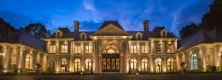

**The Interior**

Front Door

Door

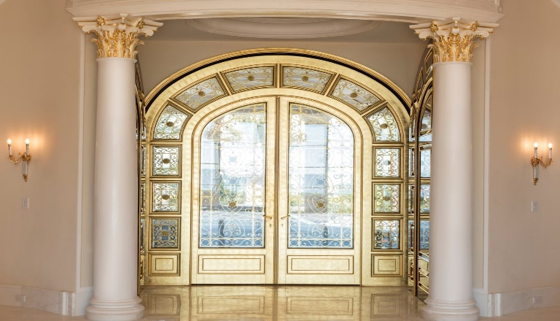

Foyer

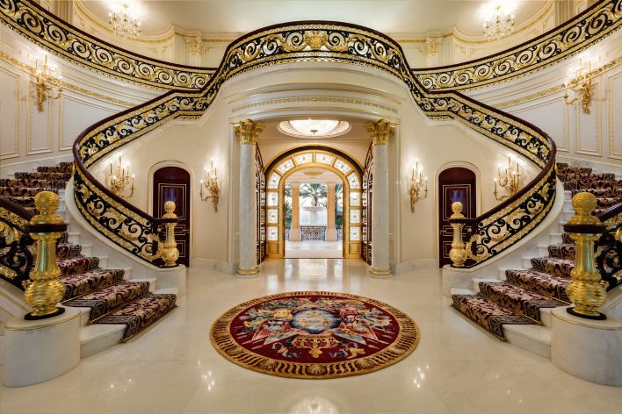

Parlor or Living Room

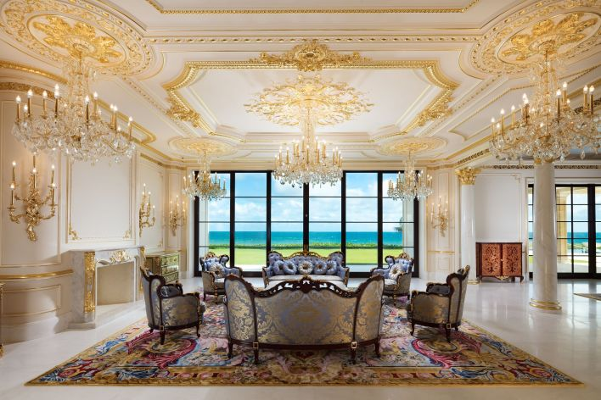

Kitchen

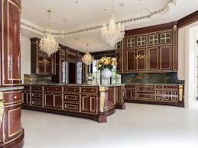

Office

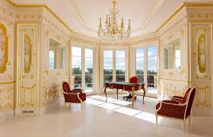

Family Room

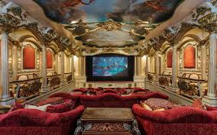

Back Yard & Pool [Movable Fence]

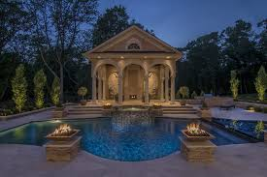

**Game Room**

#### Arcade1Up - Pac-Man Legacy 12-in-1 Arcade with the corresponding chair



#### Arcade1Up - Capcom Street Fighter II: Champion Turbo Legacy Edition Arcade with Riser & Lit Marquee - Multi with the corresponding chair

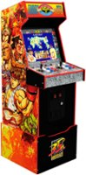

#### Arcade1Up - Mortal Kombat II Deluxe Arcade Game - Black with the corresponding chair

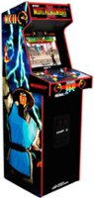

**The Bedrooms**

Queen Laura & King Landon’s Room[with mini or wet bar]

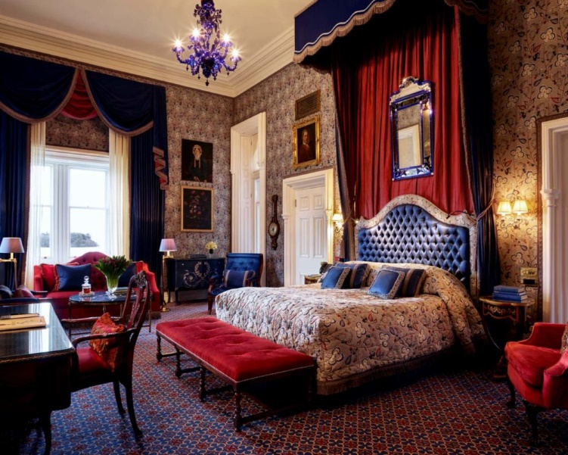

Dr. Casey’s Room [with mini or wet bar]

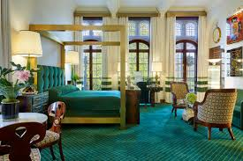

Drs. Lance & Dr. Laurie’s Room [with mini or wet bar]

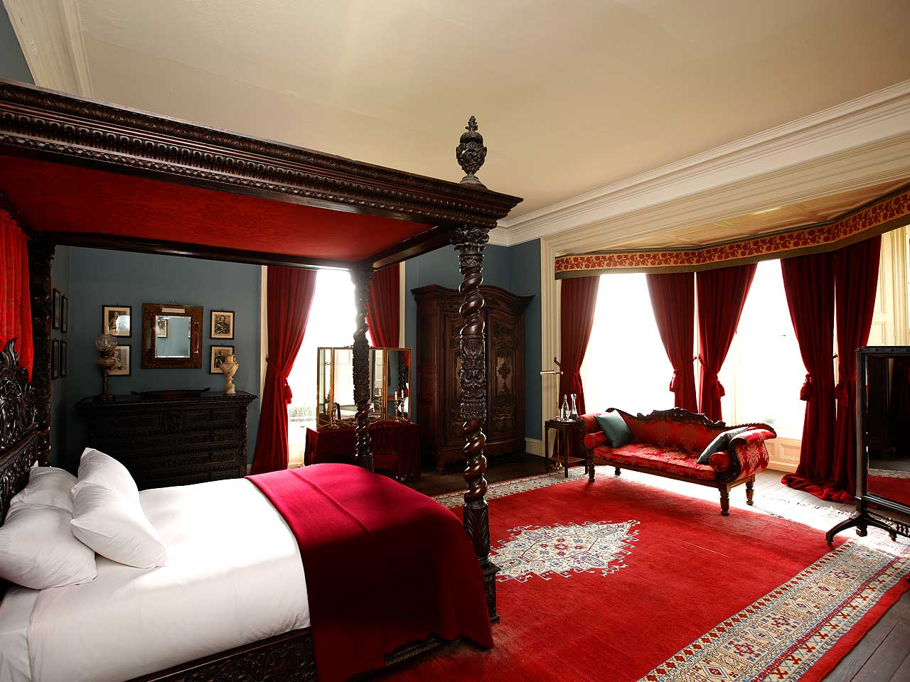

Dr. Jennifer & Drs. Matthew’s Room [with mini or wet bar]

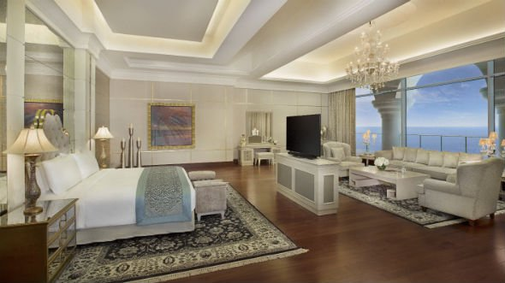

Kid’s Room

Prince Lancelot, Prince Lord, Royal Cousin Madison, & Royal Cousin Mathis

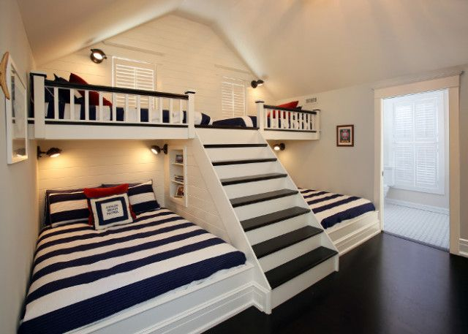

Princess Lauren & Royal Cousin Jordan

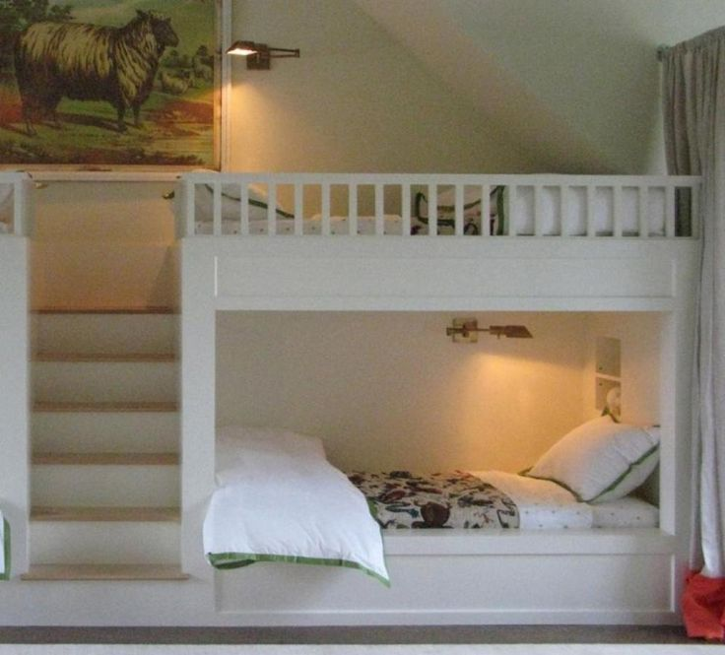

Drs. John & Cindy’s Suite With Kitchenette [60 Million Dollars]

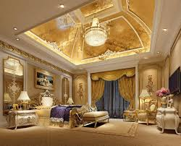

General John’s Suite With Kitchenette [108 Million Dollars]

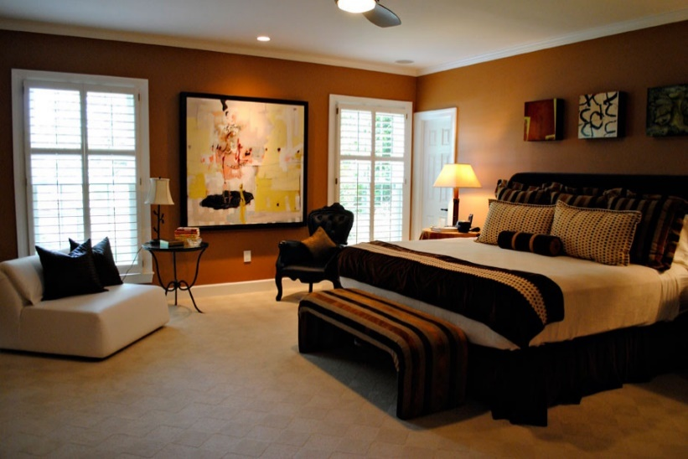

CEO Harry’s Suite With Kitchenette [305 Billion 20 Million Dollars]

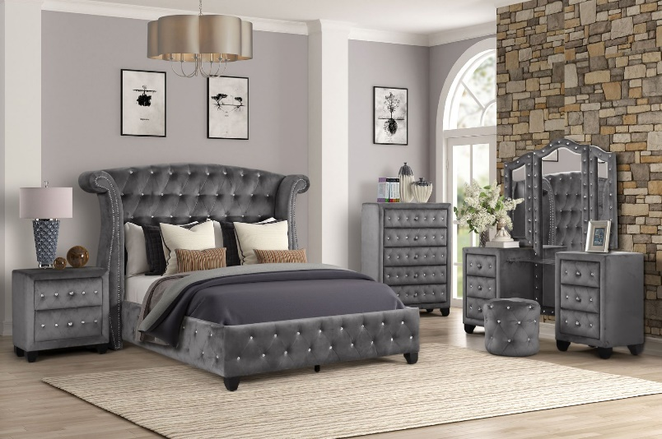

Dame Julie’s Suite With Kitchenette [1 Billion 40 Million Dollars]

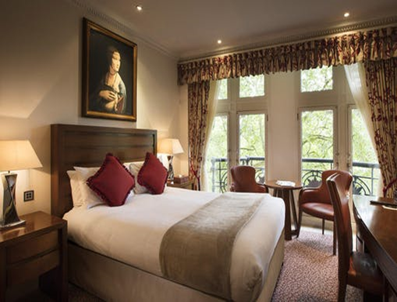

RN. Jessica’s Suite With Kitchenette [30 Million Dollars]

