

The Queen’s Savings Account To Be Funded

From The Desk Of Her Royal Majesty

Queen Laura L. Gardner
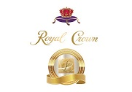

Savings Account 💰


Major Savings Account

Goldman Sachs Bank



Goldman Sachs Marcus High Yield Savings Account - $1,600,000.00

Routing Number: 124085260

Account Number: 300065691978


Queen Laura Gardner

