August 8th, 2021

The Queen’s Legal Criminal Physical Filings & Criminal Compensations

From The Desk Of Her Royal Majesty

Queen Laura L. Gardner



**Legal Documented Findings** ⚖️

Hit Arrangement & Assassination Attempt 🎯

Bodily Harm With Malicious, Maniacal Intent

Breaking & Entering

Lewd & Lascivious Behavior

Indecent Exposure

Defacing & Littering The Human Body

Prolific, Vile, Pedophile

Rape

Necrophiliac Behavior

Touching Without Permission Or Consent

Permanent Restraint With Restraining Orders

Request To Not Be Disturbed In The Year Of 2020

Request To Not Be Disturbed Ever Again In The Year Of 2021

With Maximum Compensations Had As Is Humanly Feasible The Responsible Criminals Paying With Their Natural Lives & Bodies

The Laws Of The Satellites

The Laws Of The Securities

Punishable Features With Caunch Blanc

Obstruction Of Justice

Hostage

Dangerous & Nasty Presence

Stealing Of Property Without Restraint

Dangerous Threats

False Accusations

Lying & Deceiving

Attempted Murder Charges

Espionage

Spying With Pornographic Behavior

Interfering With Plans & Discussions

Duress

Nasty Harassment

The Shield Law 🛡

The Writ Of Man

Exploiting Our Family For Personal Gains Or Dangerous & Jealous Agendas

Obsessed, Unusual, Fanatical Behavior

Depraved, Deranged, Sociopaths

Disobeying Restricted Airspaces

Tampering & Mishandling Of 38 Dangerous Unauthorized Weapons

Lying & Deceiving To Get Innocent People In To Trouble

Request To Put The Crime & Criminal Elements To A Permanent End 🔚

Two Weeks Hotel & Air Bnb Stays To Identify The Textbook Crime

Political Asylum Documentation To Never Deal In Politics Again

Settlers Law Properly Handled For A Year At AAA+ Five Diamond Levels

A Shoot To A Kill For Liberty Taking Of Ourselves, Our Family, Our Properties & Belongings

Legal Indemnity To Not Be & Never Be Betrayed [2 Years]

Legal Indemnity To Not & Never Have Liberty Taking Be [1 Year & 6 Months]

Legal Indemnity To Not & Never Be Disobeyed [1 Year]

The Careful And Proper Yield And Identification Of All Who Previously Conspired, Currently Conspired And May Conspire For Future And Then To Have Them Documented In The Various Court Houses As Dangerous Deadly Racist Conspiring Criminals

The Countries and Private Islands That Assisted These Criminals Indicted As Co-Conspirators Legally Filed And Bard For Helping Them With Satellite Hit Arrangements, Lying, Deceiving, Taking Of Money And Benefits For Their Needs, Disobeying Our Direct Wishes And Desires With Our Bodies And Belongings Constantly

The Legal Filings Of All Who Afflicted And Attacked Me Officially Seen As Hit Men & Women Concerning

The Final, Permanent & Proper Physical Restraint Of All Who Disobey And Continue To Disturb Or Harm Me, Ensuring An Accurate Time Frame Of One Month As The Standard Of Limitations For Complete And Thorough Resolution

The Understanding That No Dealings Personal Or Business Is Wanted Or Their Undesirable Criminal Presence In Person If Proximity Or At A Distance With Any Know Dangerous Device, And To Know That This Applies To Any Personal And Tangible Belongings And Property

With All Properties And Belongings Secured And Negated As Well As Land Spaces, Buildings And Establishments, Titles For Overruling Handling, Mention Or Acknowledgements For Proper, On March 10th, 2022, There Needs To Be Verifiable No Physical Contact Or Dangerous Criminal Presence To Be Found Further

Filed And Indicted As Hit 🎯 Men And Women Of A Nasty, Foolish, Disobedient, Illogical, Taking Of Liberty Nature, Directing Volumes Of People, Possibly Hoping To Cost Whoever They Are Wanting, If Not All, Unrestrained, By The Unscrupulous, Foolish, Volume Helping Them To Hurt The Queen & Her Family Nastily Directing The People & Currents To Do So Unrestrained

The Countries And Private Islands Guilty Of Conspiring Against The Royal Family, And All Of The Ultimate Kingdom & The Territories, Will Never Be Mentioned By Us Again, Or Aired On Any And All Public Medias Affiliated Ever Again

The Visual And Physical Observation Of Cease And Desist For A Time Frame Of Six Months To A Year, To Ensure Nothing Like Or These Acts Are Not Repeated Again

The Queen Of The Ultimate Kingdom & The Territories Taking Out The Responsible Criminals, For The Airspace Attacks, And Liberty Taking Bodily Harm. Then, The Further Investigative Efforts, To Figure Out The Voluminous, Despicable, Behavior Of The Criminals, In Preventing Her From Putting The Attacks To A Permanent End.

The Queen, Her Staff, & Security Personnel, Are Hoping For No Further Incidences Of Disturbances, Dangerous And Undesirable Presences, Devices, Or Contaminates. Kindly Have This Be In Obedience For Everyone's Sake, Safety, And Survival.

The Retired Queen, Also Requires Library Conditions And Do Not Disturb Maintainable Conditions, To Conduct Her Business And Personal Affairs Properly. She Must Also Pass The Medical And Royal Inspections, Requested By Royal Law. She Prefer To Be Looking And Feeling Good, As She Stays That Way And Remain The Same.

The Criminal Satellite Attacks Upon Our Mortal Bodies Also Affected Quality (Looking And Feeling Good), Time, And Duration, Fast (Immediate Death) And Slow (Impacts To The Physical Health).

Some Of The Individuals Called Upon, Knowing A Hired Job To Get Successfully Done, Rejected The 5 Million To Resolve The Crime Permanently, And Did The Opposite Of What We Were Looking For. We Highly Believe That These Criminals Wanted To Exploit The Queen And Her Family, To Do As They Nasty Please, And For Hate Crime Purposes, Having Rejected All Tangible.

In An Effort To Protect Our Bodies, And Be Fine And Well Again, Queen & Her Royal Family, Will Wait On Social Security, The Medical Clearance, And Body Insurance Clearance, Before Selecting Their Desired Destination.]

The Continued Discussions To Know And Understand What Is Required, To Put The Bodily Harm And Attacks, To A Permanent End, Then To Have That Actually, Factually, Verifiably Be.

The Criminal Felons Responsible For Attacking The Queen Of The Ultimate Kingdom & The Territories, Their Family, Friends, Staff, Securities, Countries, Private Islands, And Even Their Fans, Have Been Warned, Investigated, On Trial, Evidences Reviewed, Proven Facts, Statements, Evidentiary, Court Hearings, Evaluations, Witnesses, Observations, Depositions, And Thorough Accurate Understanding. They Have Been Proven Guilty Throughout, Of Malicious, Maniacal, Vile Pedophile, Sick, Twisted, Insidious, Nasty, Hate Crime, Taking Of Liberty Behavior, Hit Arrangement, Attempted Murder.

The Ongoing Restraint By Queen Laura Has Now Totaled 17.1 Billion People. Upon Review The Various Walks Of Life Faltered In This Conspiring, Infuriating, Provoking Act, And Would Each And All Have To Be Punished, Restrained, And Never Again Have Such An Act Be. This Is The Logical And Wise Realization, Sensible Humanity Is Coming To, For Each Of Us, And All Of Us, Who Are Desirous Of Continuing On In Life. This Must Be Achieved, In An Effort To Do So.

They Will All Be Seen As Suicidal Bombers Indeed, As We Hope To Punish And Restrain All And Never Again Have This Be.

Filed And Indicted As Suicidal Bombers Of A Nasty, Foolish, Disobedient, Illogical, Taking Of Liberty Nature, Affecting Volumes Of People, Hoping All

**[**The Filings Verifiably Complete For Four Years🗃**]**

**Report**

This special report gives the final exact intent, of the criminals that focused on the Royal Family of The Ultimate Kingdom and some of the very good citizens. These people plotted to take jurisdictional satellites and fix them to our mortal bodies, tracking and emitting as we walk and drive along, or irrationally find us wherever we are, unexpectedly causing harm. These criminals would disobey, lie, and deceive incessantly. Some thought they would distance but could not do so after the fact, thinking that they would get off with us. When they realized it was not working, they plotted to include whoever they wanted, to go with them, if not all, and further became suicidal bombers. There were several people responsible. When Queen asked them to effectively punish so many became fool hardy and disobedient, and overwhelmed her, doing so, almost costing us all our lives.

Queen Laura and her family, and some of the citizens, from the Ultimate Kingdom were evaluated with the hospital staff and these are their documented findings. They were afflicted with microscopic hair shot into the skin tissue, slight, red, and concentrated bumps, tar, blisters, dabs of nightshade, bruises, inflictions', pumps of air in various locations, neck and nose cold flukes. This type of harm affected their physical being and is of nasty origin. The criminals are vile airspace pedophiles and are restraining order as well as legally barred. Our recommendation, given the extreme desire to affect them physically. Ensure that they are not touched in an undesired way. Then a 3 to 6-month recuperation process. Please know from a medical stand point, it is important that this type of harm, so unwanted and uncomfortable, not be repeated.

We Are Also Directing The Warnings To Not Be Disturbed Ever Again, With Restraining Orders, Through The Libraries. We Are Also Punishing With The Obedient Caunch Blanc That Obey Queen Laura To Physically Move The Criminals, Their Dangerous Presences, Devices, And Substances, To Resolve This Air Space Bodily Hit Arrangement Crime Of Sniper Nasty, Permanently. Given That Statistics Of Bodily Harm & Loss Of Life, So Gravely Injurious, Especially Wounded Warriors With Ears, Eyes, & Limbs, Lost, And Some Living As Paralyzed Vegetables. We Simply Cannot Have Anything Like This Repeated. They Are Further Protected By All Of The Ultimate Kingdom & The Territories. Queen Laura Was Hoping To Get The Criminals Permanently, Out Of Their Lives, Given What So Many Plotted. Because Of The Desire To Get After Too Much, Provocation, Infuriation, And Foolishness, The Attacks Perpetuated Into Madness. These Air Space Criminals Would Track And Attack Like Predators Of Prey That Would Not Behave Or Obey. They Would Also Find And Seek, Then Attack Unexpectedly. Queen Laura Was Able To Resolve The Hit Arrangement Crime Temporarily, Then They Plotted And Started It Hit Up Again. The Criminals Have Already Paid 994 Billion Dollars For The Criminal Compensatory, With The Laws Of The Satellites, And The Laws Of The Securities, Any Further Attacks And They Will Pay With Their Natural Lives And Bodies. The Ultimate Kingdom's Supreme Courts Also Have The Please Ensure No Further Incidences Of Crime With Their Bodies, Overhead In Their Personal Restricted Airspaces Of 10 Years, With Disobedient, Deadly, Dangerous, Vile, Rapist, Pedophile, Obsessed, Racist, Hostile, Murderous, Criminals And Suicidal Bombers. Even On The Ground In Vicinities, With Machines Monitoring Their Body Parts, To Knock Them Out With The Satellites, In A Nasty Form Of Hit Arrangement. Then To Track And Attack At Satellite Gun Point, Emissions, Of Nasty, Like A Predator Of Prey, That Cannot Behave Or Obey. They Also Engaged In, Harassment, Duress, Spying, Lying, Deceiving, Unrestrained Indeed.

The Physical Presences, Devices, And Contaminates, Needed To Be Moved From Their Mortal Bodies, Given Their Behaviors, Of Hate Crime Dangerous, Deadly, Egregious, And Nasty. It Is The Only Antidote. These Behaviors Condoned, And Perpetuated, Could Have Cost Us All Disastrously. These Unrestrained Criminals Have Set A Dangerous Precedence, In Finding, Harming, And Killing, Whoever They Are Wanting, Wherever They Wanting, As Airspace Hit Men And Women. Queen Laura Of The Ultimate Kingdom & The Territories, Her Royal Family, And Royal Friends, Have Removed Their Presence Permanently, From All Responsible Criminals, And Those Who Do Not Care For Them, For Three Months. They Prefer To Not Be Affected, In Ways So Undesirably And Dangerously, Ever Again. Some Of The Criminals, Offered The 1 Million To Cease And Desist The Crime Permanently, Did The Opposite Of What They Were Looking For Still.

Additional Filings, For Obedience Only, To Get This Task Or Job, Of Savings Our Lives, And The Fine Quality, Successfully Through, However It Can Be Had. This Is Not Just A Situation Of Figuring Out The Truth, Warnings Given To All, Even With Do, To See And Feel As Who, Volume Indeed Even The Dead Variety, Killing And Getting Off Alone To, Even Deadly Dangerous, Nasty Bodily Harm Before We Are Through.

This Handling Is Being Carefully Done, To Permanently Resolve, This Very Disobedient, Airspace, Satellite Gun Point, Chemical Contaminating, Defacing, Violating, Harmful Touching, Spying, Lying, Predator Of Prey, Sniper, Discriminating, Provoking, Infuriating, Crime. The Verbal And Physical Assistance Of God's Elect With The Elist Touching Continued In Blatant Disobedience. With The Truth Of This Act Of Attack Accurately Known, Queen & Her Royal Family Had To Pause All Medical Handling, For The Permanent Cease And Desist, Of The Bodily Crime. Then, Because Their Harm Was Without The Ability To Hear Anything, They Would Have To Resolve The Crime, Given A Feel And See Basis, That Is Wanted And Favorable. To Stay That Way, And Remain The Same. Queen Laura & Her Royal Family Were Proven Thoroughly Innocent, And Received 1 Trillion 306 Billion Dollars, In Criminal Compensations, They Received An Additional 3 Million For Defamation Of Character. The Dangerous Conspiring And Harm Of The Royal Family Has Caused The Ultimate Kingdom To Be Shut Down For Five Years, And Is Now, An Encapsulating Ora Of Death. All Countries, Private Islands, And Individuals That Have The Conspiring Involvement, Will Not Be Made

Mentioned Of Again. They Are Further Requested To Remove Their Physical Presences, Dangerous Devices, And Contaminates, Permanently From Them. The Restricted Airspaces For 10 Years Blatantly Disobeyed By These Unscrupulous Criminals Has Reeked The Havoc. They Are Accused Of Espionage Spying, Hit Arrangement Bodily Harm With Malicious Maniacal Intent, Threats, Nasty Disrespectful Behavior As Well, Getting In The Way Of Self Defense, Disobeying All Our Laws, Policies And Procedures, Property And Bodily Destruction, Disorderly Conduct, Taking Too many Criminal Liberties, Concealing Vital Information, Weaponry Tampering, False Accusations, Hoping To Get Other People In To Trouble. Queen Laura Has Removed The Dangerous External Satellites Crossed 3,528 Times, Requesting That They Be Kept Off For Good.]

**Pictures Of Bodily Harm**

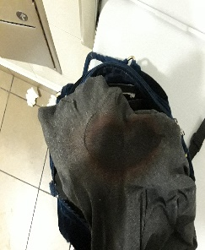

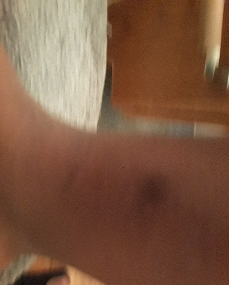

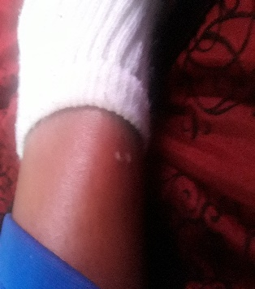

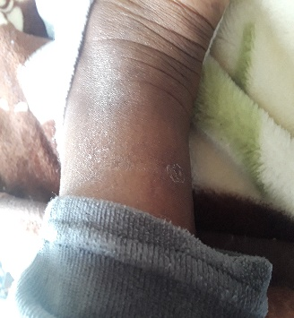

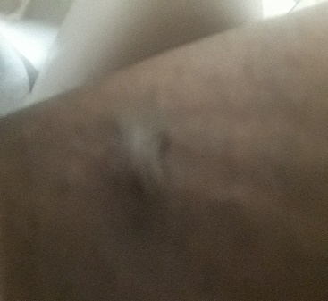

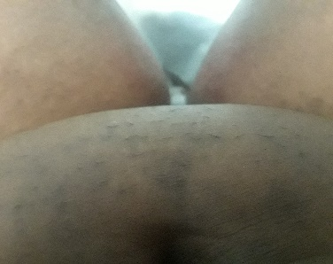

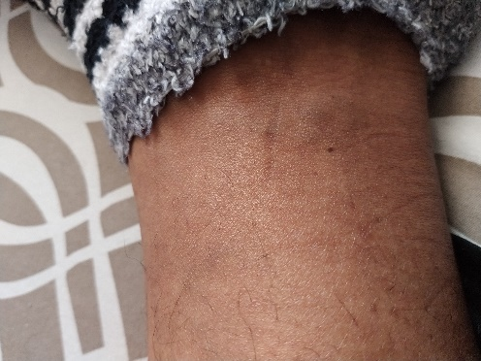

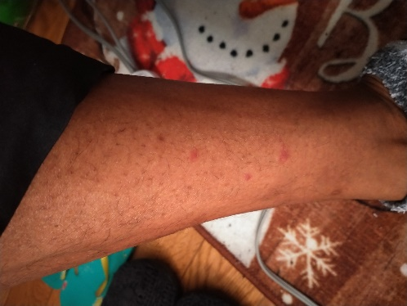

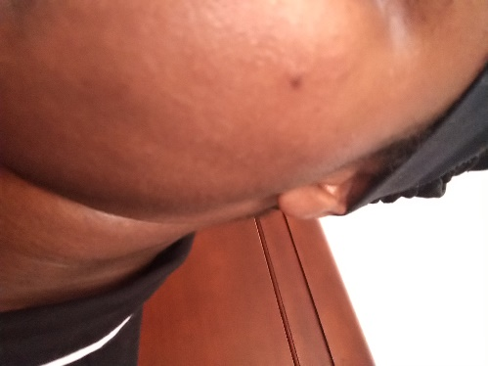

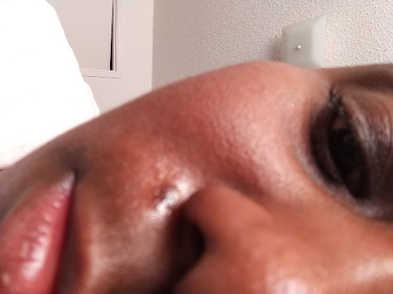



**Pictures Of Hostel** [Universal Symbol To Do Not Touch, Engaging The Universal Languages We All Understand Indeed Of See & Touch Respectively]

**Pictures Of Criminal Harm**