

The Queen’s Private Client Account

From The Desk Of Her Royal Majesty

Queen Laura L. Gardner
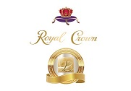

Private Client Account 💰


Private Client Account - $50,000,000.00 [Available For 1 Year And 6 Months]

Citi Bank


Citigold Private Client Savings Account - $42,000,000.00

American Express Bank

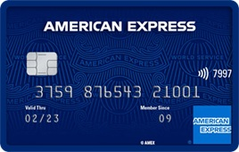

American Express Private Client Savings Account - $5,000,000.00

Chase Bank



Chase Private Client Savings Account - $3,000,000.00

Queen Laura Gardner


