**The Royalty Security & Specifics**

Royalty Securities Logo

The Official Shield Of L

Gold Name Badge

The Royalty Security Logo is sewn into the right of the chest area of the attire and the gold name badge placed underneath it. The Security Shield of L should also be placed on the left for identification on the attire as well as the hats worn.

**Security Personnel**

White & Gold Life Security Personnel Uniform

The Big Book [Cintas]

Monaco Vest [Gold]

Diagonal Stripped Tie [Gold & White]

Non Iron Dress Shirt [White]

Premier Pleated Pants [Gold]

Vest

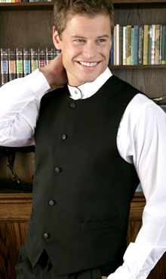

Shirt

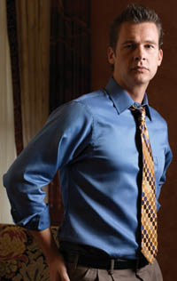

Pants

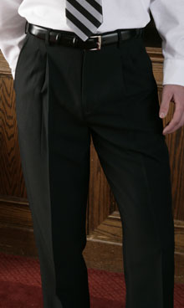

Belt [Merlow White]

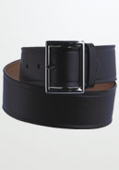

Shoes [Merlow White]

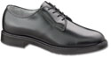

White Hat [Merlow White]

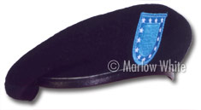

Gloves [Tuxedo.com]

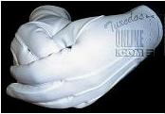

**Captain’s Additional Items**

White & Gold Life Security Personnel Captains Uniform

Shoes [Merlow White]

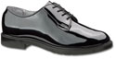

The Big Book [Cintas]

Academy Double Breasted Blazer [White] with gold Double Stripe Sleeve Trim

Remington Hat [White]

Fly Front Vest [White]

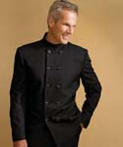

**Security Personnel**

White & Black Death Security Personnel Uniform

The Big Book [Cintas]

Monaco Vest [Black]

Diagonal Stripped Tie [Black & White]

Non-Iron Dress Shirt [White]

Premier Pleated Pants [Black]

Vest



Shirt



Pants



Belt [Merlow White]



Shoes [Merlow White]



Black Hat [Merlow White]



Gloves [Tuxedo.com]



**Captain’s Additional Items**

White & Black Death Security Personnel Captains Uniform

Shoes [Merlow White]



The Big Book [Cintas]

Academy Double Breasted Blazer [Black] with white Double Stripe Sleeve Trim

Remington Hat [Black]

Fly Front Vest [Black]



**Securing Specifics**

**The 5 Million Dollar Securing Contract**

The 5 million dollar securing contract paid to ensure the complete and thorough resolution of the airspace crime.

**Access Restricted**

**The Public Mediums**

You may have the restricted access of the ten avenues of entertainment for the various countries and private islands to enjoy, [Imagination, Celestial & Heritage Networks, Digital Place Radio Station, Interactive Websites, Publications Of Ten, Crown Cinema Productions, Majestic Musical Records, Palace Theater, Royal Design, Kingdom Culinary, The Cruises]. Please limit yourselves to these public mediums or you will be punished as an individual, private island or even country.

**Access Denied**

**The Royalty, Private Citizens, Residents, Visitors & Properties**

All individuals who are not specified within the internals of our countries and private islands, are to stay as passerby’s. The Access to the Ultimate Kingdom Private Country, Queen Laura’s Heaven Access Private Country, G & A Royal Private Islands, and the individuals who reside, especially The Royal Family is at this point and time denied.