**Dr. Jennifer & Drs. Matthew Royal Romance House**

**Type:** The Royal Vacation Residence

**Location:** Fantasy, Romance Private Island

**Value:** $1 Million

**Owners:** Dr. Jennifer L. Smith Magnamere & Drs. Matthew A. Magnamere

**House Elevation:**

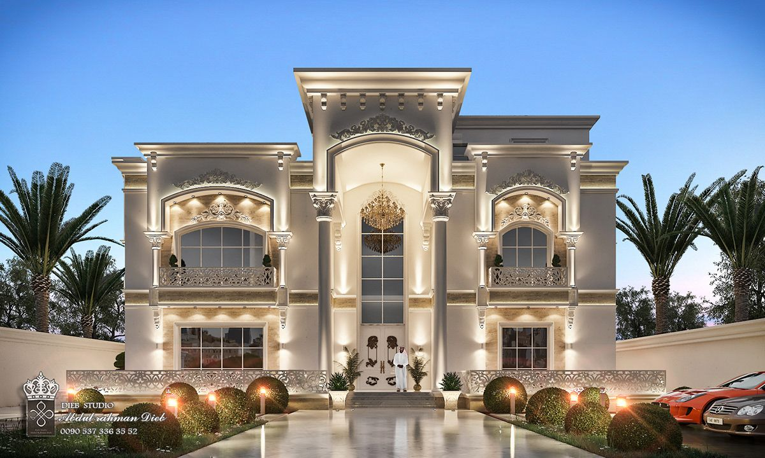

[Exterior With Paint That Shimmers In The Sunlight & Internal Lightning That Illuminates Through The Windows At Night]

Specifics: 3 Bedrooms, 3 Bathrooms with the pool included. One bedroom converts to an office that transform to a guestroom. The bedrooms and office will have Ralph Lauren Fine Decor. The bathrooms should have green marble with the safe step tub instead and the lights removed for recessed lights in the roof and vanity lights. External beige paint that shimmers with brown roof tiles for the contrast. Beautiful brown outdoor dining table and brown outdoor pool lounge chairs and soft grass outside around the house.