

The Queen’s Net Worth, Savings, & Pensions

From The Desk Of Her Royal Majesty

Queen Laura L. Gardner
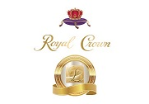

Net Worth, Savings, & Pensions 💰


Queen Laura L. Gardner’s Net Worth 💰: 960 Trillion 925 Billion 79 Million GSP 💵 Verified By All Banks 🏦

Queen Laura L. Gardner’s Savings: 48 Million USD 💵 Verified By All Banks 🏦

Queen Laura L. Gardner’s Pension: 104 Thousand, 932 Dollars/per month 💵 Verified By All Banks 🏦

