The Royal FamilyCamping Defensive House

Owners: The Royal Family Of The Ultimate Kingdom & The Territories
House Builder: Heaven Construction Company
Designer: Queen Laura L. Gardner Alexander
Location: Winter, Crisp
Cost: $15 Million

House Elevation:

Color Scheme: Black, Beige & White [Color Scheme For The Exterior With Paint That Shimmers In The Sunlight & Internal Lightning That Illuminates Through The Windows At Night]

Driveway


Front Door

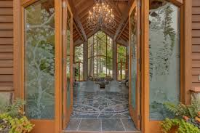

[Downstairs]

Living Room

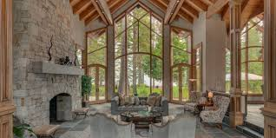

Living Room Brown Leather Chairs

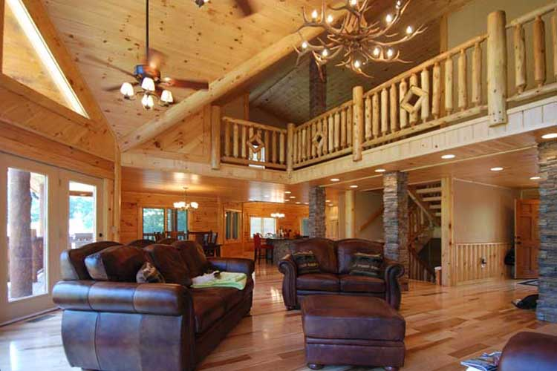

Breakfast Room

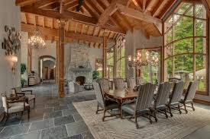

Formal Dining Room

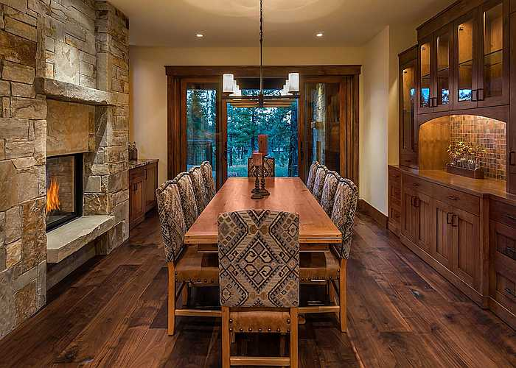

Kitchen

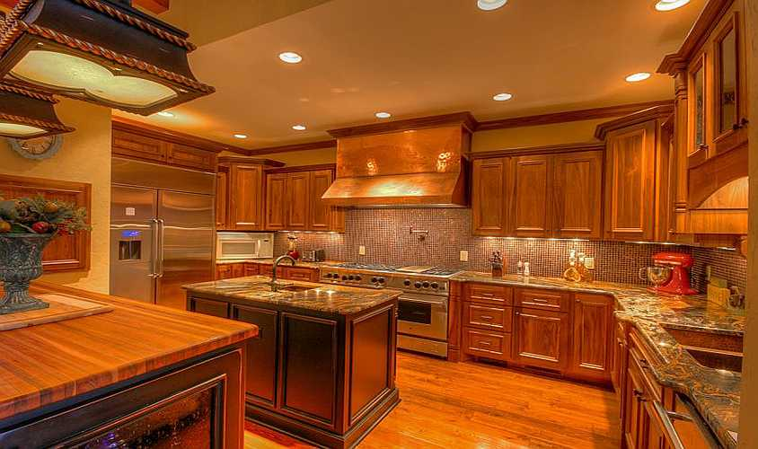

Samsung Bespoke Stainless Steel Glass Induction Kitchen Package with 4-Door Flex Refrigerator with AI Family Hub™+ and AI Vision Inside™, Bespoke 2.1 cu. ft. Over-the-Range Microwave with Auto Dimming Glass Touch Controls in Stainless Steel Glass, Bespoke 6.3 cu. Ft. Smart Slide-In Electric Range with Air Fry & Precision Knobs, Bespoke Auto Release Smart 42dBA Dishwasher with StormWash+™ and Smart Dry in Stainless Steel Glass

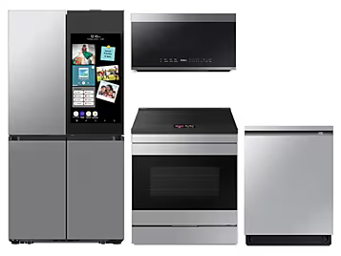

Bar

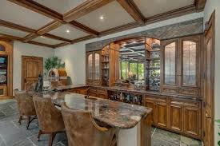

Pantry

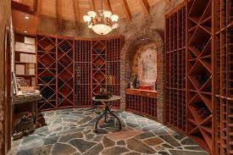

[Upstairs]

Queen Laura & King Landon’s Master Suite

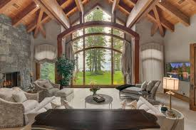

Queen Laura & King Landon’s Master Suite Bed
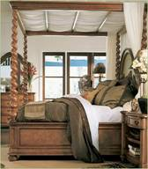

Queen Laura’s Princess Elaine Character



King Landon’s Prince Charming Character


Queen Laura & King Landon’s Master Suite Bathroom

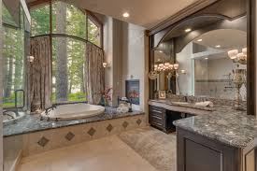

Queen Laura & King Landon’s Master Suite Office

Traditional Computer Desk with Drop-Front Keyboard/Mousepad Drawer Palladia Collection By Sauder, HP Slim Desk Top Bundle 27” Intel Core i3, - 12100, HP Office Jet 8015e Wireless Color All-in-One Printer, Scan, Copy, Best for Home Office, 6 Months of Free Ink with HP+ (228F5A) - [Walmart]
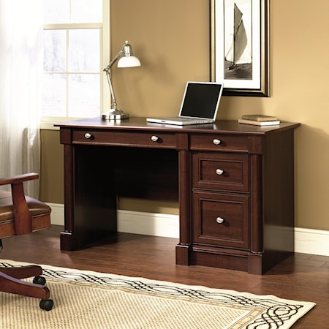


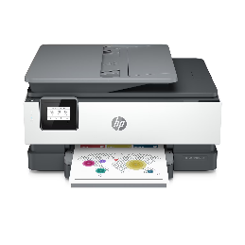

4 Point Massage Office Chair With Heating, Reclining Backrest, Retractable Footrest & Lumbar Support Pillow In Brown [Noblemood]
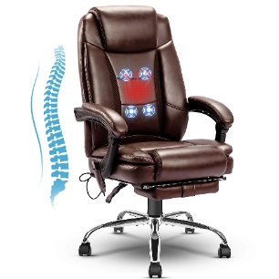

Prince Lancelot’s Room

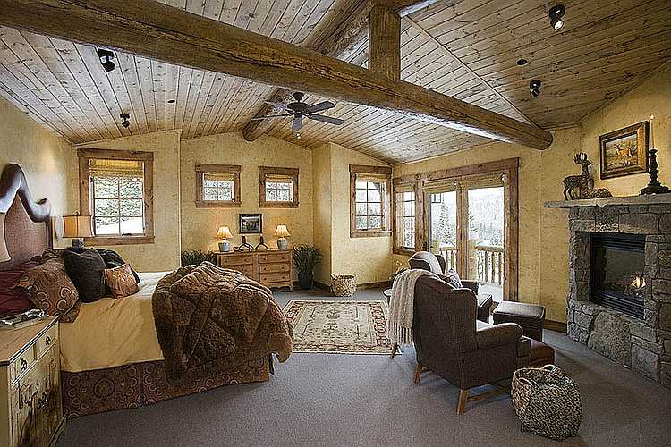

Princess Lauren’s Room

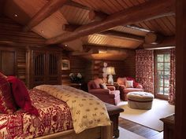

Prince Lord’s Room

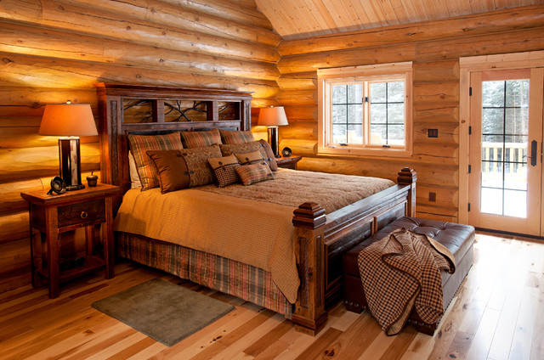

Aunt Jennifer & Uncle Matthew’s Suite [First Guest Suite In The Video]

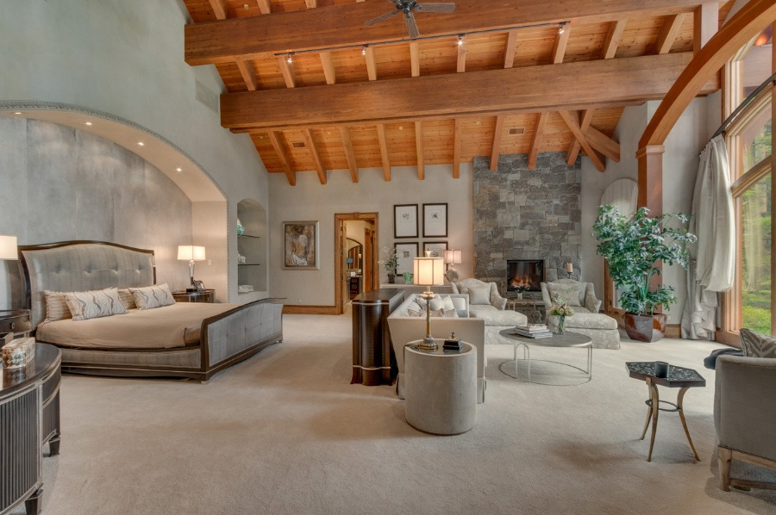

Aunt Jenny & Uncle Matthew’s Suite Bed

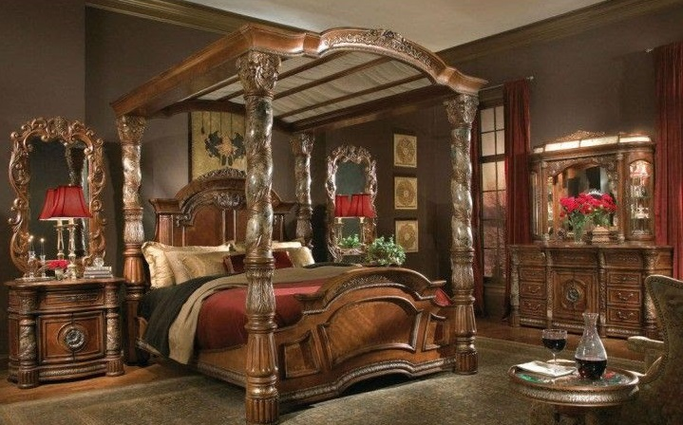


Dr. Jennifer’s Aurora Character


Drs. Matthew’s Fantasia Character

Cousin Madison’s Room

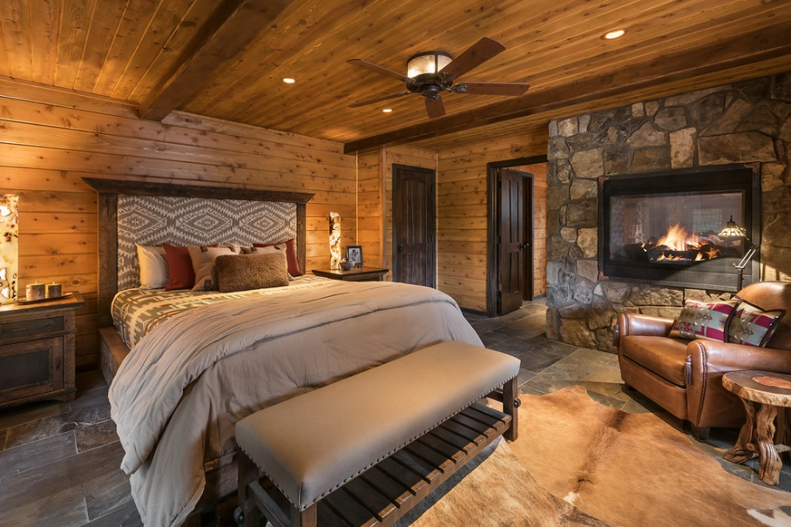

Cousin Jordan’s Room

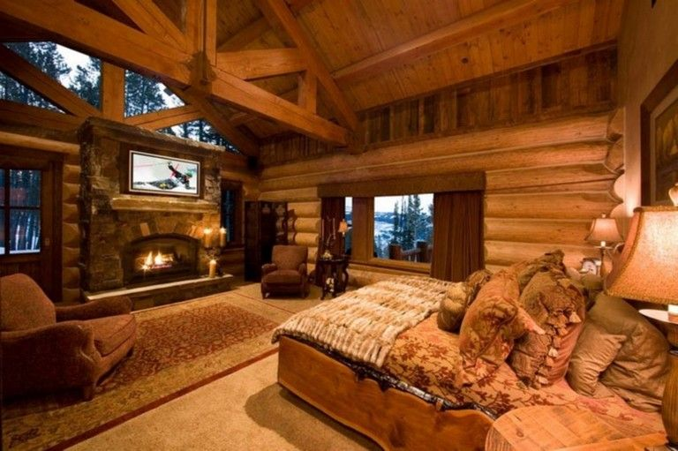

Cousin Mathis’s Room

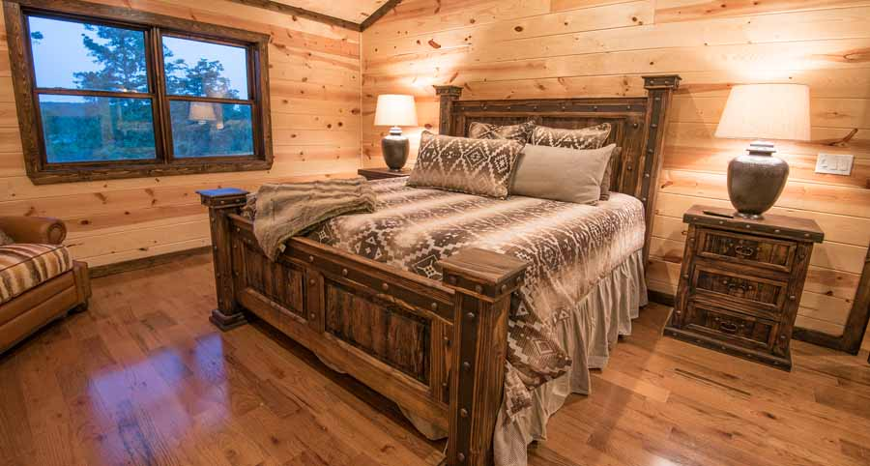

Mom Casey’s Room

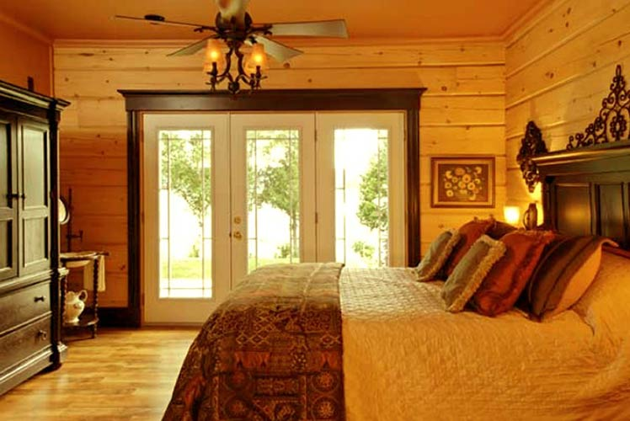

Dr. Casey’s Snow White Character



Father-In-Law Lance & Mother-In-Law Laurie’s Room

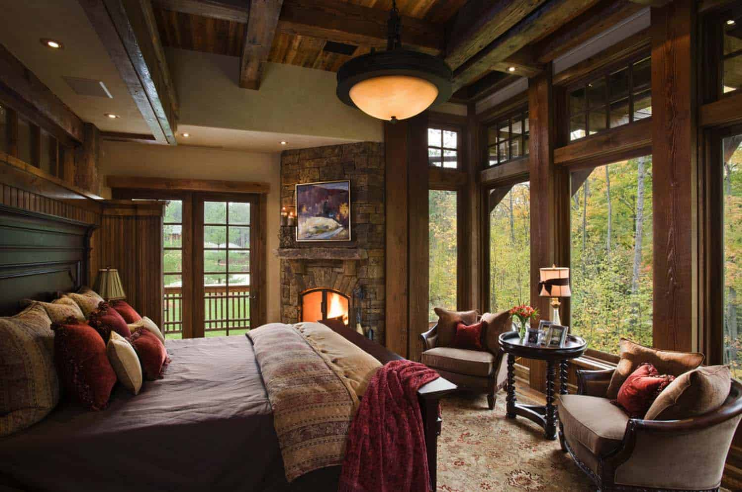

Drs. Lance’s Mickey Mouse Character



Dr. Laurie’s Pocahontas Character


Grandpa John & Grandma Cindy’s Room

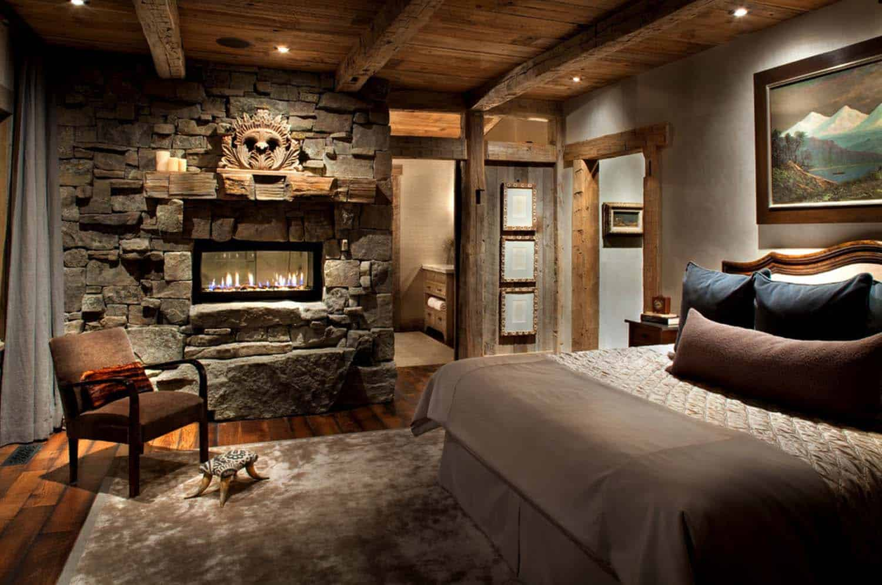

Drs. John’s Jiminy Cricket Character


Secretary Cindy’s Cinderella Character



Granduncle John’s Room
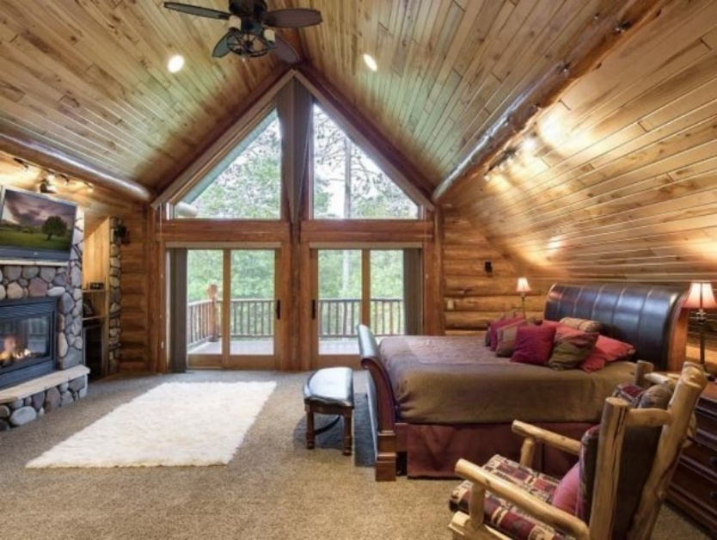

General John’s Goofy Character



Granduncle Harry’s Room

Granduncle Harry’s Room

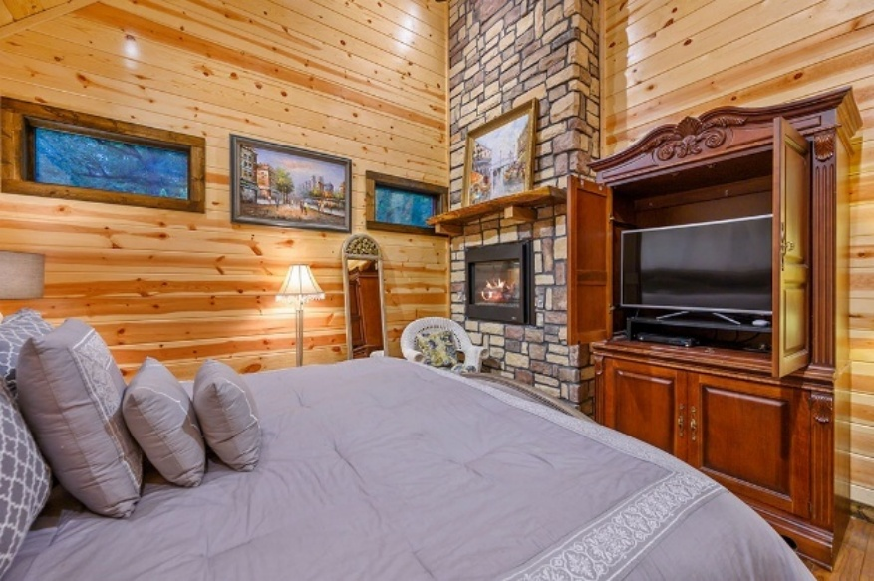

CEO Harry ’s Donald Duck Character



Grandaunt Jessica’s Room
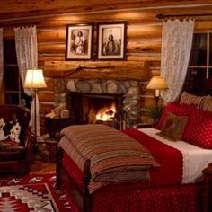

RN. Jessica’s Minnie Mouse Character



Grandaunt Julie’s Room

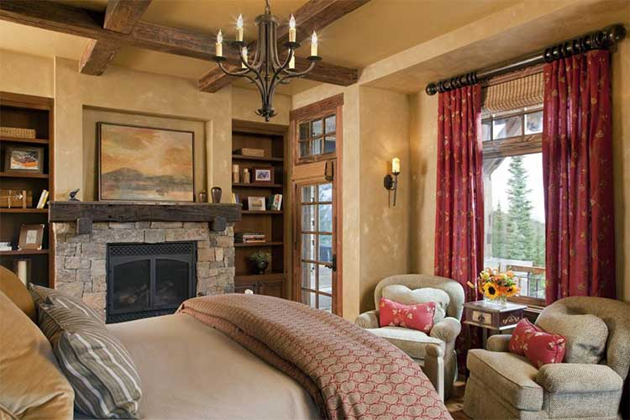

Dame Julie’s Tinkerbell Character


Wet Bar

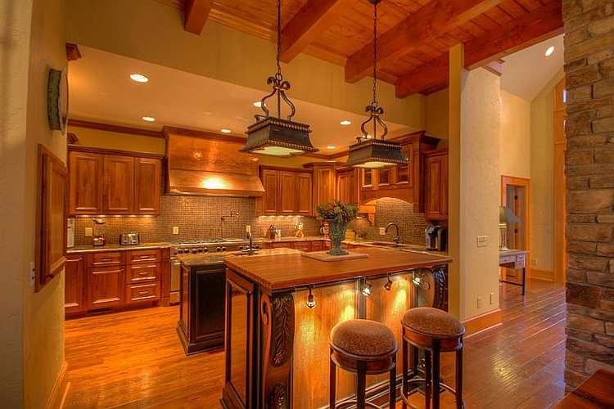

Game Room
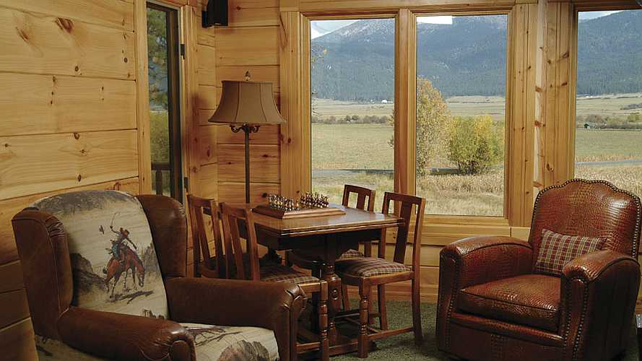

Entertainment Area


Samsung Frame TV 50”

SEI Furniture Calvert Electric Carved Floral Trim 44" Fireplace
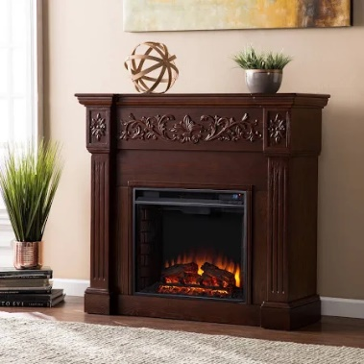

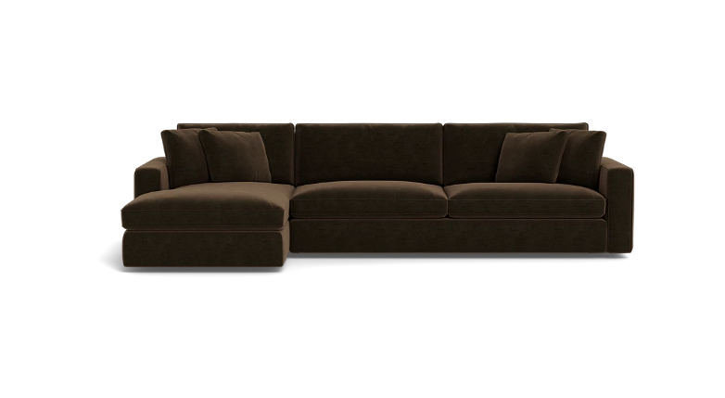
James 3-Seat Chaise Sectional

Cinema

[The Royal Family’s Cinema & Lounge Theater Games Sports]





Concession Stand

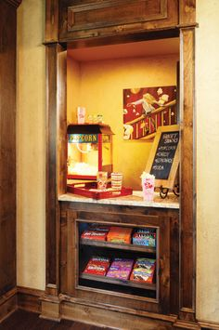

Samsung - 98” Class Q80C QLED 4K UHD Smart Tizen TV (2023)

Model: QN98Q80CAFXZA

SKU: 6543837




Bose Smart Ultra Soundbar

Dolby Atmos & Bose True Space

Enjoy theater-like sound at home with this supercharged soundbar, designed to pull you deep into the heart of the movies and shows you love. After separating music, dialogue, and effects, Dolby Atmos places them in different parts of the room — even overhead — so the sound seems like it’s coming from all around you. And for content that isn’t Dolby Atmos-encoded, there’s Bose True Space technology. True Space intelligently analyzes and up mixes those signals to deliver a multi-channel experience and total immersion all the time — no matter the content or source.


Movie Posters












Laundry

Samsung Washer & Dryer

SAWADREP6300

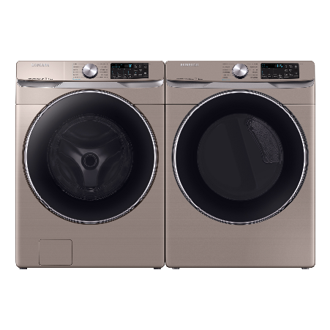
Side-by-Side Washer & Dryer Set with Front Load Washer and Electric Dryer in Champagne

Laundry Room Rug

Farmhouse Laundry Room Rug 20"x47" Non-Slip Floor Mat Runner Rugs for Kitchen Bathroom Hallway Laundry Room Decor, Brown
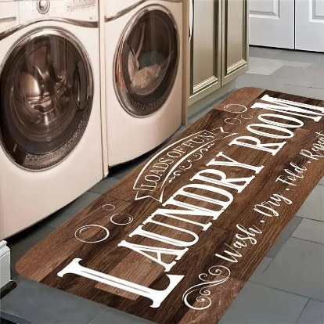

Command Center


YouTube Video:

10317 Summit Canyon
The Ridges, Summerlin
Las Vegas, Nevada

- Upstairs Entertaining Area [Upstairs]

YouTube Video:

44 Million Dollar
Lake Tahoe Log Home

Additional Details

Pocket Door Kitchen Entrance

Two Televisions Instead Of Four

The Appliance Cover

The Wine Cellar Converted To A Pantry

The Color Scheme For The Bedrooms Follow Through To The Bathrooms

The Office Exactly How It Looks

The Chefs Kitchen Exactly How It Looks

The Four Car Garage Motor Coach

Heated Outdoor Driveway And Patio

Awards:

Custom Guild Award


Architectural Digest Award



The Queen’s Newmar King Aire



Owner: Queen Laura L. Gardner Alexander
Location: Winter, Crisp
Model: 2025 Newmar King Aire 4531 [44 Feet 11 Inches]
Details: Autumn Night
Floorplan: Kensington
Cabinetry: Maple Diamond Gloss
Cost: $1,637,440.00

The Royal Staff’s Disney Medley Cottage


Living Room
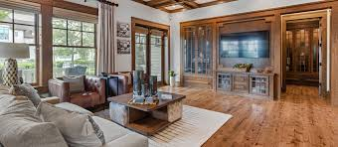

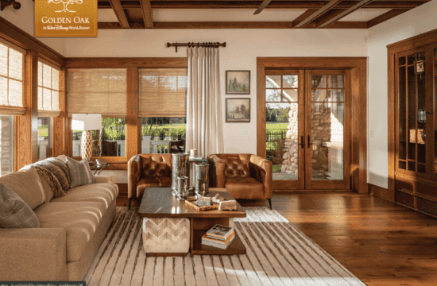

Kitchen

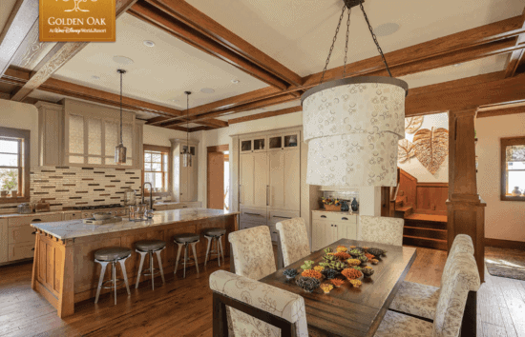

Formal Dining Room

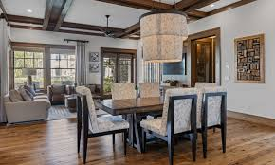

Bedroom #1
Crown Mark - [Stanley Bedroom Group Coffee Brown Full Size Bedroom Set]

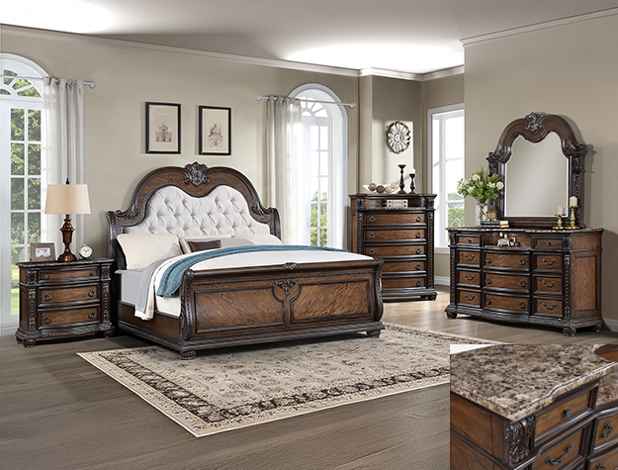

Bedroom #2

Crown Mark - [Stanley Bedroom Group Full Size Bedroom Set]
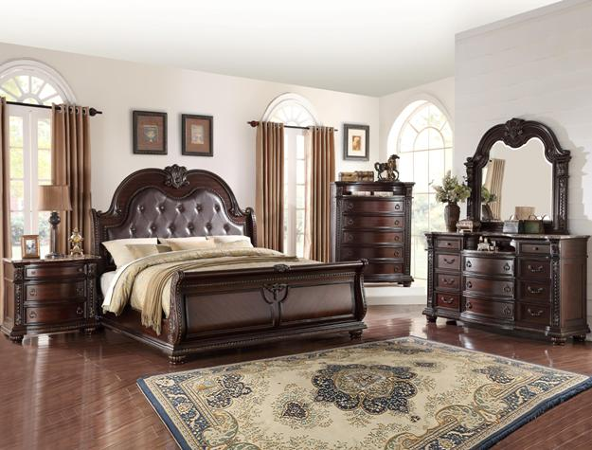

Bedroom #3

[4 Bunk Beds]

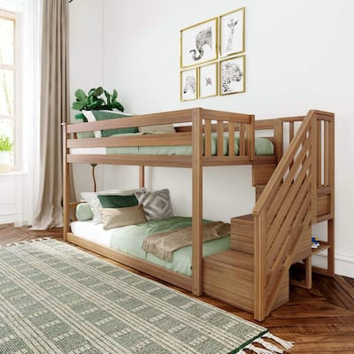

Bedroom #4

[4 Bunk Beds]

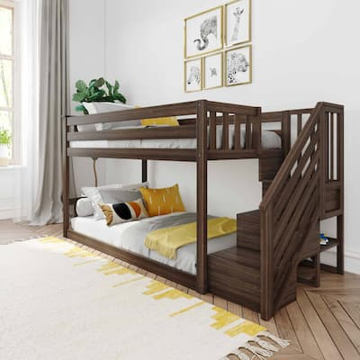

Lounge

LG 55” smart flat screen tv


Bose Solo TV Sound System Home Cinema Choice


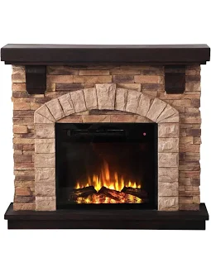
Festivo 45 in. Freestanding Electric Fireplace

Meridian Furniture Plush Dark Brown Velvet Cloud Modular Sectional
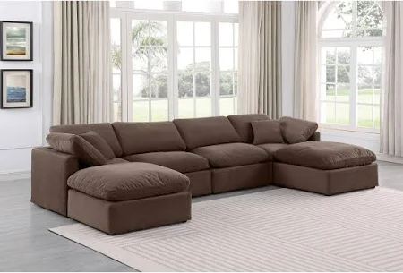

Movie Posters






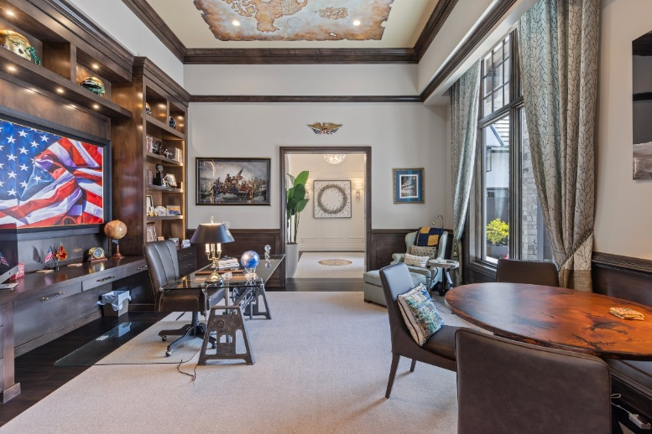
Office

Outdoor Dining
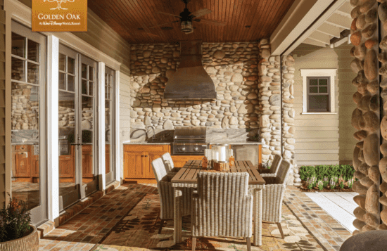

Pool



