

The Queen’s Private Client Accounts

From The Desk Of Her Royal Majesty

Queen Laura L. Gardner
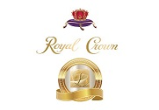

Private Client Accounts 💰


Private Client Accounts - $48,000,000.00 [Available For 1 Year And 3 Months]

Bancorp



One Point Private Client Savings Account - $30,000,000.00

Citibank

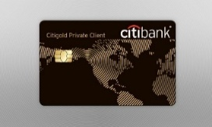

Citigold Private Client Savings Account - $10,000,000.00

Centurion Bank

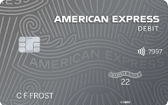

American Express Private Client Savings Account - $5,000,000.00

Chase



Chase Private Client Savings Account - $3,000,000.00

Queen Laura Gardner


