**The A Royal Private Island**

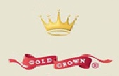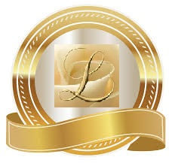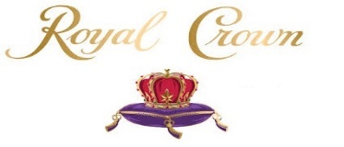

[The A or Alexander Royal Family Private Island]

**1 Billion 220 Million Dollars**

This private island is owned and operated by Queen Laura L. Gardner Alexander, King Landon D. Alexander, Drs. Lance D. Alexander, & Dr. Laurie M. James Alexander.

.

**A Or Alexander Royal Private Island *[Normal Privacy Conditions]***

**The Residents:** 15

**The Visitors:** 10

The Power Of Stability

**The Private Island [2 Acres]**

**The Exterior**

Land Space

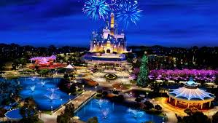

The Happily Ever After Castle

The Dollar General

The Family Dollar

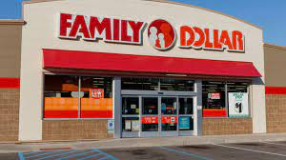

The Medical Base

