The Queen’s Vacation House Keys

[Each Specially Crafted Key Can Be Purchased At Lowes & Etsy, And Keys, Address,
& Documentations For Each House, Given At The Mall, Before Departure]

Queen & King’s Century Avery Vacation House

Minute Key White Kwikset Brass House/Entry Key Blank [4 House Keys]
Item #604670 |
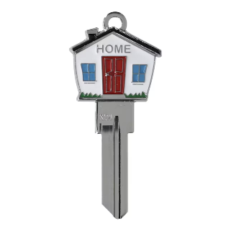
Model #9976308

Queen’s Vacation Waters Beach House

Etsy At the Beach House Vacation Painted House Key Blank Home or Office House uncut by Pretty-Keys [5 House Keys]
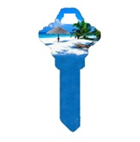

Queen’s Tiny Township Entertainment House

Fanatix Florida State Seminoles Multicolored Blank Brass House/Entry Key Blank [3 Keys]
Item #66667 |
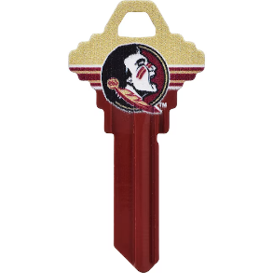
Model #89967

Queen’s Disney Camping Defensive Splendor House

Minute Key Green #68 Sc1 Brass House/Entry Key Blank [10 House Keys]
Item #803733
Model #9976339
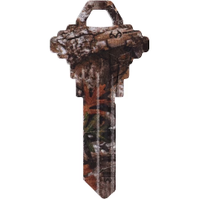

Queen’s Tiny Pampering Hawaii House

Minute Key Multicolor #68 Sc1 Brass House/Entry Key Blank [3 House Keys]
Item #612805
Model #9976400
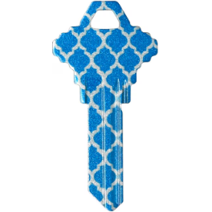

Queen Laura’s White 2026 Atlas Airstream Mercedes Interstate 19 Modern Greige RV Key [2 Keys]
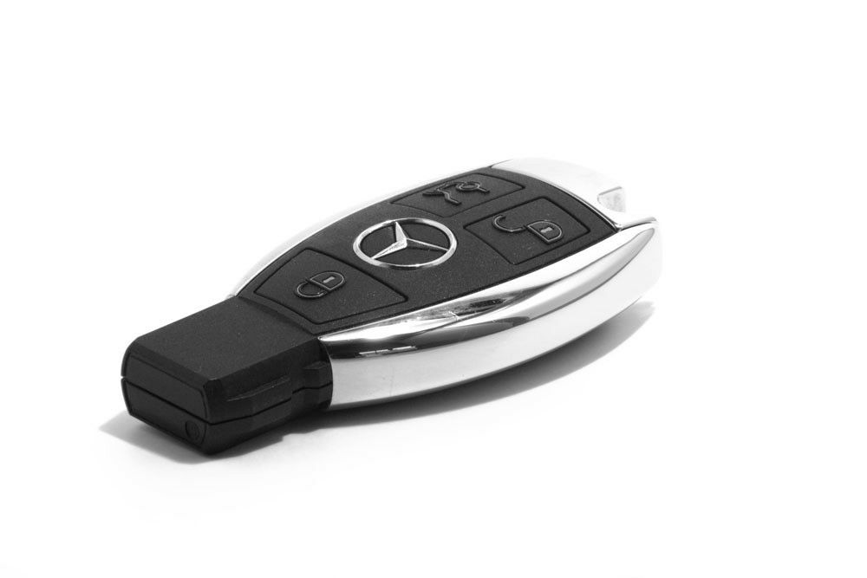

Octavia’s Silver 2026 Atlas Airstream Mercedes Interstate 19 Tommy Bahama Special Edition RV Key [2 Keys]

Roy’s Black 2026 Atlas Airstream Mercedes Interstate 19 Modern Greige RV Key [2 Keys]

