The Royal Vacation Century Houses

Names: Queen Laura L. Gardner Alexander & King Landon D. Alexander

Builder: Century Homes Builders



Cost: $612,490.00

Location: Whistle, Avery

House Elevation: Glenville Elevation A4
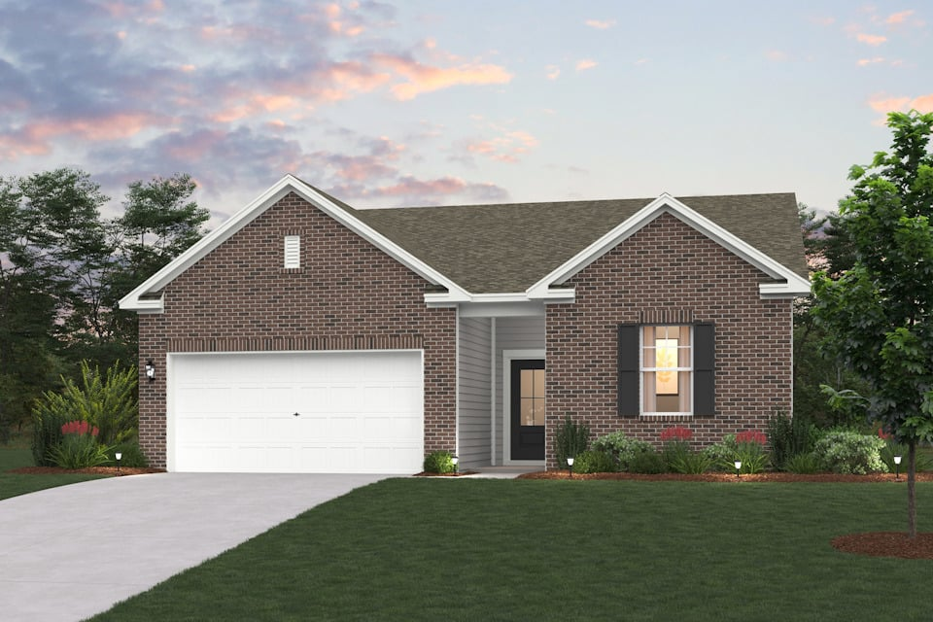

Specifics:
2,012 sq ft

4 beds

3 baths

1 floor

2 car garage

First Floor Plan
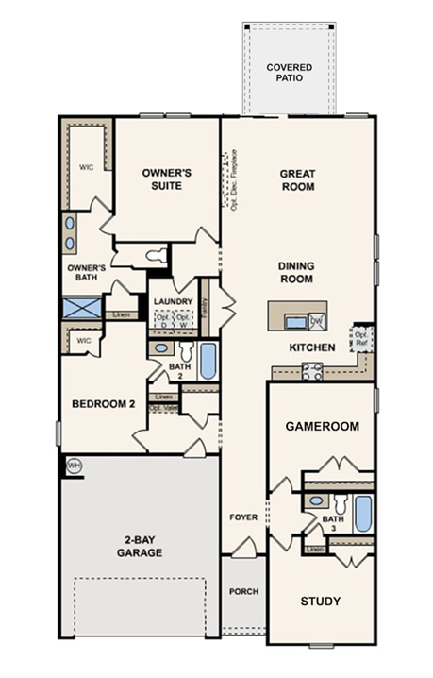

Garage

Queen Laura’s White 2026 Atlas Airstream Mercedes Interstate 19 Modern Griege RV

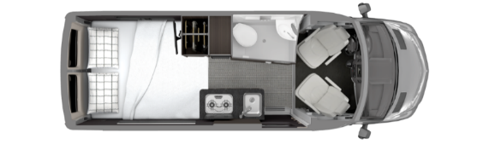

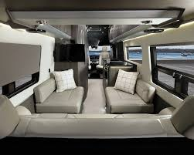
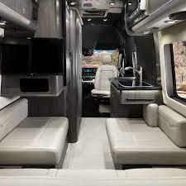

King Landon’s Black 2026 Atlas Airstream Mercedes Interstate 19 Modern Griege RV

Porch

Porch

Outdoor Infrared Lantern Heater - [Plow And Hearth]
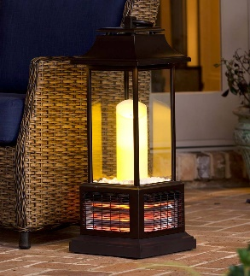

Study

Grey Office Desk & HP Slim Desk Top Bundle 27” Intel Core i3, - 12100, HP Office Jet 8015e Wireless Color All-in-One Printer, Scan, Copy, Best for Home Office, 6 Months of Free Ink with HP+ (228F5A) - [Walmart]

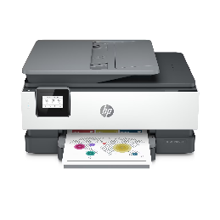
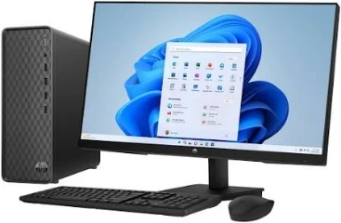
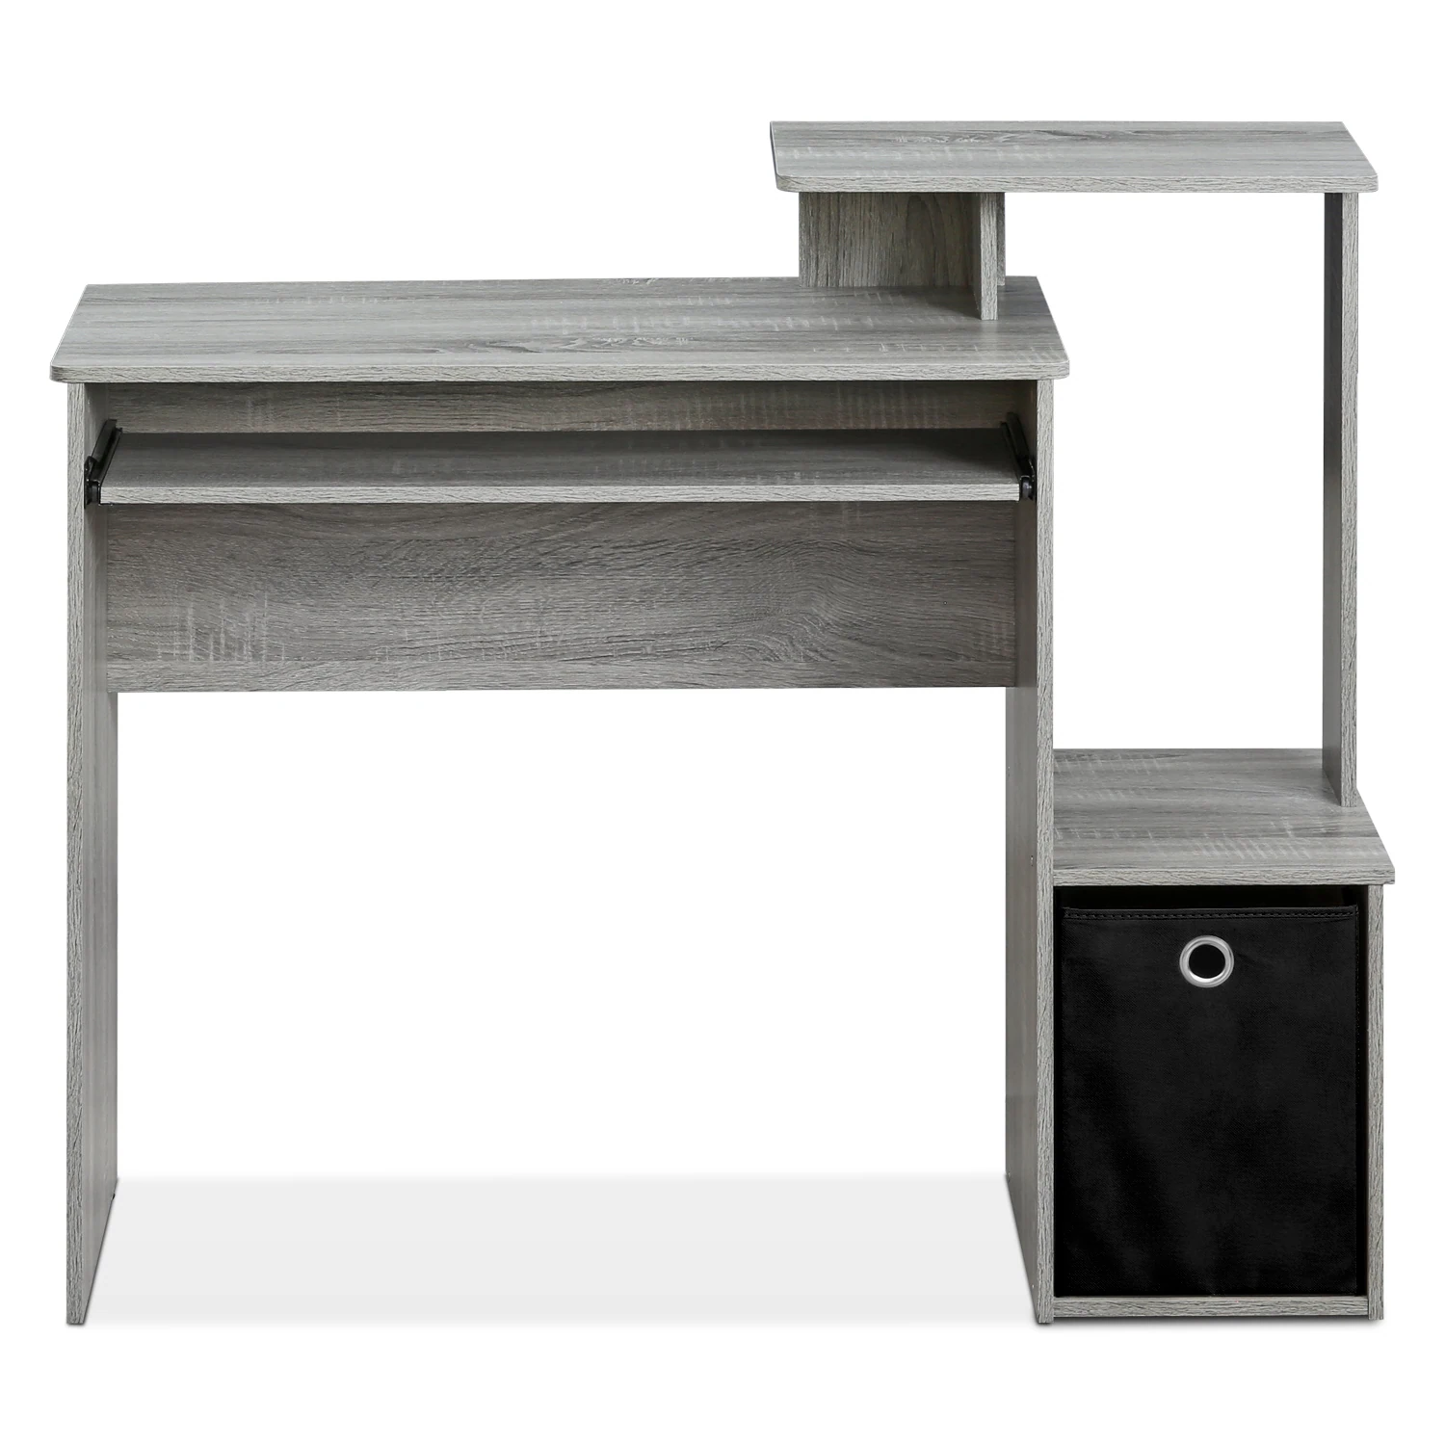

Grey Office Chair - [B&Q Furniture]

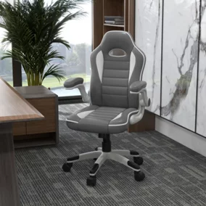

Convertible Sofa - [Rent A Center]
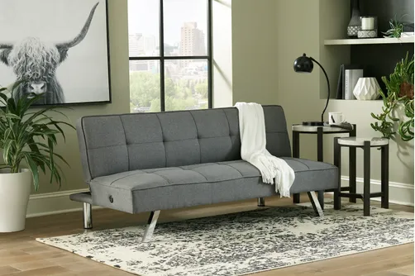

Game Room/Home Theater

The Alexander’s Home Theater – [Etsy]


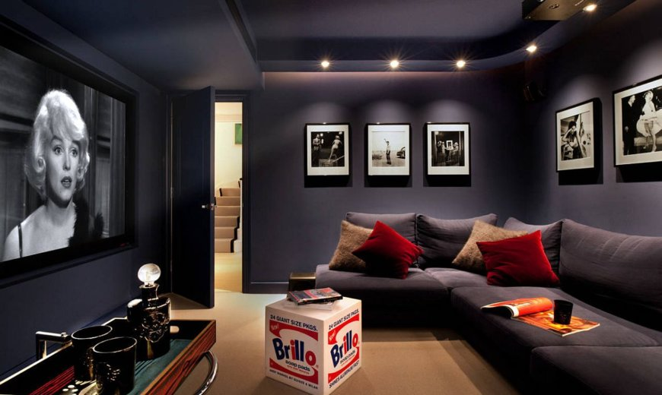

Valencia Tuscany Leather Home Theater Seating Row of 2, Charcoal Grey [6 Sets]

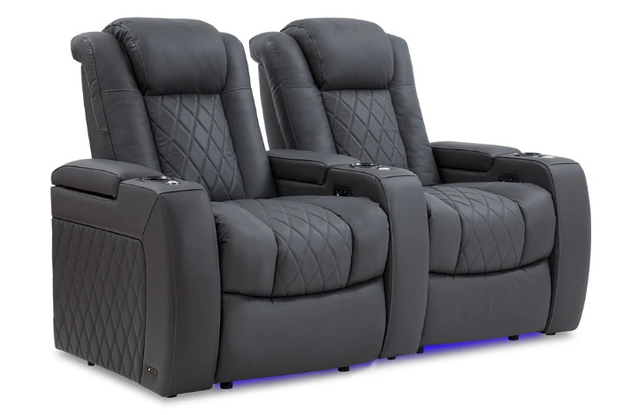

Nostalgia 300 W2.5 Black Popcorn Cart with 5 Qt. Popcorn Bowl
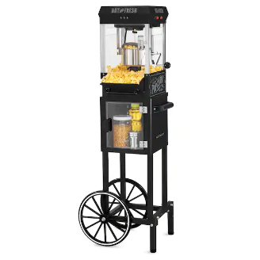

Samsung - 98” Class Q80C QLED 4K UHD Smart Tizen TV (2023)

Model: QN98Q80CAFXZA

SKU: 6543837

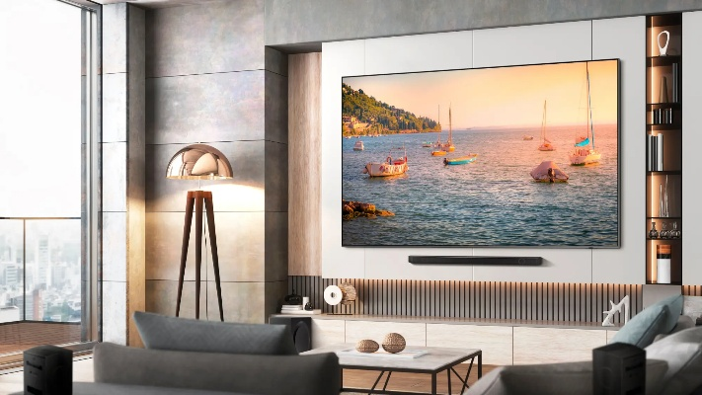


Bose Smart Ultra Soundbar

Dolby Atmos & Bose True Space

Enjoy theater-like sound at home with this supercharged soundbar, designed to pull you deep into the heart of the movies and shows you love. After separating music, dialogue, and effects, Dolby Atmos places them in different parts of the room — even overhead — so the sound seems like it’s coming from all around you. And for content that isn’t Dolby Atmos-encoded, there’s Bose True Space technology. True Space intelligently analyzes and up mixes those signals to deliver a multi-channel experience and total immersion all the time — no matter the content or source.
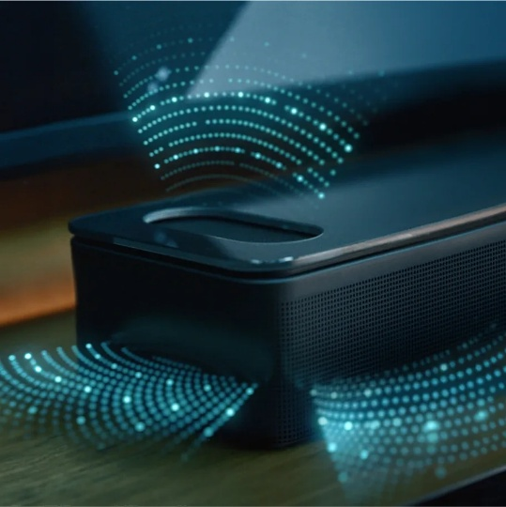

Movie Posters

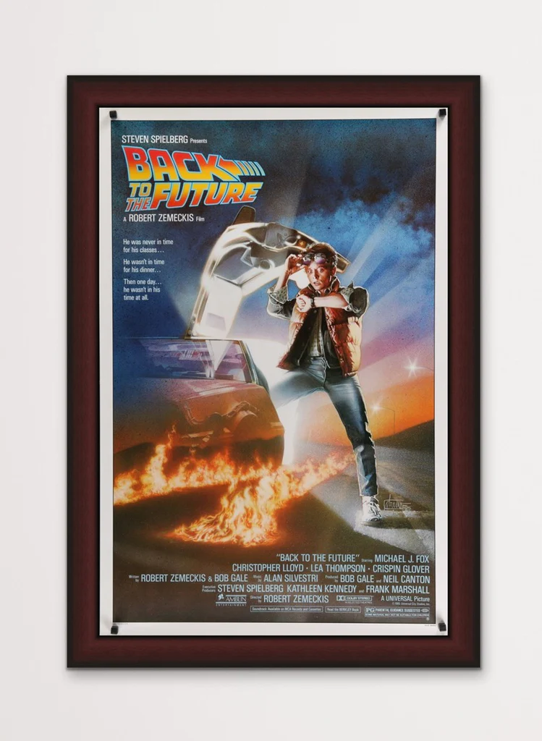





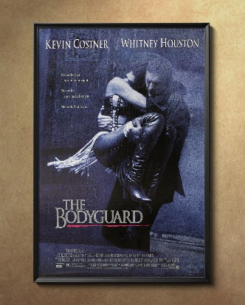









Kitchen
Samsung Bespoke Stainless Steel Glass Induction Kitchen Package with 4-Door Flex Refrigerator with AI Family Hub™+ and AI Vision Inside™, Bespoke 2.1 cu. ft. Over-the-Range Microwave with Auto Dimming Glass Touch Controls in Stainless Steel Glass, Bespoke 6.3 cu. Ft. Smart Slide-In Electric Range with Air Fry & Precision Knobs, Bespoke Auto Release Smart 42dBA Dishwasher with StormWash+™ and Smart Dry in Stainless Steel Glass
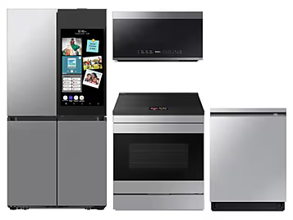

Dining Room

Crown Mark Klina Leg Table Dining Group
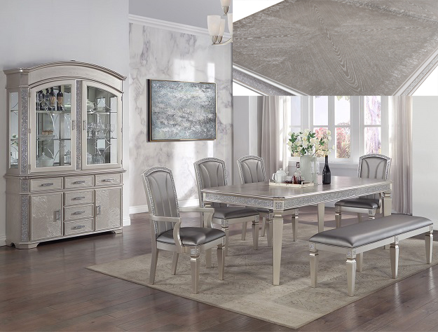

Great Room

Television
SAMSUNG 50” Class The Frame 4K Ultra HD QLED Smart TV – QN50LS03ADFXZA Item # 99000208
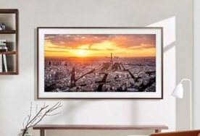

Fireplace [Grey And White Fire Place]
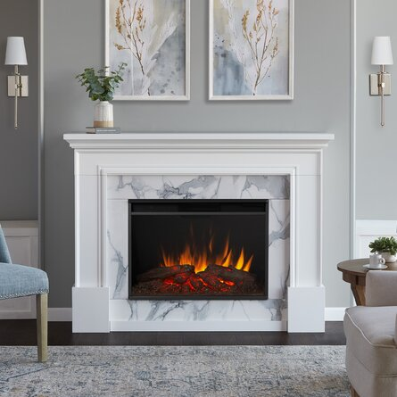

Meridian Furniture Plush Gray Velvet Cloud Modular Sectional
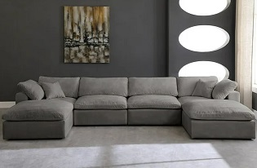

Patio

Ashley Furniture 4 Person Outdoor Seating Group With Cushions Patio Set
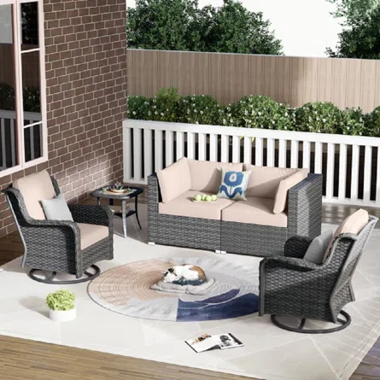

Backyard Discovery Fusion Flame Outdoor Kitchen
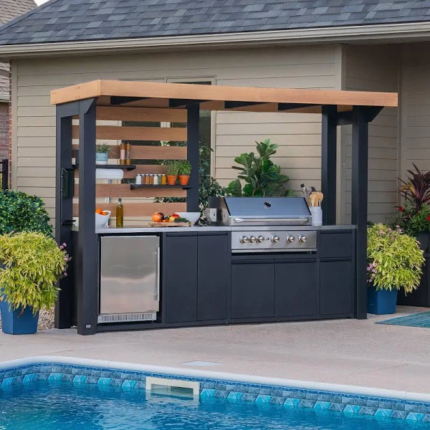

Guest Room/Bedroom #2

Crown Mark - [Sharpe Bedroom Group Full Size Bedroom Set]
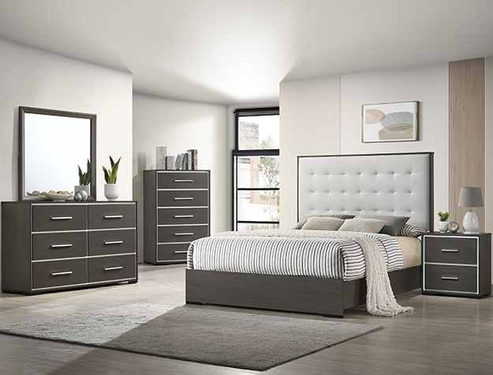

Mattress
Full Size Bed Sleep Easy Cool Gel - [Furniture Distribution Center]
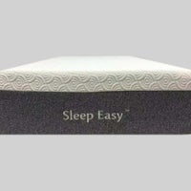

Pillows

Bodipedic Super Coolin Gel-Infused Gusseted Memory Foam Pillow

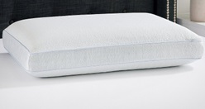

Gracie Oaks Bradgate TV Stand for TVs up to 42" with Fireplace Included - [Wayfair]


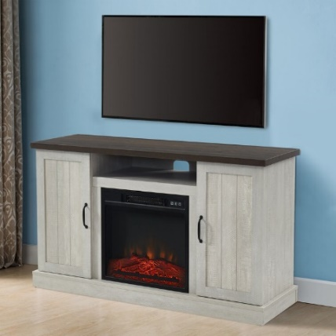

Charcoal Recliner with heat and massage - [Rent A Center]
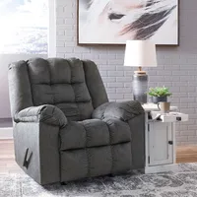

Hamilton Beach 0.9 cu. ft. Countertop Microwave Oven, 900 Watts, Stainless Steel
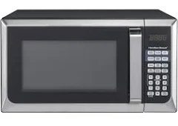

Whirlpool Refrigerator

Whirlpool Mini Fridge - 3.1 Cu. Ft. With Dual Door True Freezer - Brushed Stainless Steel Silver

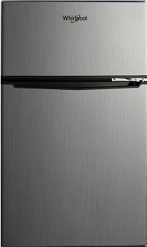

Guest Bathroom

Bathtub [Grey & White Like The Picture Safe Step Tub]
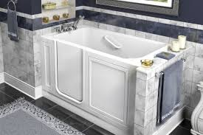



Laundry

Samsung Washer & Dryer

SAWADREP6300

Side-by-Side Washer & Dryer Set with Front Load Washer and Electric Dryer in Platinum
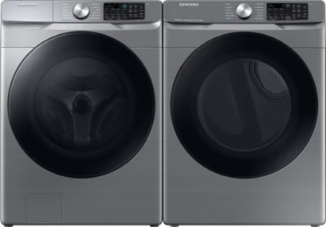

Laundry Room Rug

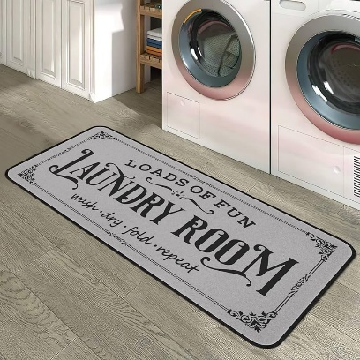
Farmhouse Laundry Room Rug 20"x47" Non-Slip Floor Mat Runner Rugs for Kitchen Bathroom Hallway Laundry Room Decor, Light Grey

Queen Laura & King Landon’s Owner Suite

Wayfair - [Grey Diamond Velvet Queen Size Bedroom Set]
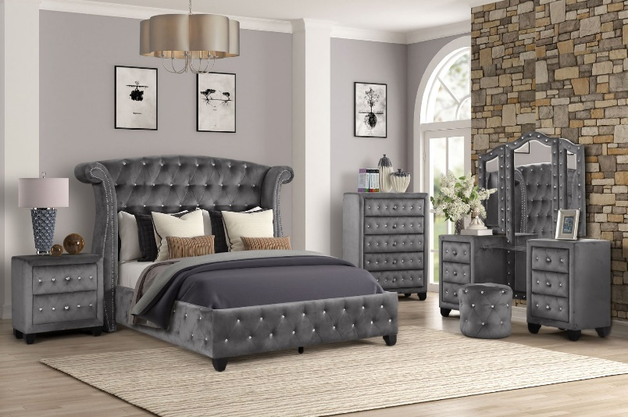

Mattress
Full Size Bed Sleep Easy Cool Gel - [Furniture Distribution Center]

Pillows

Bodipedic Super Coolin Gel-Infused Gusseted Memory Foam Pillow

Gracie Oaks Bradgate TV Stand for TVs up to 42" with Fireplace Included - [Wayfair]

Charcoal Recliner with heat and massage - [Rent A Center]

Hamilton Beach 0.9 cu. ft. Countertop Microwave Oven, 900 Watts, Stainless Steel

Whirlpool Refrigerator

Whirlpool Mini Fridge - 3.1 Cu. Ft. With Dual Door True Freezer - Brushed Stainless Steel Silver

Guest Bathroom

Bathtub [Grey & White Like The Picture Safe Step Tub]

Storage Area [Aosom Steel Storage Shed]
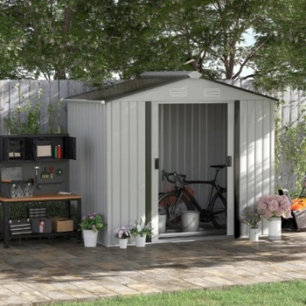

Award:

Custom Guild Award


Names: Drs. John R. Smith & Secretary Cindy A. Andrews Smith

Builder: Century Homes Builders

Cost: $

Location: Whistle, Avery

House Elevation:
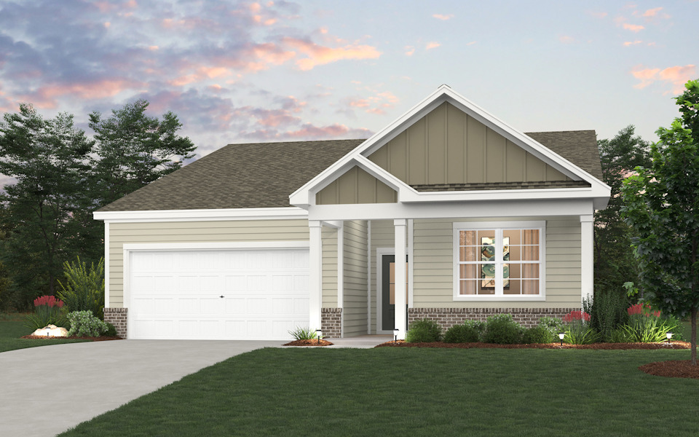

First Floor Plan

Garage

Dr. Casey’s Room
Crown Mark - [Lyssa Bedroom Group SetB4300 Full Size Bedroom Set]
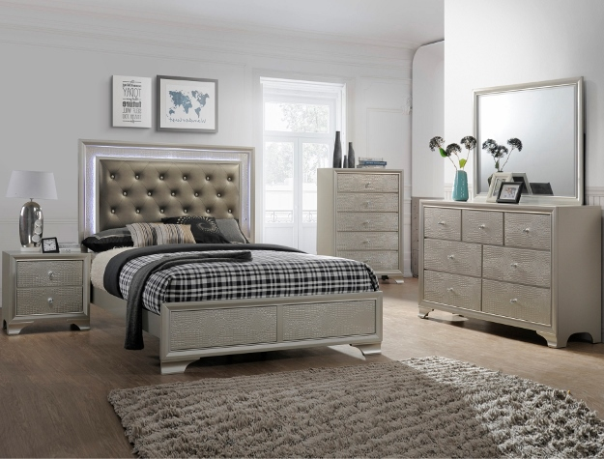

Mattress
Full Size Bed Sleep Easy Cool Gel - [Furniture Distribution Center]

Pillows

Bodipedic Super Coolin Gel-Infused Gusseted Memory Foam Pillow

Gracie Oaks Bradgate TV Stand for TVs up to 42" with Fireplace Included - [Wayfair]

Charcoal Recliner with heat and massage - [Rent A Center]

Hamilton Beach 0.9 cu. ft. Countertop Microwave Oven, 900 Watts, Stainless Steel

Whirlpool Refrigerator

Whirlpool Mini Fridge - 3.1 Cu. Ft. With Dual Door True Freezer - Brushed Stainless Steel Silver

Guest Bathroom

Bathtub [Grey & White Like The Picture Safe Step Tub]

Laundry

Samsung Washer & Dryer

SAWADREP6300

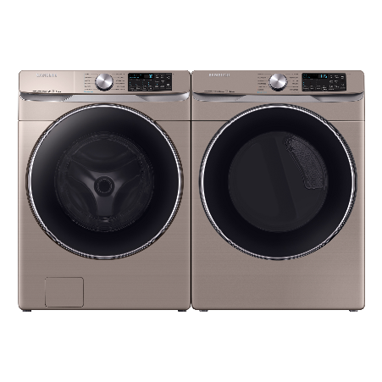
Side-by-Side Washer & Dryer Set with Front Load Washer and Electric Dryer in Champagne

Laundry Room Rug

Farmhouse Laundry Room Rug 20"x47" Non-Slip Floor Mat Runner Rugs for Kitchen Bathroom Hallway Laundry Room Decor, Brown
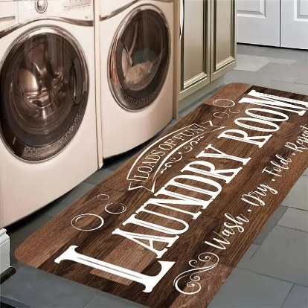

Drs. John & Secretary Cindy’s Owner Suite
Crown Mark - [Stanley Bedroom Group Coffee Brown Queen Size Bedroom Set]

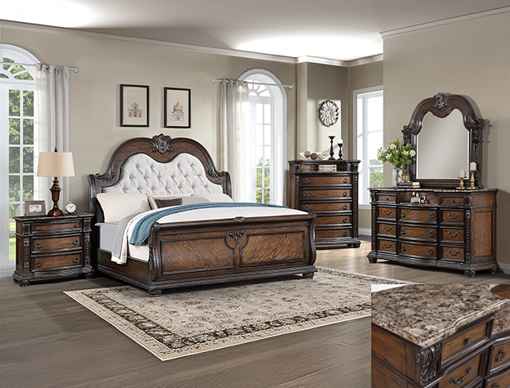

Mattress
Full Size Bed Sleep Easy Cool Gel - [Furniture Distribution Center]

Pillows

Bodipedic Super Coolin Gel-Infused Gusseted Memory Foam Pillow

Gracie Oaks Bradgate TV Stand for TVs up to 42" with Fireplace Included - [Wayfair]

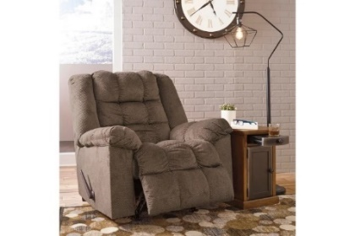
Autumn Recliner with heat and massage - [Rent A Center]

Hamilton Beach 0.9 cu. ft. Countertop Microwave Oven, 900 Watts, Stainless Steel

Whirlpool Refrigerator

Whirlpool Mini Fridge - 3.1 Cu. Ft. With Dual Door True Freezer - Brushed Stainless Steel Silver

Owner Suite Bathroom

Bathtub [Grey & White Like The Picture Safe Step Tub]

Stand Up Shower [Grey & White Like The Picture Safe Step Tub]
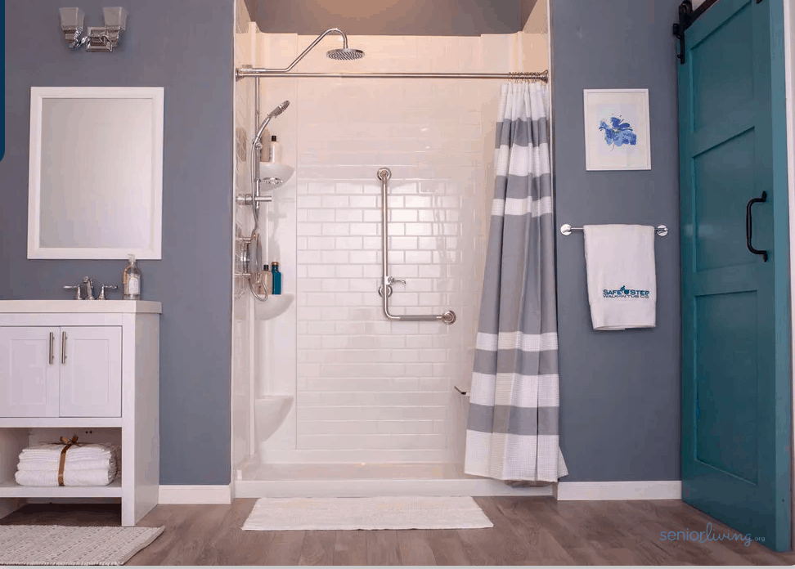

Study

Dark Brown Office Desk & HP Slim Desk Top Bundle 27” Intel Core i3, - 12100, HP Office Jet 8015e Wireless Color All-in-One Printer, Scan, Copy, Best for Home Office, 6 Months of Free Ink with HP+ (228F5A) - [Walmart]
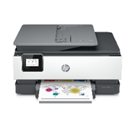
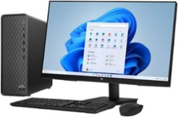
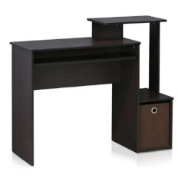

Dark Brown Dkelincs Office Chair Ergonomic Desk Chair Mid Back Adjustable Computer Chair with Lumbar Support Armrest - [Walmart]

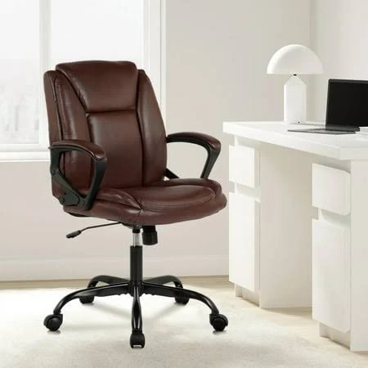

Game Room

Samsung - 98” Class Q80C QLED 4K UHD Smart Tizen TV (2023)

Model: QN98Q80CAFXZA

SKU: 6543837

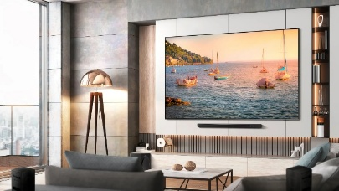


Bose Smart Ultra Soundbar

Dolby Atmos & Bose True Space

Enjoy theater-like sound at home with this supercharged soundbar, designed to pull you deep into the heart of the movies and shows you love. After separating music, dialogue, and effects, Dolby Atmos places them in different parts of the room — even overhead — so the sound seems like it’s coming from all around you. And for content that isn’t Dolby Atmos-encoded, there’s Bose True Space technology. True Space intelligently analyzes and up mixes those signals to deliver a multi-channel experience and total immersion all the time — no matter the content or source.
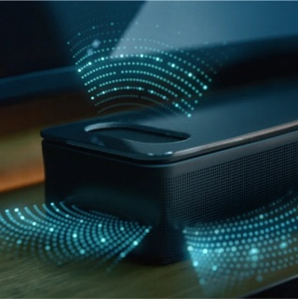

Nikko Manual Living Room Love Seat In Brown
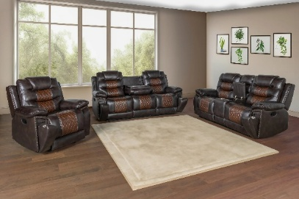

Furniture Pieces

Kitchen
Samsung Bespoke Stainless Steel Glass Induction Kitchen Package with 4-Door Flex Refrigerator with AI Family Hub™+ and AI Vision Inside™, Bespoke 2.1 cu. ft. Over-the-Range Microwave with Auto Dimming Glass Touch Controls in Stainless Steel Glass, Bespoke 6.3 cu. Ft. Smart Slide-In Electric Range with Air Fry & Precision Knobs, Bespoke Auto Release Smart 42dBA Dishwasher with StormWash+™ and Smart Dry in Stainless Steel Glass

Dining Room
Crown Mark Langley Counter Height Group
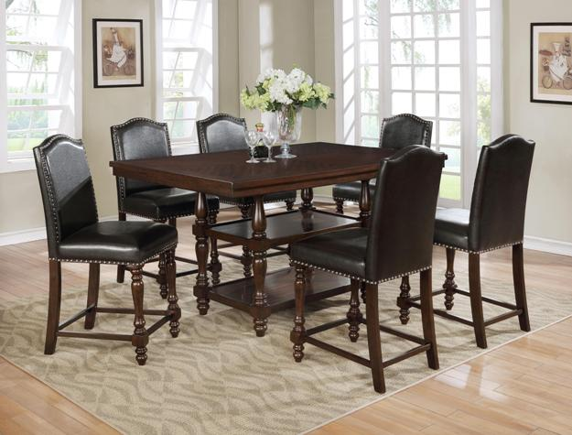

Great Room
[Wall Cabinetry, Stonework, Fireplace, & The End Chairs]
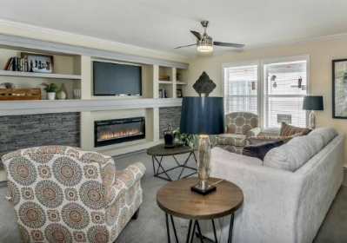

Covered Patio
Wayfair Furniture 4 Person Outdoor Seating Group With Cushions Patio Set
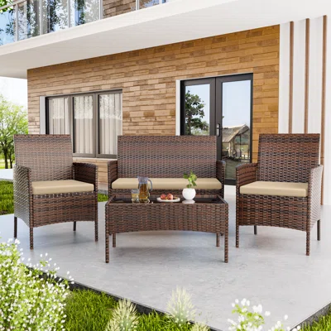

Names: Dr. Jennifer L. Smith Magnamere & Drs. Matthew A. Magnamere

Builder: Century Homes Builders

Cost: $612,490.00

Location: Whistle, Avery

House Elevation: Glenville Elevation A3

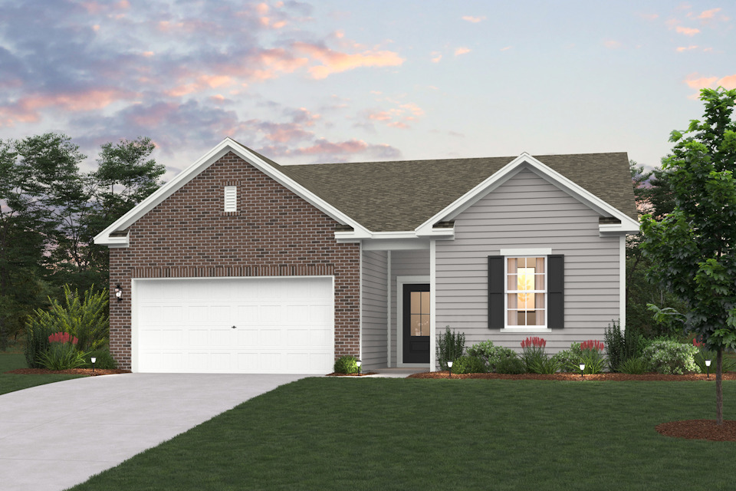

Specifics:
2,012 sq ft

4 beds

3 baths

1 floor

2 car garage

First Floor Plan

Garage

Porch

Outdoor Infrared Lantern Heater - [Plow And Hearth]

Study

Grey Office Desk & HP Slim Desk Top Bundle 27” Intel Core i3, - 12100, HP Office Jet 8015e Wireless Color All-in-One Printer, Scan, Copy, Best for Home Office, 6 Months of Free Ink with HP+ (228F5A) - [Walmart]

Grey Office Chair - [B&Q Furniture]

Convertible Sofa - [Rent A Center]

Game Room/Home Theater

The Magnamere’s Home Theater – [Etsy]

Meridian Furniture Plush Gray Velvet Cloud Modular Sectional

Patio

Samsung - 98” Class Q80C QLED 4K UHD Smart Tizen TV (2023)

Model: QN98Q80CAFXZA

SKU: 6543837

Bose Smart Ultra Soundbar

Dolby Atmos & Bose True Space

Enjoy theater-like sound at home with this supercharged soundbar, designed to pull you deep into the heart of the movies and shows you love. After separating music, dialogue, and effects, Dolby Atmos places them in different parts of the room — even overhead — so the sound seems like it’s coming from all around you. And for content that isn’t Dolby Atmos-encoded, there’s Bose True Space technology. True Space intelligently analyzes and up mixes those signals to deliver a multi-channel experience and total immersion all the time — no matter the content or source.

Movie Posters

Kitchen
Samsung Bespoke Stainless Steel Glass Induction Kitchen Package with 4-Door Flex Refrigerator with AI Family Hub™+ and AI Vision Inside™, Bespoke 2.1 cu. ft. Over-the-Range Microwave with Auto Dimming Glass Touch Controls in Stainless Steel Glass, Bespoke 6.3 cu. Ft. Smart Slide-In Electric Range with Air Fry & Precision Knobs, Bespoke Auto Release Smart 42dBA Dishwasher with StormWash+™ and Smart Dry in Stainless Steel Glass

Dining Room

Crown Mark Klina Leg Table Dining Group
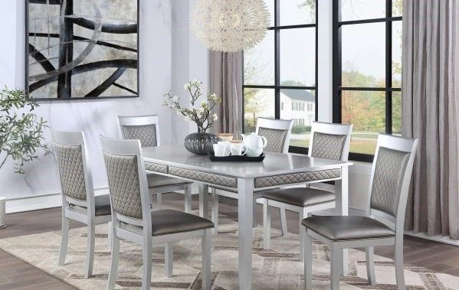

Great Room

Television
SAMSUNG 50” Class The Frame 4K Ultra HD QLED Smart TV – QN50LS03ADFXZA Item # 99000208

Fireplace [Grey And White Fireplace]

Felicia Living Room Set In Light Grey By Bellanest
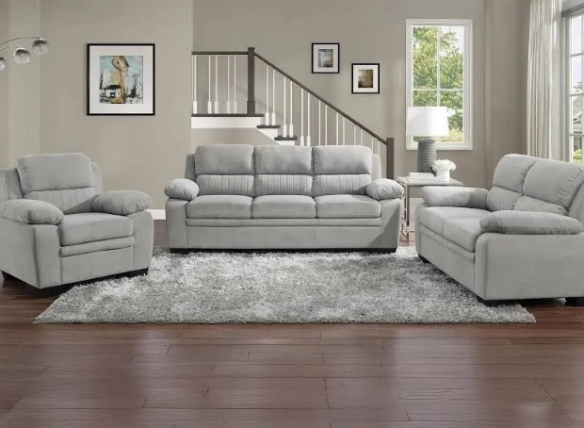

Patio

6 Piece Outdoor Seating In Grey From Target With Cushions Patio Set
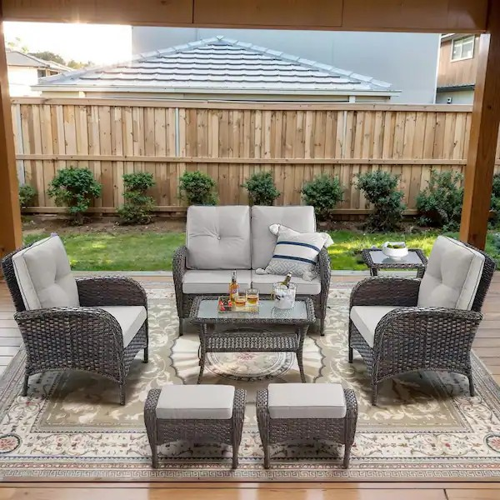

Guest Room/Bedroom #2

Crown Mark - [SetB4310 Lyssa Bedroom Frost Full Size Bedroom Set]
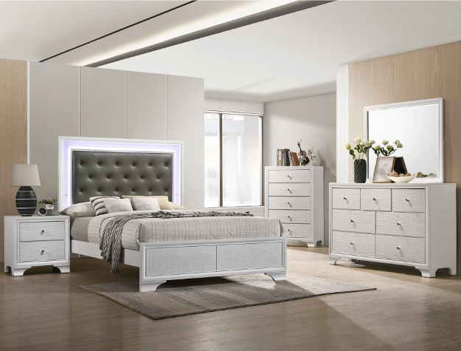

Mattress
Full Size Bed Sleep Easy Cool Gel - [Furniture Distribution Center]

Pillows

Bodipedic Super Coolin Gel-Infused Gusseted Memory Foam Pillow

Gracie Oaks Bradgate TV Stand for TVs up to 42" with Fireplace Included - [Wayfair]

Charcoal Recliner with heat and massage - [Rent A Center]

Hamilton Beach 0.9 cu. ft. Countertop Microwave Oven, 900 Watts, Stainless Steel

Whirlpool Refrigerator

Whirlpool Mini Fridge - 3.1 Cu. Ft. With Dual Door True Freezer - Brushed Stainless Steel Silver

Guest Bathroom

Bathtub [Grey & White Like The Picture Safe Step Tub]

Laundry

Wash & Dry Laundry Service In Gray From Amazon

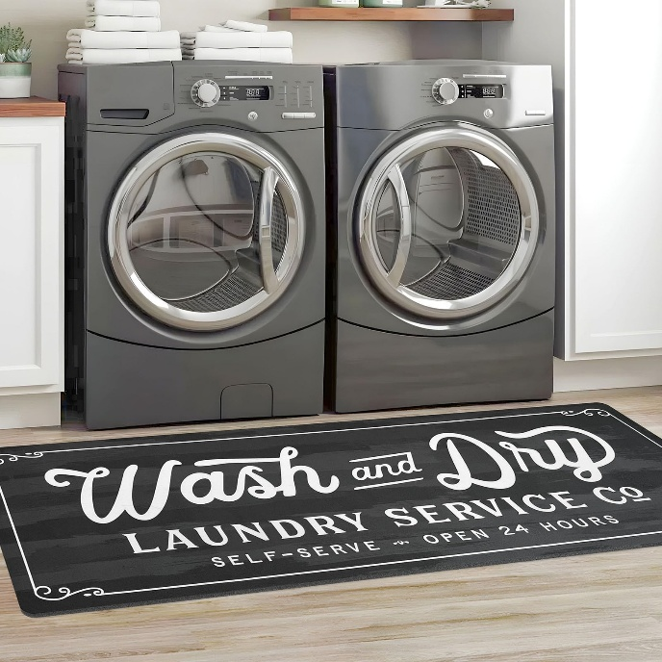

Dr. Jennifer & Drs. Matthew’s Owner Suite

Crown Mark - [SerB6910 Amalia Bedroom Group Queen Size Bedroom Set]
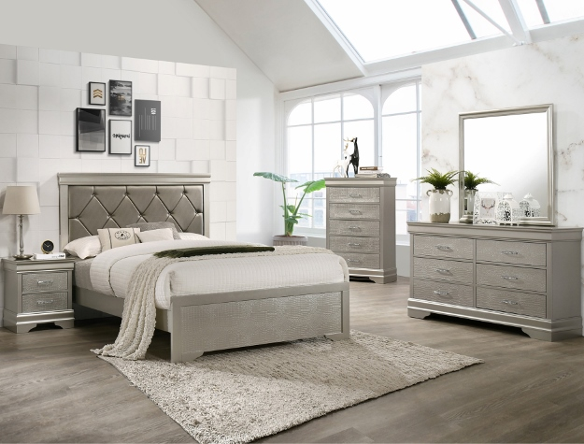

Mattress
Full Size Bed Sleep Easy Cool Gel - [Furniture Distribution Center]

Pillows

Bodipedic Super Coolin Gel-Infused Gusseted Memory Foam Pillow

Gracie Oaks Bradgate TV Stand for TVs up to 42" with Fireplace Included - [Wayfair]

Charcoal Recliner with heat and massage - [Rent A Center]

Hamilton Beach 0.9 cu. ft. Countertop Microwave Oven, 900 Watts, Stainless Steel

Whirlpool Refrigerator

Whirlpool Mini Fridge - 3.1 Cu. Ft. With Dual Door True Freezer - Brushed Stainless Steel Silver

Guest Bathroom

Bathtub [Grey & White Like The Picture Safe Step Tub]

Names: RN. Jessica A. Smith & Dame Julie N. Andrews

Builder: Century Homes Builders

Cost: $

Location: Whistle, Avery

House Elevation:
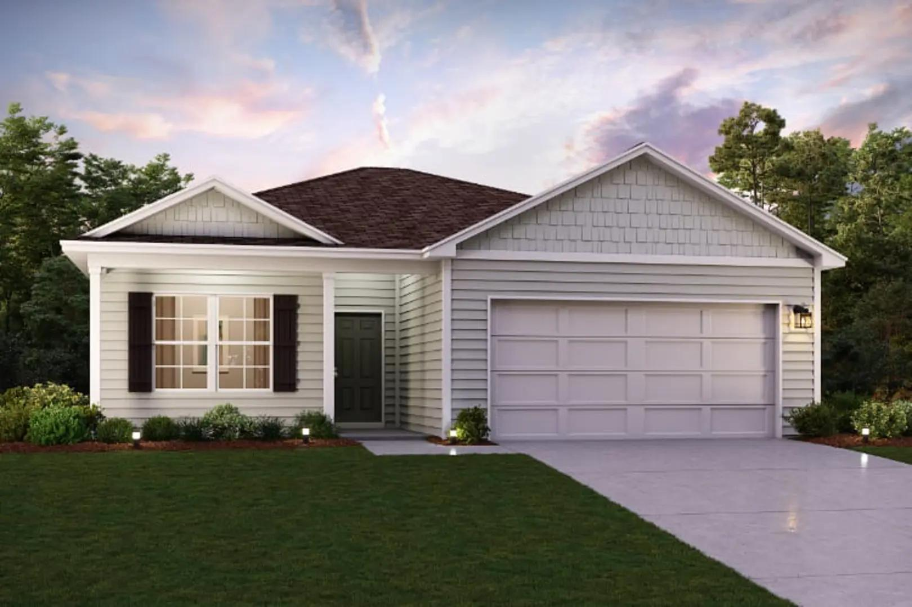

Names: General John R. Houston & CEO Harry T. Ford

Builder: Century Homes Builders

Cost: $

Location: Whistle, Avery

House Elevation:
