**The Royal Majestic Palace**

**Owners:** The Royal Family Of The Ultimate Kingdom

**House Builder:** Heaven Construction Company

**Designers:** Queen Laura L. Gardner Alexander

**Location:** Majestic City, Queen Laura’s Heaven Access

**Cost**: $15 Million

**House Elevation:**

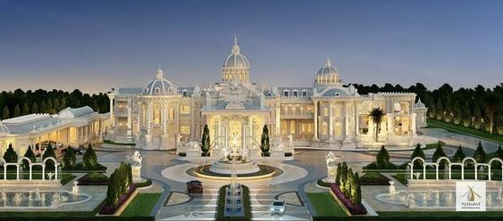

[Color Scheme White, Black & Gold For Exterior With Paint That Shimmers In The Sunlight & Internal Lightning That Illuminates Through The Windows At Night]

**Entry Gate & Fence:**

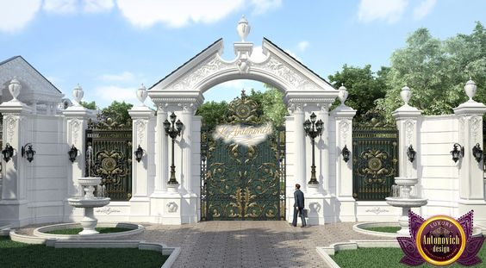

**YouTube Video:**

7600 Silver Meadow Court

The Ridges, Summerlin

Las Vegas, Nevada

1. The Courtyard Seating, Firepit, Fountain, & Lighting
2. Guest House & Entrance

**Functional Entertaining Spaces**

**YouTube Video:**

30 Meadow Hawk Lane

The Ridges, Summerlin

Las Vegas, Nevada

**Specific Features:**

1. Courtyard Fireplace
2. Stain Glass Door
3. Half Bath
4. Baby Grand Piano
5. Kitchen
6. Dinette Or Breakfast Room
7. Entertaining Bar
8. Outdoor Kitchen
9. Pool & Hot Tub
10. Wine Cellar Converted To Pantry
11. Sauna [Placed Near To The Pool Instead]
12. Basement Craft Room
13. Basement Game Room
14. Basement Wet Bar
15. Pool Bathroom [Place Near To The Pool Instead]
16. Fire & Wall Waterfall Feature [Double Doors That Open At The Back To The Outdoor Entertaining Areas]

**YouTube Video:**

26 Promontory Ridge Drive

The Ridges, Summerlin

Las Vegas, Nevada

1. Picture In The Pool Room
2. Outdoor Patio Space
3. Outdoor Patio Heaters
4. Table Tennis
5. Basketball Court
6. Golf Course
7. Upstairs Entertainment Area [Upstairs]

**[Downstairs]**

**The Foyer**

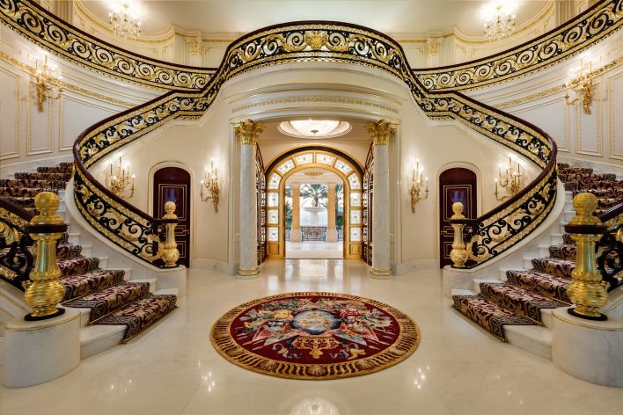

**The Parlor or Living Room**

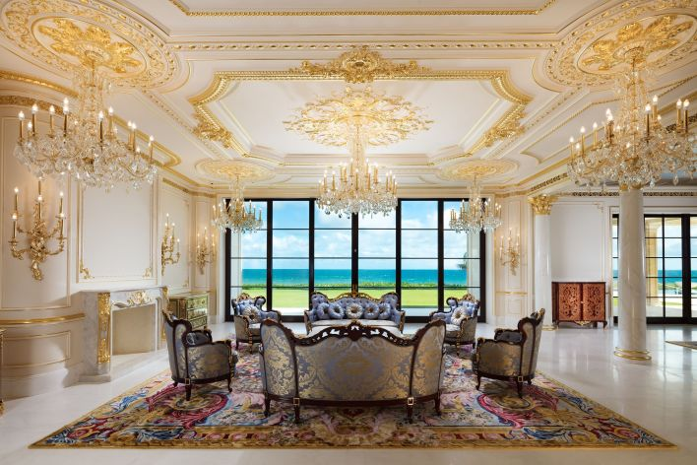

**The Dining Room**

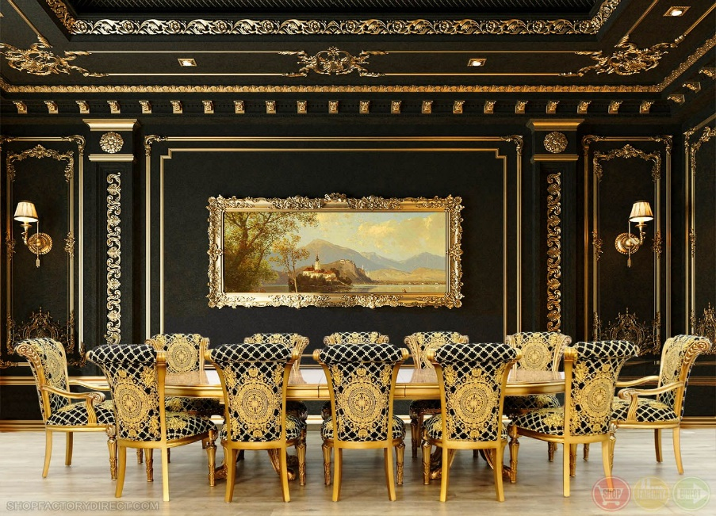

**The Office Room**

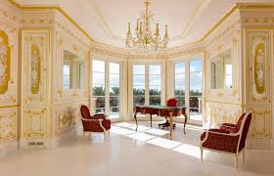

**The Royal Guest Rooms** [Accentuated amenities from The Plaza Suite 411, The Kevin Suite From Home Alone II]

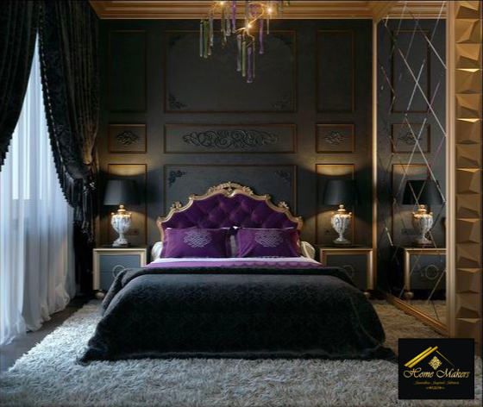

[The rooms each have a walk-in closet, ports for telephone, internet, and cable, plugs, same roof, and lighting]

[The bathrooms have the same color scheme as the rooms with safe step tubs, plugs, lining closet, and proper lighting]

**[Upstairs]**

**The Royal Bedrooms**

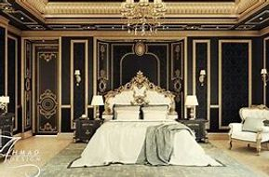

Queen Laura & King Landon’s Master Suite [Royal Vogue Fine Black With Double Doors Accentuated Amenities from The Conrad Suite, From Hilton Chicago From Home Alone II]

Lancelot’s Room [Royal Vogue Fine Dark Blue With Single Door Accentuated Amenities from The Plaza Suite 411, The Kevin Suite From Home Alone II]

Lauren’s Room [Royal Vogue Fine Dark Pink With Single Door Accentuated Amenities from The Plaza Suite 411, The Kevin Suite From Home Alone II]

Lord’s Room [Royal Vogue Fine Dark Beige With Single Door Accentuated Amenities from The Plaza Suite 411, The Kevin Suite From Home Alone II]

Casey’s Room [Royal Vogue Fine Dark Green With Single Door Accentuated Amenities from The Plaza Suite 411, The Kevin Suite From Home Alone II]

Lance & Laurie’s Room [Royal Vogue Fine Burgundy With Double Doors Accentuated Amenities from The Plaza Suite 411, The Kevin Suite From Home Alone II]

John & Cindy’s Room [Royal Vogue Fine Cream With Double Doors Accentuated Amenities from The Plaza Suite 411, The Kevin Suite From Home Alone II]

Jennifer & Matthew’s Room [Royal Vogue Fine White With Double Doors Accentuated Amenities from The Plaza Suite 411, The Kevin Suite From Home Alone II]

Madison’s Room [Royal Vogue Fine Charcoal With Double Doors Accentuated Amenities from The Plaza Suite 411, The Kevin Suite From Home Alone II]

Jordan’s Room [Royal Vogue Fine Champagne With Double Doors Accentuated Amenities from The Plaza Suite 411, The Kevin Suite From Home Alone II]

Mathis’s Room [Royal Vogue Fine Ivory With Double Doors Accentuated Amenities from The Plaza Suite 411, The Kevin Suite From Home Alone II]

John’s Room [Royal Vogue Fine Brown With Double Doors Accentuated Amenities from The Plaza Suite 411, The Kevin Suite From Home Alone II]

Harry’s Room [Royal Vogue Fine Grey With Double Doors Accentuated Amenities from The Plaza Suite 411, The Kevin Suite From Home Alone II]

[The rooms each have a walk-in closet, ports for telephone, internet, and cable, plugs, same roof, and lighting]

[The bathrooms have the same color scheme as the rooms with safe step tubs, plugs, lining closet, and proper lighting]

**The Royal Offices**

The Royal Family also has a very special set up and feature in their offices inspired by the movie Richie Rich for finding the family anywhere on earth if they choose to. There is also a similar handling for training, teaching, and handling as heirs to the throne and the wealthiest kids in the world.

The very special office set up feature with the various furniture pieces.

[**Outside]**

Piazza [The same as the one in the Sheik’s Palace Of Gold & Ivory with double doors opened from the hallway that leads into the piazza]

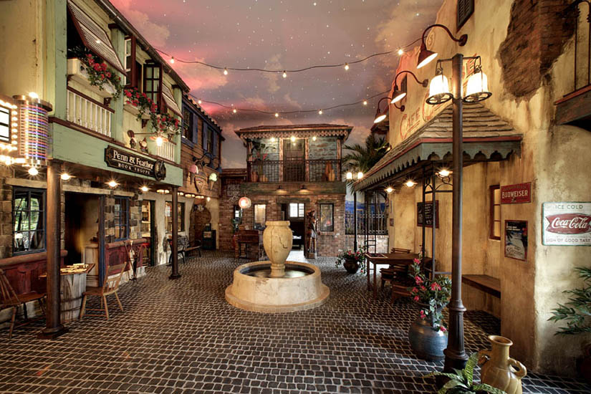

Piazza Skyline [leisure room]

Cinema

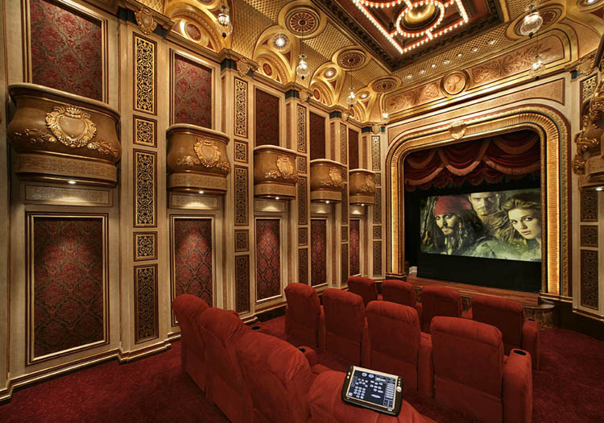

McDonalds

The very special outdoor McDonalds on the Royal Property.

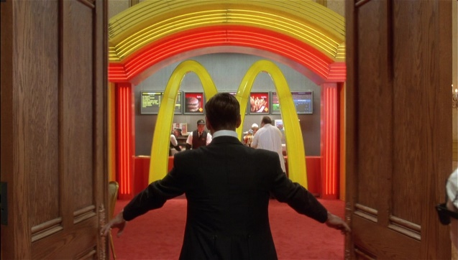

Duncan’s Toy Chest

The very special outdoor Duncan’s Toy Chest on the Royal Property.

