

The Queen’s Savings Accounts To Be Funded

From The Desk Of Her Royal Majesty

Queen Laura L. Gardner
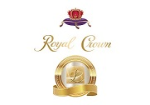

Pension & Savings Accounts 💰


[The Various Savings Accounts Will Be Funded By]

Major Savings Account

Goldman Sachs Bank



Goldman Sachs Marcus High Yield Savings Account - $955,170.00

Routing Number: 124085260

Account Number: 300065691978

Chase Bank


Chase Secured Checking Account - $100,765.00

Routing Number: 267084131

Account Number: 558650902

Intermediate Savings Account

One Pay Bank



One Pay Savings Account - $50,000.00

Routing Number: 125109006

Account Number: 102333614901

Capital One Bank


Performance Saving Account - $40,000.00

Account Number - 36161332085

Routing Number - 031176110

Minor Savings Account

Chime Bank

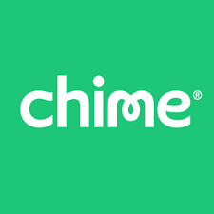

Chime Saving Account - $20,000.00

Account Number - 156120711189

Routing Number - 031101279


Queen Laura Gardner

