

The Queen’s Private Client Accounts

From The Desk Of Her Royal Majesty

Queen Laura L. Gardner

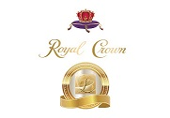

**Private Client Accounts 💰**



**Private Client Accounts -** $48,000,000.00 [Available For 1 Year]

**Bancorp**

**One Point Savings Account -** $30,000,000.00

**Citibank**

**Citigold Private Client Savings Account -** $10,000,000.00

**American Express**

**American Express Private Client Savings Account -** $5,000,000.00

**Chase**

**Chase Private Client Savings Account -** $3,000,000.00

**Queen Laura Gardner**

