The LawsOf The Securities
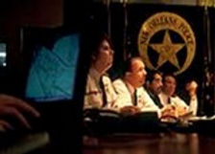

This special law was created by the various countries, private islands, and authorities, to apply a standard of fairness, if the satellites of the jurisdiction were to ever be used for criminal or unscrupulous purposes.

This law is one that allows for any individual, in the various walks of life, whose behavior and handing may be destructive or undesirable, to handle themselves, their properties and who asks for them only. Especially, if they may be criminal in nature and behavior, in doing as they please with others, or trying to rule and overrule. It is even more so of great importance, with those who may lead other people, and for those who engage in law breaking and very destructive behavior.

The Laws Of The Securities states, that if the satellites are ever used for criminal purposes, you have to hold and handle yourself, and who ask for you only, especially if criminal and dangerous in nature, with a motive, intent, and behavior that is dangerous and destructive.

