**The Royal And Presidential Palace**

**Owners:** The Royal Family Of The Ultimate Kingdom

**House Builder:** Heaven Construction Company

**Designers:** Queen Laura L. Gardner Alexander

**Location:** Head Quarters, Ultimate Kingdom

**Cost**: $20 Million

**House Elevation:**

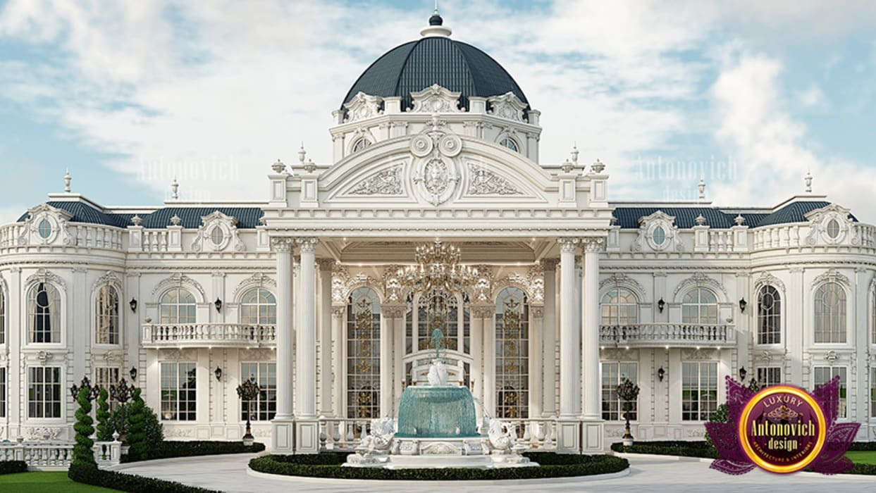

[Color Scheme For The Gardner Alexander Estate For Exterior With Paint That Shimmers In The Sunlight & Internal Lightning That Illuminates Through The Windows At Night]

**The Driveway**

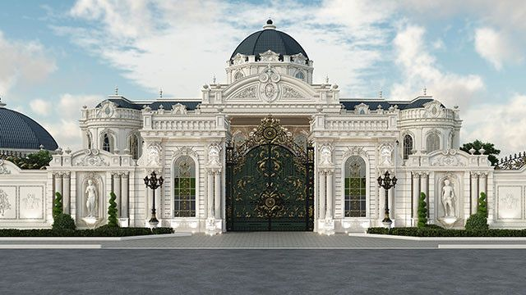

**The Staircase**

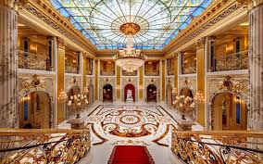

**[Downstairs]**

**The Royal & Presidential Palace Dining Room**

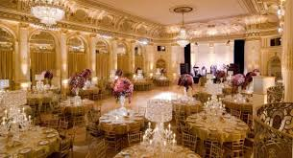

**The Royal & Presidential Palace Meeting Room**

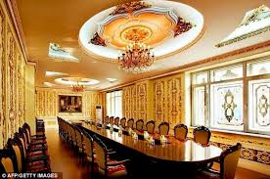

**[Upstairs]**

**The Royal & Presidential Place Royal Family Suites**

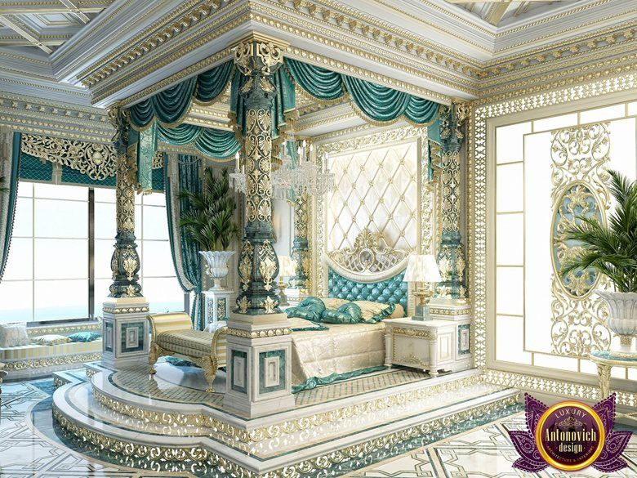

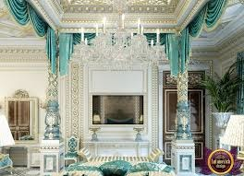

Queen Laura & King Landon’s Master Suite [Palatial Black & Gold With Double Doors & mini or wet bar]

Lancelot’s Room [Palatial Dark Blue & Gold With Single Door]

Lauren’s Room [Palatial Dark Pink & Gold With Single Door]

Lord’s Room [Palatial Dark Beige & Gold With Single Door]

Casey’s Room [Palatial Dark Green With Single Door & mini or wet bar]

Lance & Laurie’s Room [Palatial Burgundy With Double Doors & mini or wet bar]

John & Cindy’s Room [Palatial Cream With Double Doors & mini or wet bar]

Jennifer & Matthew’s Room [Palatial White With Double Doors & mini or wet bar]

Madison’s Room [Palatial Charcoal With Single Door]

Jordan’s Room [Palatial Champagne With Single Door]

Mathis’s Room [Palatial Ivory With Single Door]

John’s Room [Palatial Brown With Single Door]

Harry’s Room [Palatial Grey With Single Door]

Jessica’s Room [Palatial Green With Single Door]

Julie’s Room [Palatial Royal Purple With Single Door]

[The rooms each have a walk-in closet, ports for telephone, internet, and cable, plugs, same roof and lighting, the chandelier removed]

[The bathrooms have the same color scheme as the rooms with safe step tubs, plugs, lining closet, and proper lighting]

**The Piazza**

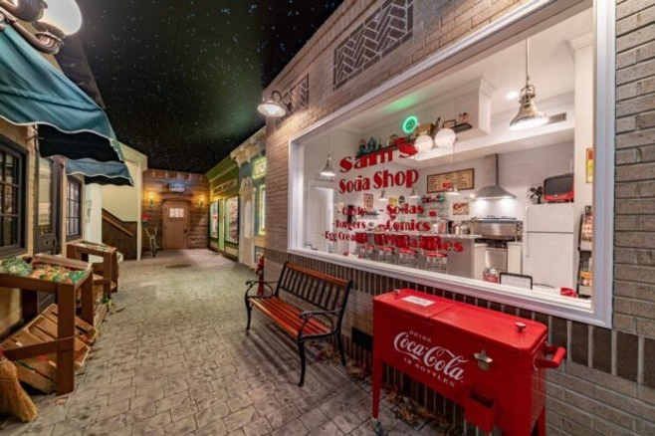

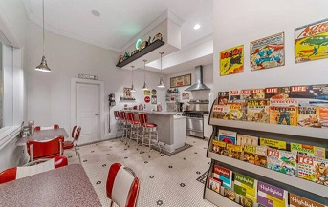

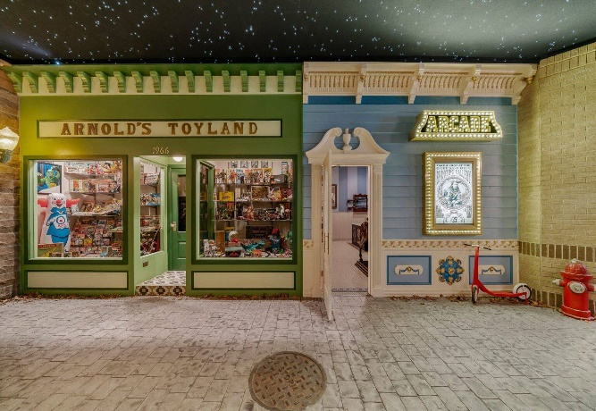

**The Cinema**

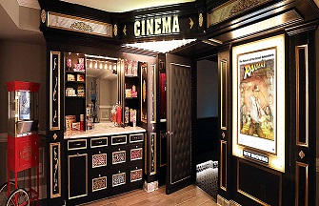

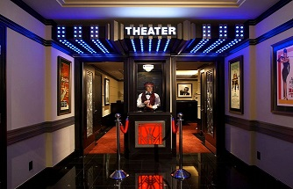

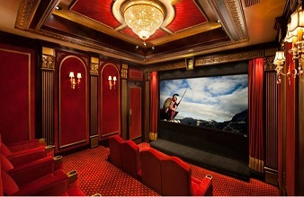

**The Parlor**

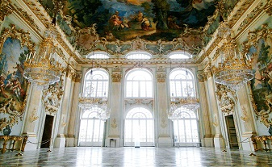

**The Portrait Room**

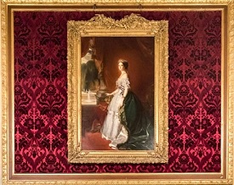

**The Royal & Presidential Palace Throne Room**

The room should look like the picture below with the color scheme of white and gold, of black and purple accents. The floor black and the throne area purple.

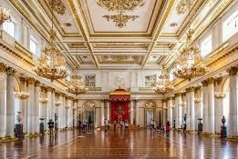

**The Royal & Presidential Palace Throne Area**

The columns should be of white marble with gold accent pieces at the top and bottom of the column. The steps leading to the throne should be made of pure ivory. The red area should be purple and the inner columns black marble.

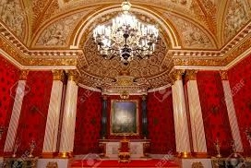

**The Royal Thrones**

The thrones should look like the picture below and be made of white and pure gold. The crown in the second picture should be placed within the throne chair at the top of the back rest, and the height of the second picture as well.

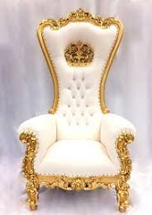

**YouTube Video:**

1. Million Dollar House

**Additional Rooms**

The Front Statue With Water Fountain

The Living Room

The Conference Room

The Dining Room

The Pool Room

The Powder Room

The Kitchen

The Spa