March 1st, 2026


The Social Security Disability Pension

Name: Laura L. Gardner
DOB: 07/26/1981
Social Security Number: 559-67-1605

Fact Findings: Bronze American Indian of the American Indian Tribe Of Houston Of South Dakota. Great, Great Granddaughter Of American Indian Chief Adam T. Houston, Great Granddaughter Of Anjelica A. Houston Ford, Grandniece Of General John R. Houston & CEO Harry T. Ford. Father Passed Away. Thyroid Malfunction & Collapsed Lung At 19 Years Old. Filed As Dependent By Father Drs. Leroy L. Gardner & Hospital Santo Tomas On File. Everything Completed Properly.

Current SSD: $994.00/per month

Late Father’s Program
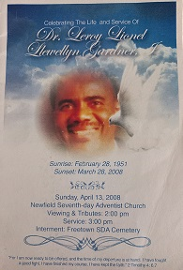

Baby Picture
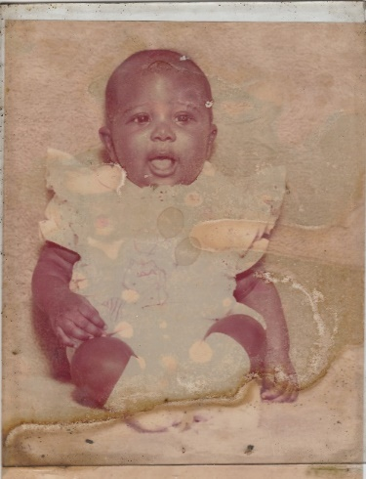

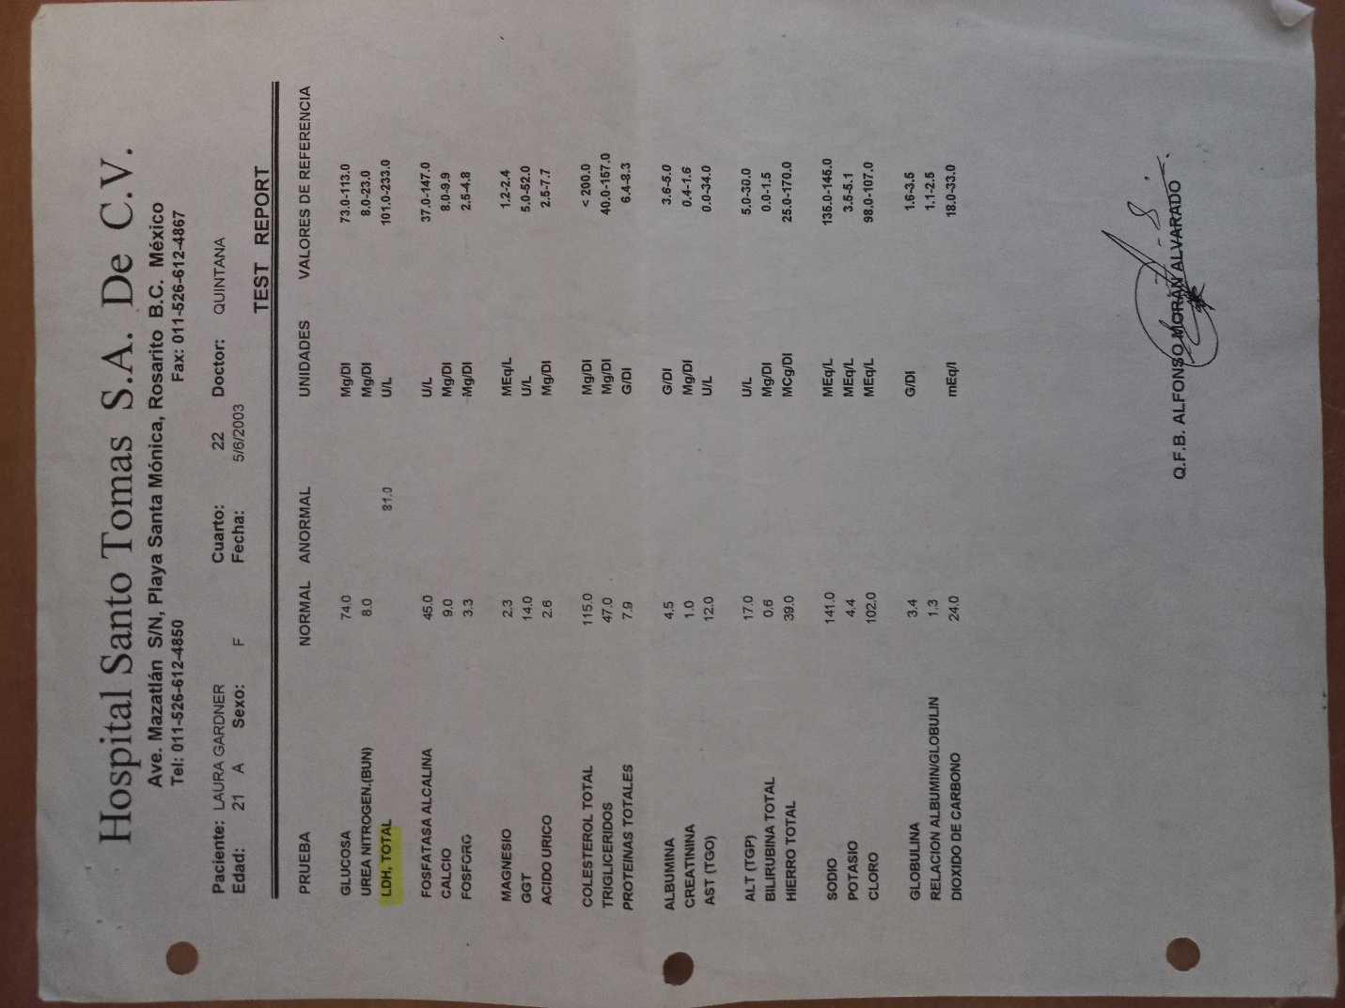

Social Security Administration Board: Honolulu, Hawaii
RM 1-114 FED BLDG,
Prince Kuhio Federal Building,
300 Ala Moana Blvd,
Honolulu, HI 96850

Direct Deposit Information For Disability Pensions:

Capital One 360

Bank: Capital One

Type: Capital One 360 Checking

Account #: 36060637409

Routing #: 031176110

SSI Disability Amount: $994.00/per month [Every 1st Of The Month]

Mailing Address:

Laura Gardner
5013 S Louise Ave
Unit # 531
Sioux Falls, SD 57108

Laura Gardner

