November 18th, 2025

The Unemployment Document



Name: Queen Laura L. Gardner
DOB: 07/26/1981
Social Security Number: 559-67-1605

The Unemployment Document
Effective Date: 07/07/2024
Benefit Year End Date: 07/06/2025
Unemployment Amount: $3,300.00
Status: Exhausted
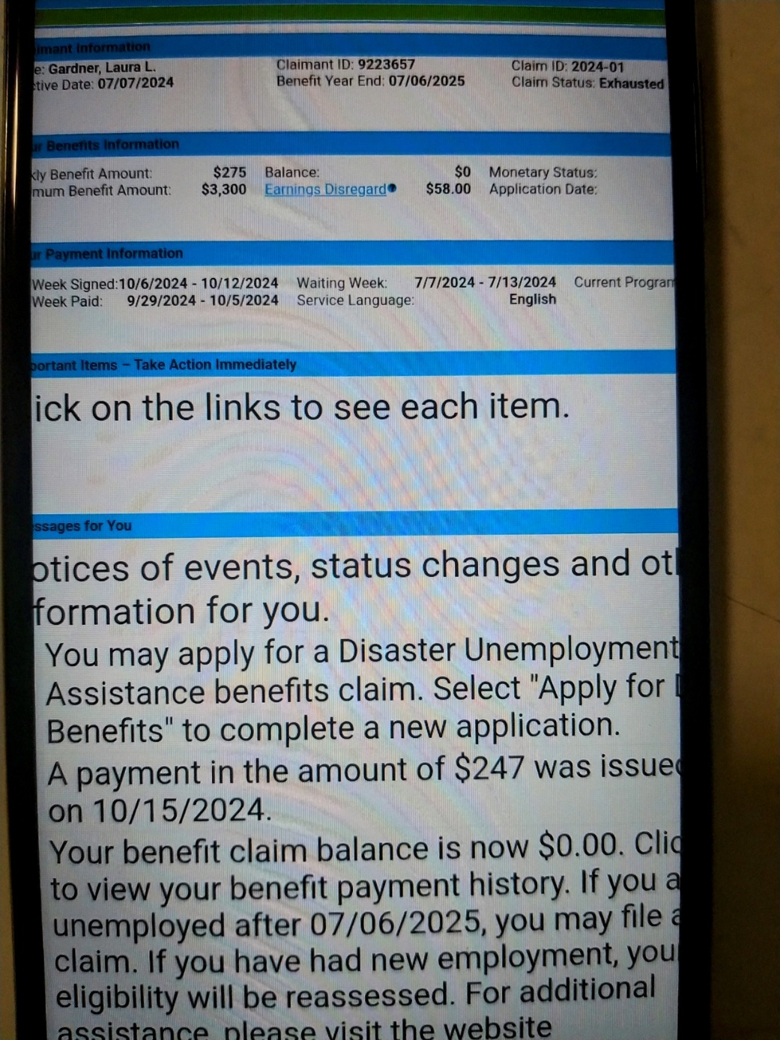

The Unemployment Document
Effective Date: 07/13/2025
Benefit Year End Date: 07/12/2026
Unemployment Amount: $3,300.00
Status: Exhausted
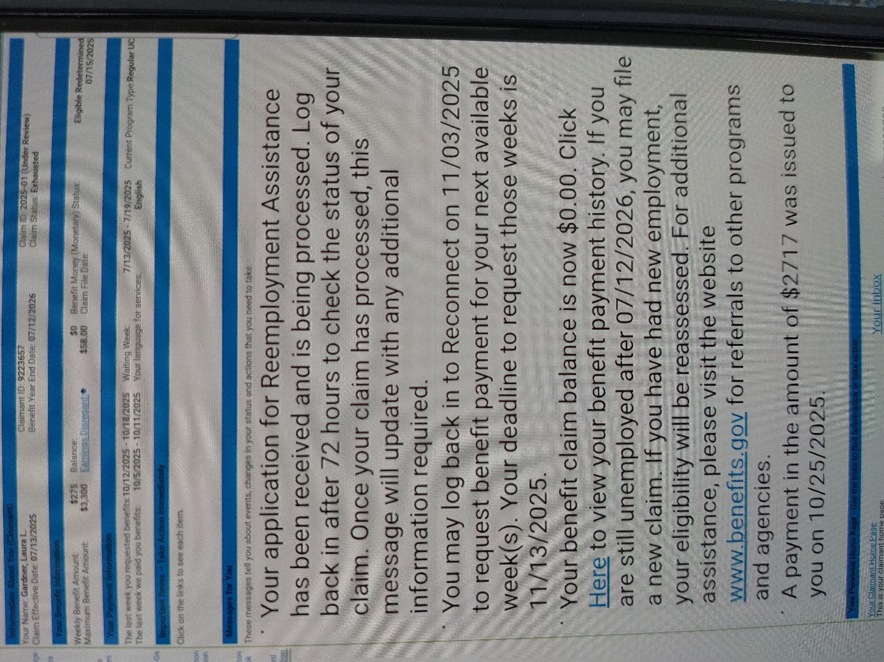

The Unemployment Document Claimant Specifics
Unemployment Amount: $6,600.00
Status: Exhausted

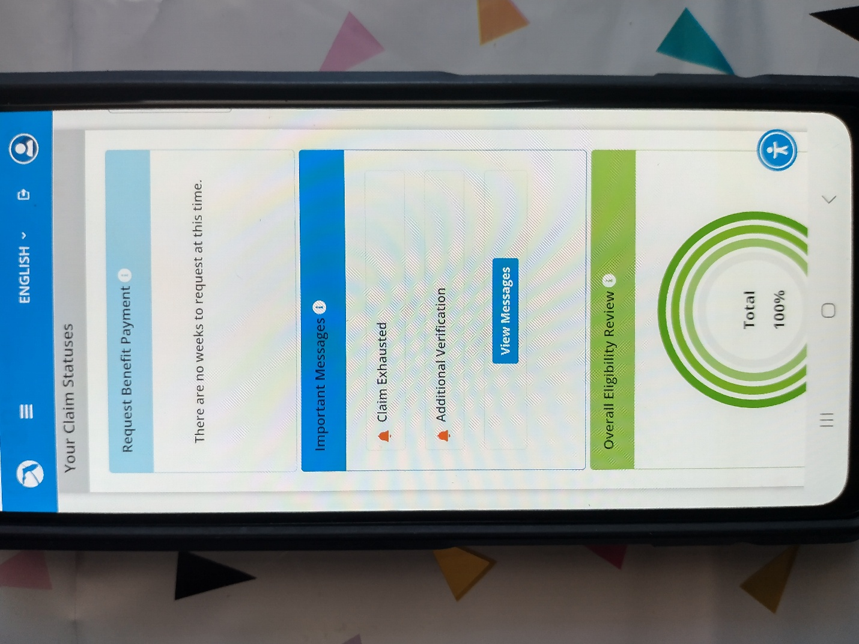

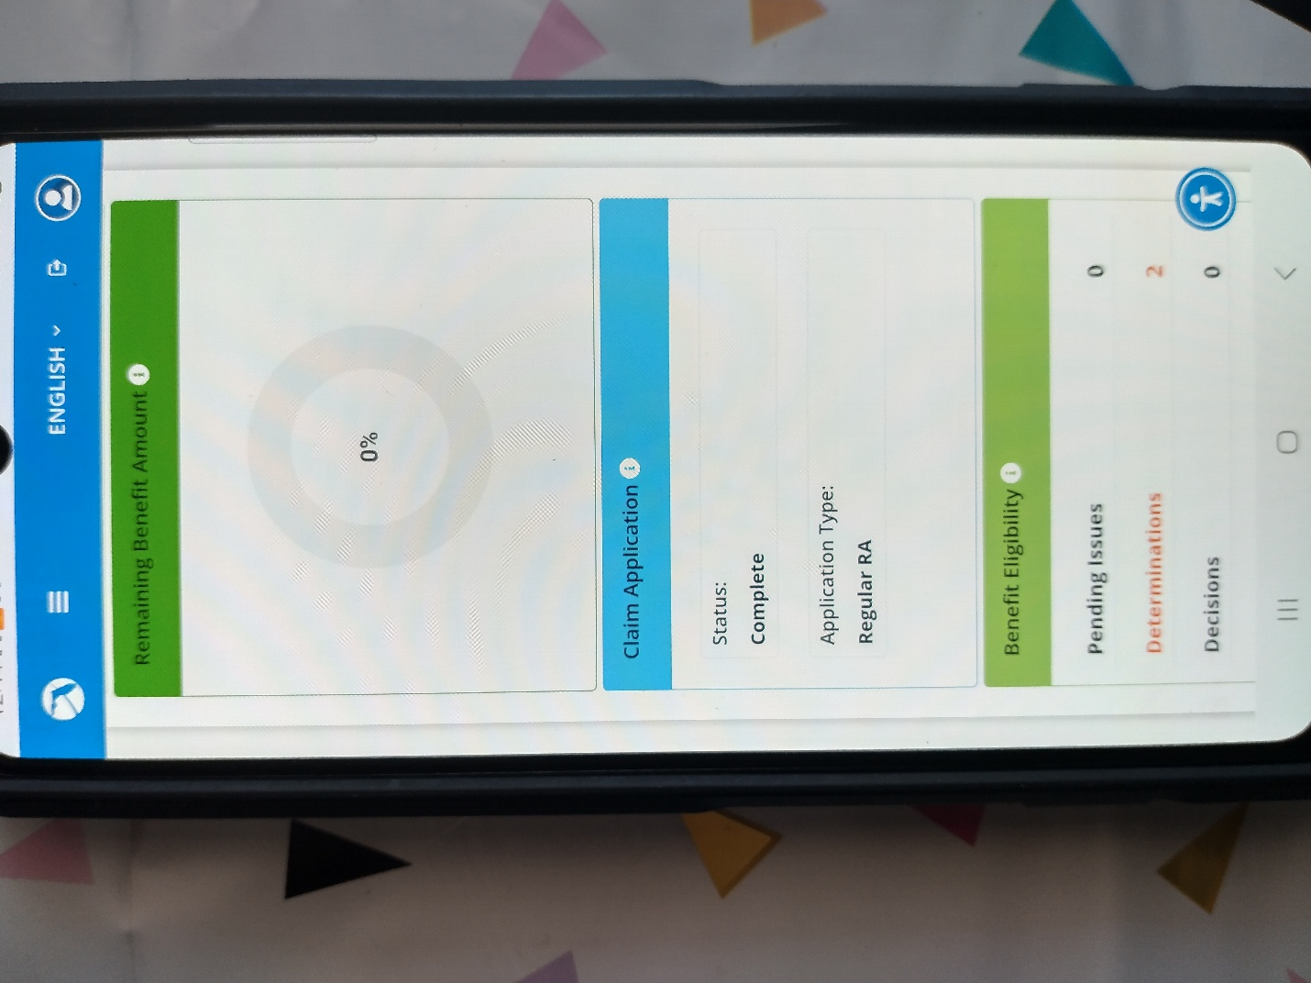

Queen Laura Gardner


