**The Queen & King’s Royal Romance House**

**Type:** The Royal Vacation Residence

**Location:** Fantasy, Romance Private Island

**Value:** $1 Million

**Owners:** Queen Laura L. Gardner Alexander & King Landon D. Alexander

**House Elevation:**

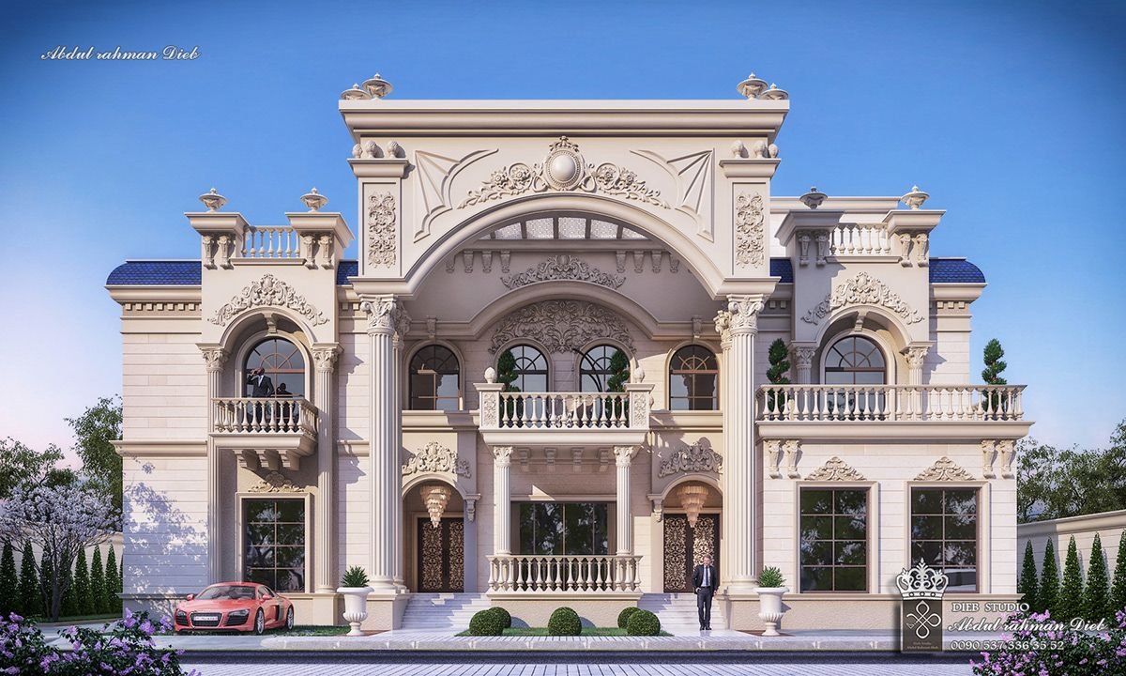

[Color Scheme For The Exterior With Paint That Shimmers In The Sunlight & Internal Lightning That Illuminates Through The Windows At Night]

**[Downstairs]**

**Color Scheme**

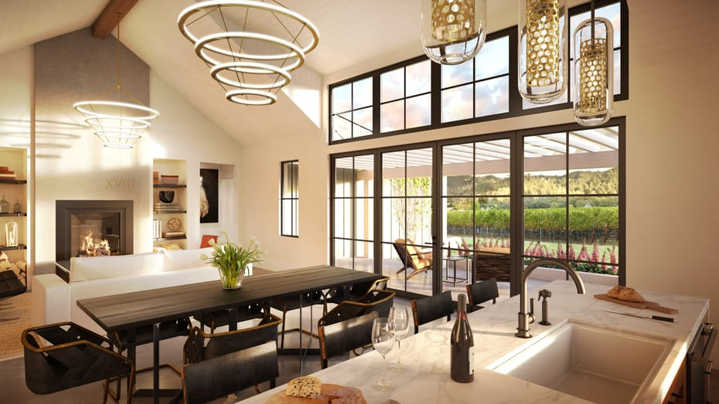

**Functional Spaces**

Foyer

Kitchen

[with butler’s pantry and whirlpool brush stainless steel appliances, delta touch faucet, double sink for the dishes, and an island sink for the food]

Office Room

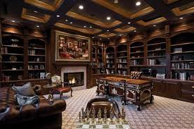

Game Room

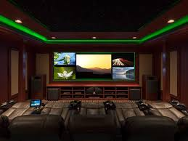

Guest Room [with mini or wet bar]

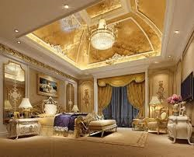

[The rooms each have a walk-in closet, ports for telephone, internet, and cable, plugs, same roof, and lighting]

[The bathrooms have the same color scheme as the rooms with safe step tubs, plugs, lining closet, and proper lighting]

**YouTube Video:**

26 Promontory Ridge Drive

The Ridges, Summerlin

Las Vegas, Nevada

Movie Theater Room [Downstairs]

**[Upstairs]**

**Bedrooms**

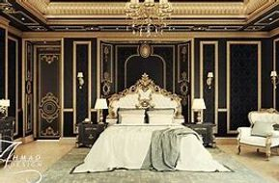

Queen Laura & King Landon’s Master Suite [Royal Vogue Fine Red With Double Doors & mini or wet bar]

[The rooms each have a walk-in closet, ports for telephone, internet, and cable, plugs, same roof and lighting]

[The bathrooms have the same color scheme as the rooms with safe step tubs, plugs, lining closet, and proper lighting]

**Functional Rooms**

Leisure Room

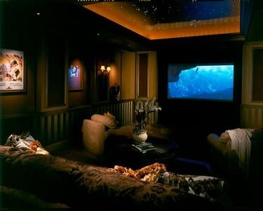

Laundry Room

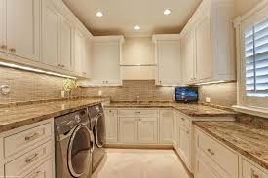

Outdoor Summer Kitchen [with refrigerator, wine cooler, grill, stove, sink, places to put cups, plates and cutlery, seating area and outdoor fire pit, to the right of the living and dining room area outside of the glass doors]

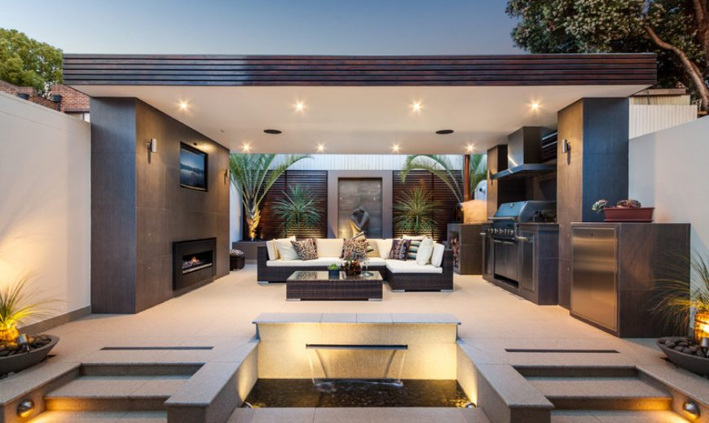

Pool [waterfall pool]

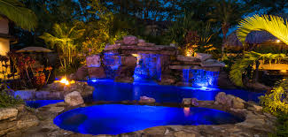

Pool Bathroom

