**The Royal NFL Character House**

**Owners:** The Royal Family Of The Ultimate Kingdom & The Territories

**House Builder:** Heaven Construction Company

**Designers:** Queen Laura L. Gardner Alexander

**Location:** Honor City, The Ultimate Kingdom

**Cost**: $5 Million

**House Elevation:**

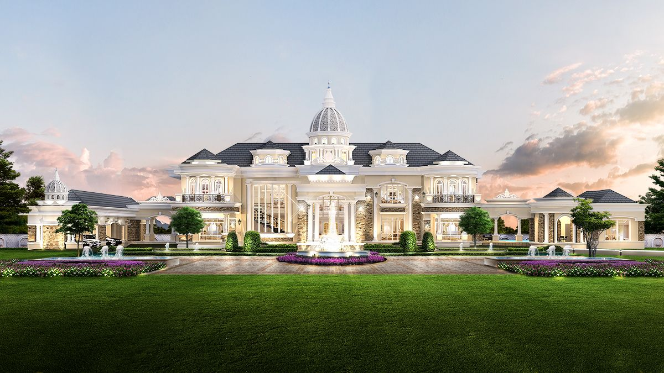

**Color Scheme:** Grey, White, & Blue[Color Scheme For The Exterior With Paint That Shimmers In The Sunlight & Internal Lightning That Illuminates Through The Windows At Night

**The NFL Character Bedrooms**

**Queen Laura & King Landon’s Bedroom** [with office and mini or wet bar]

Wallpaper



Curtains



Mail & Key Holder

Plaque

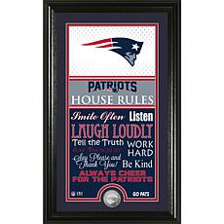

Poster

Clock

Lighted Display

Football Display

Floor Mat

Bed

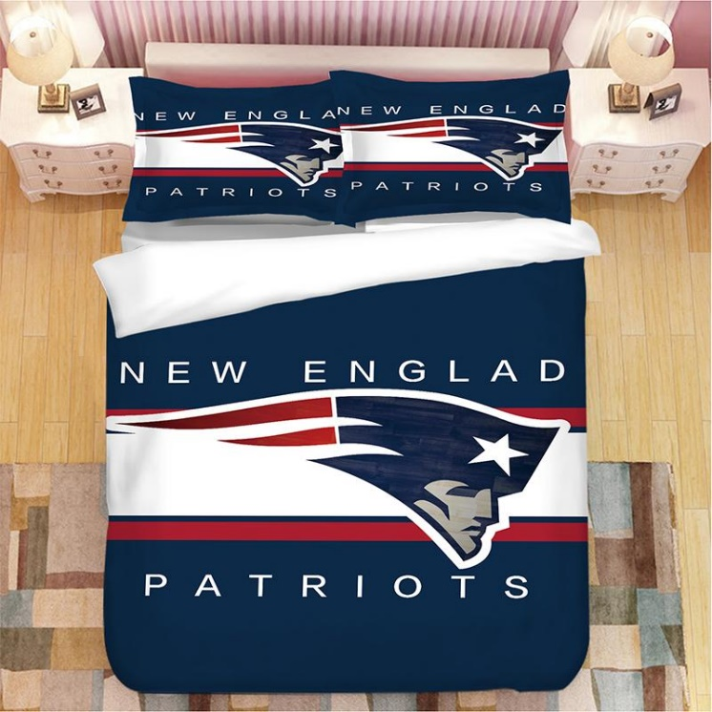

Pillow

Bed Rugs

Lamp

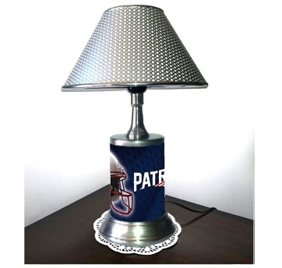

Special Edition Night Table

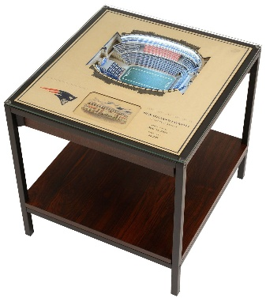

Reclining Chair

Storage Ottoman

Magazine Table

Royal Plush Throw

Google Home

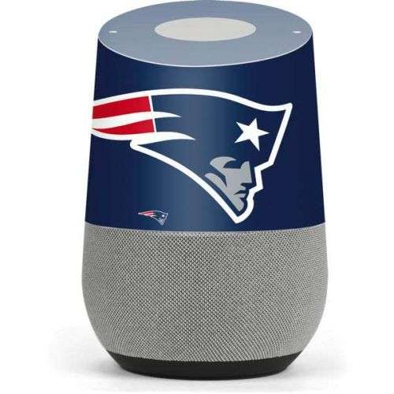

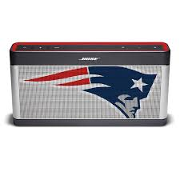Bose Speakers

Night Light

Wax Melt

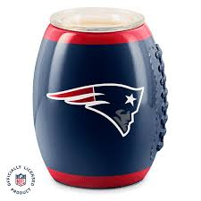

Football

Teddy Bear

# NFL Electric Full Body Shiatsu Massage Chair with Foot Roller

Floor Mat

**Mini Or Wet Bar**

**Bathroom**

Wallpaper



Bathroom Floor

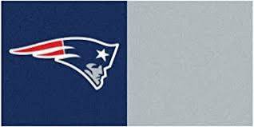

Night Light

Shower Curtain & Bathroom Paraphernalia

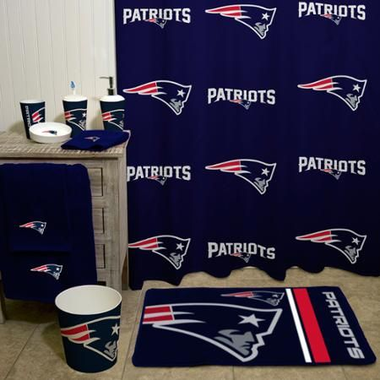

Toilet Cover, Sink & Toilet Mat

Towels

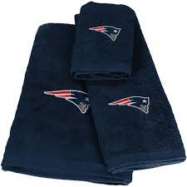

Clothes Hamper

Waste Basket

Storage Box

Footlocker

**Office**

Wallpaper



Clock

Wall Display

Computer

Chair

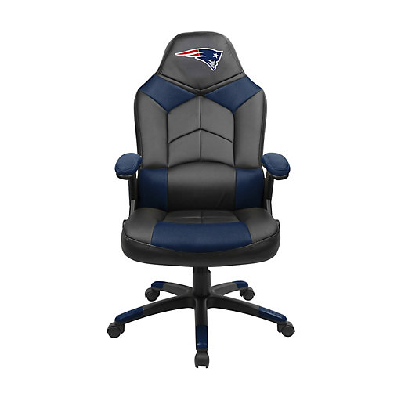

Light

Phone Docking Station

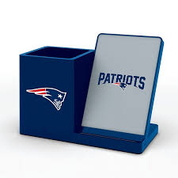

Charger

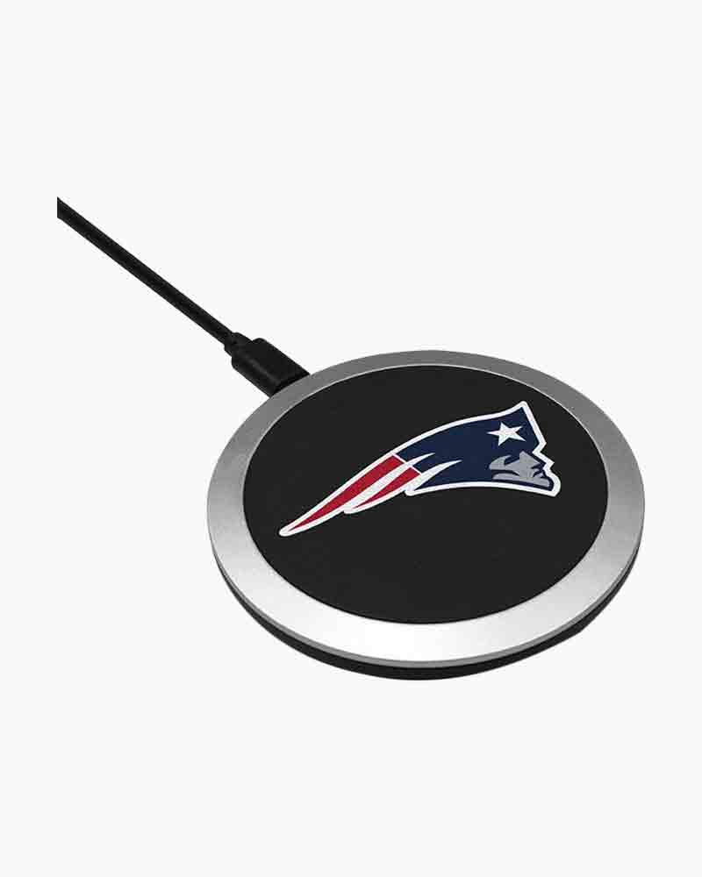

Light Switch

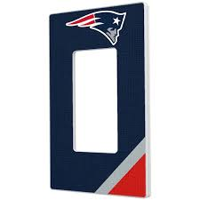

**Nursery**

Royal Plush Throw

Pillow

Quilt

Gaming Pillow

Toy & Throw

Rug



Flags

Onesie

Onesie, Bibs, Shoes, Pacifier

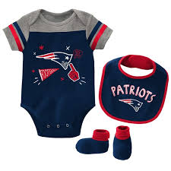

Tumblers

Mug

Sweater

Hoodie

Shirt

**Casey’s Room** [with office and mini or wet bar]

Wallpaper



**Lance & Laurie’s Room** [with office and mini or wet bar]

Wallpaper



**John & Cindy’s Room** [with office and mini or wet bar]

Wallpaper



**Jennifer & Matthew’s Room** [with office and mini or wet bar]

Wallpaper



**John’s Room** [with office and mini or wet bar]

Wallpaper



**Harry’s Room** [with office and mini or wet bar]

Wallpaper



**Jessica’s Room** [with office and mini or wet bar]

Wallpaper



**Julie’s Room** [with office and mini or wet bar]

Wallpaper



**Lancelot’s Room** [with office and mini or wet bar]

Wallpaper

**Lauren’s Room** [with office and mini or wet bar]

Wallpaper

**Lord’s Room** [with office and mini or wet bar]

Wallpaper

**Madison’s Room** [with office and mini or wet bar]

Wallpaper

**Jordan’s Room** [with office and mini or wet bar]

Wallpaper

**Mathis’s Room** [with office and mini or wet bar]

Wallpaper

[The rooms each have a walk-in closet, ports for telephone, internet, and cable, plugs, same roof, and lighting] [The bathrooms have the same color scheme as the rooms with safe step tubs, barn doors, plugs, lining closet, and proper lighting]

**The Internal Doors**

Office Barn Door [In White]

Nursery Barn Door [In Grey]

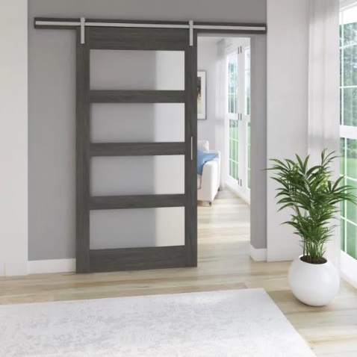

Bathroom Doors [In Blue]

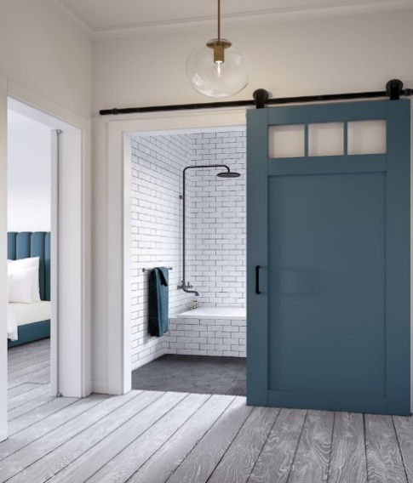

Closet Doors [In White]

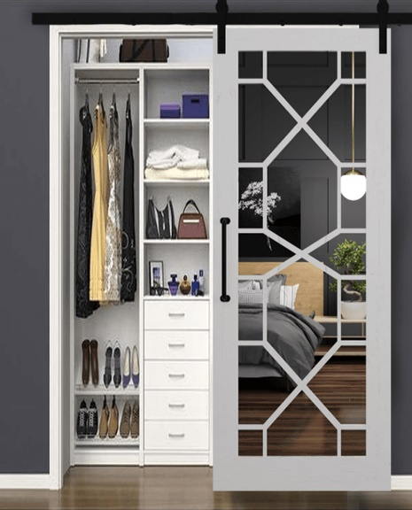

Laundry Barn Door [In Black]

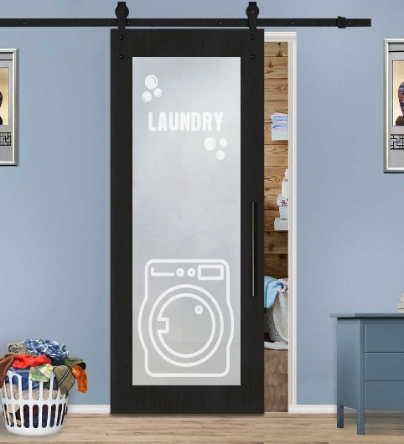

Pantry Barn Door [In Blue]

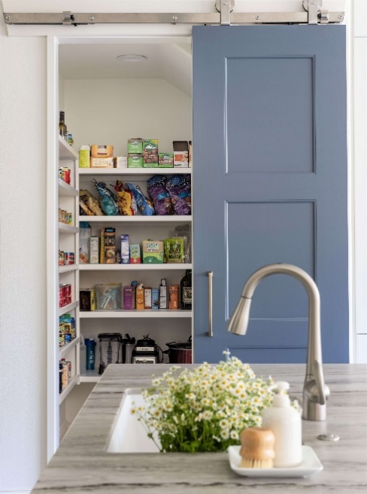

Pantry Barn Door [Glass Insert]

**The Waiting & Music Room**

Yamaha Clavinova CLP 765 – GP Digital Polish - white

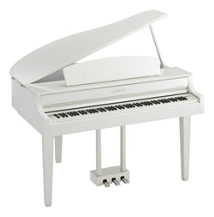

Bose Wave Music System Multi-cd changer - white

Sofa

Plush Velvet Down Fill Cloud Modular 4-Seat Sectional and Ottoman, Blue, Seatin By Meridian Furniture

**The Living Room**

Wallpaper

Carpet

Furniture Pieces

Television & Fireplace

**The Kitchen**

**The Dining Room**

Roof & Walls

Table, Chairs & Floor

**The Half Bath**

Light Fixture

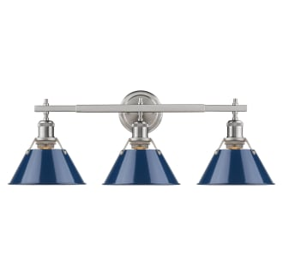

Sink

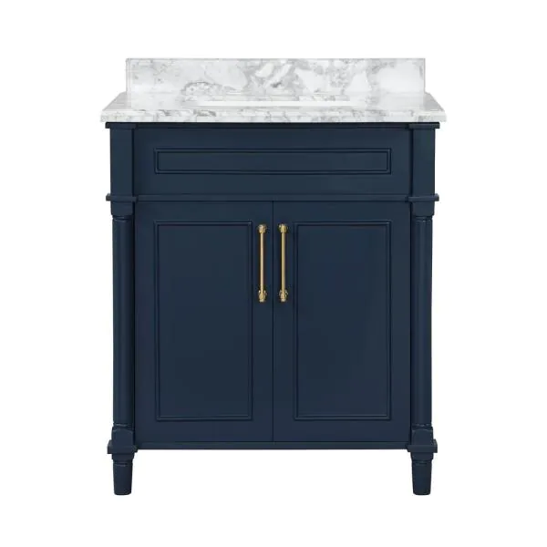

Toilet

Walls

Floor Tile



**The Guest Bedroom**

The Roof

Walls & Floor

Bed & Furniture

**The Guest Bathroom**

Wallpaper

Floor, Mats, & Shower Curtain

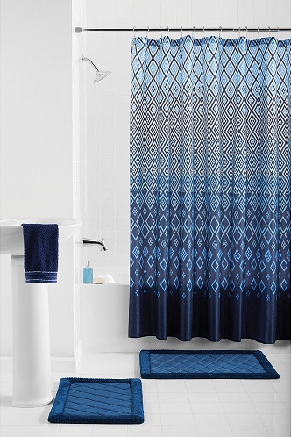

Sink

Mirror

Cabinet Over Toilet

Toilet

**Backyard**

Entertaining Area

Outdoor Seating & Eating Area

Pool Bathroom

**Piazza**

**Theater**

Moonlight Entrance & Marque

On The Rocks

**Restaurants**

[black and white tiles]

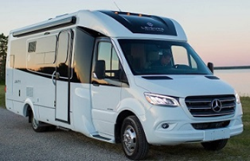

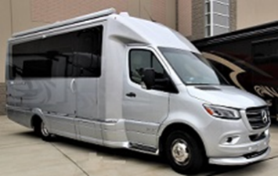

**YouTube Video:**

30 Meadow Hawk Lane

The Ridges, Summerlin

Las Vegas, Nevada

**Specific Features:**

1. Baby Grand Piano In White [Living Room]
2. Entertaining Bar
3. Outdoor Or Service Kitchen
4. Pool & Hot Tub
5. Sauna & In House Massage Room [Placed Near To The Pool Instead]
6. Basement Game Room & Wet Bar
7. Pool Bathroom [Place Near To The Pool Instead]
8. Fire & Wall Waterfall Feature [Double Doors That Open At The Back To The Outdoor Entertaining Areas]