The G Royal Private Island



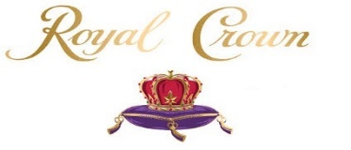

[The G or Gardner Royal Family Private Island]

20 Billion 290 Million Dollars

This private island is owned and operated by Queen & Drs. Laura L. Gardner, Drs. Leroy L. Gardner & Dr. Casey L. Smith Gardner.

G Or Gardner Royal Private Island [Normal Privacy Conditions]

The Residents: 25

The Visitors: 15

The Power Of Constancy

The Private Island [4 Acres]

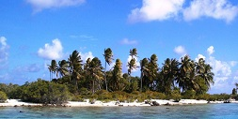

The Exterior

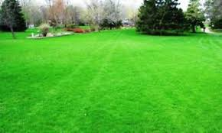
Land Space

The Star Wars Castle, Moat & Fountains [Left Medical Center & Right Command Center]


The Interior

Castle [Twelve of the finest hotel suites in all the world]

Walmart [With McDonalds & Subway]



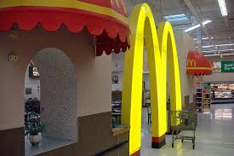

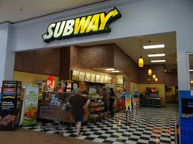

The Chapel

