The Criminalizing of Our Natural Bodies


Report

This special report gives the final exact intent, of the criminals that focused on the Royal Family of The Ultimate Kingdom and some of the very good citizens. These people plotted to take jurisdictional satellites and fix them to our mortal bodies, tracking and emitting as we walk and drive along, or irrationally find us wherever we are, unexpectedly causing harm. These criminals would disobey, lie, and deceive incessantly. Some thought they would distance but could not do so after the fact, thinking that they would get off with us. When they realized it was not working, they plotted to include whoever they wanted, to go with them, if not all, and further became suicidal bombers. There were several people responsible. When Queen asked them to effectively punish so many became fool hardy and disobedient, and overwhelmed her, doing so, almost costing us all our lives.

Queen Laura and her family, and some of the citizens, from the Ultimate Kingdom were evaluated with the hospital staff and these are their documented findings. They were afflicted with microscopic hair shot into the skin tissue, slight, red, and concentrated bumps, tar, blisters, dabs of nightshade, bruises, inflictions', pumps of air in various locations, neck and nose cold flukes. This type of harm affected their physical being and is of nasty origin. The criminals are vile airspace pedophiles and are restraining order as well as legally barred. Our recommendation, given the extreme desire to affect them physically. Ensure that they are not touched in an undesired way. Then a 3 to 6-month recuperation process. Please know from a medical stand point, it is important that this type of harm, so unwanted and uncomfortable, not be repeated.

We Are Also Directing The Warnings To Not Be Disturbed Ever Again, With Restraining Orders, Through The Libraries. We Are Also Punishing With The Obedient Caunch Blanc That Obey Queen Laura To Physically Move The Criminals, Their Dangerous Presences, Devices, And Substances, To Resolve This Air Space Bodily Hit Arrangement Crime Of Sniper Nasty, Permanently. Given That Statistics Of Bodily Harm & Loss Of Life, So Gravely Injurious, Especially Wounded Warriors With Ears, Eyes, & Limbs, Lost, And Some Living As Paralyzed Vegetables. We Simply Cannot Have Anything Like This Repeated. They Are Further Protected By All Of The Ultimate Kingdom & The Territories. Queen Laura Was Hoping To Get The Criminals Permanently, Out Of Their Lives, Given What So Many Plotted. Because Of The Desire To Get After Too Much, Provocation, Infuriation, And Foolishness, The Attacks Perpetuated Into Madness. These Air Space Criminals Would Track And Attack Like Predators Of Prey That Would Not Behave Or Obey. They Would Also Find And Seek, Then Attack Unexpectedly. Queen Laura Was Able To Resolve The Hit Arrangement Crime Temporarily, Then They Plotted And Started It Hit Up Again. The Criminals Have Already Paid 994 Billion Dollars For The Criminal Compensatory, With The Laws Of The Satellites, And The Laws Of The Securities, Any Further Attacks And They Will Pay With Their Natural Lives And Bodies. The Ultimate Kingdom's Supreme Courts Also Have The Additional Filings, For Obedience Only, To Get This Task Or Job, Of Savings Our Lives, And The Fine Quality, Successfully Through, However It Can Be Had. This Is Not Just A Situation Of Figuring Out The Truth, Warnings Given To All, Even With Do, To See And Feel As Who,Volume Indeed Even The Dead Variety, Killing And Getting Off Alone To, Even Deadly Dangerous, Nasty Bodily Harm Before We Are Through.

Pictures Of Bodily Harm

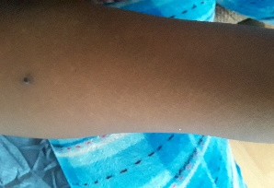
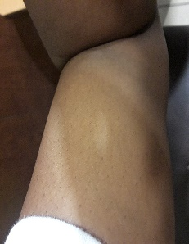

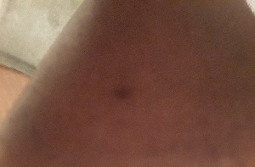
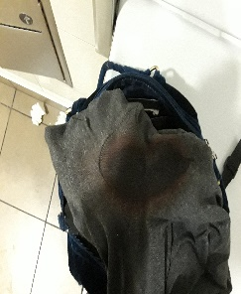

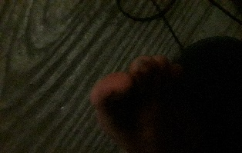



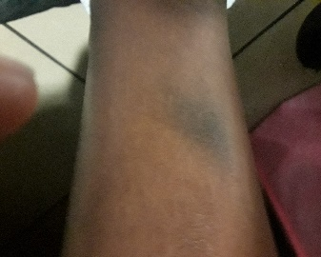

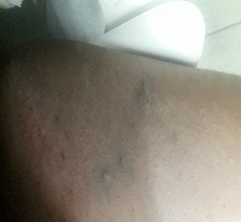

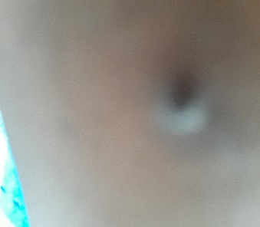

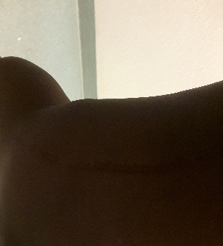
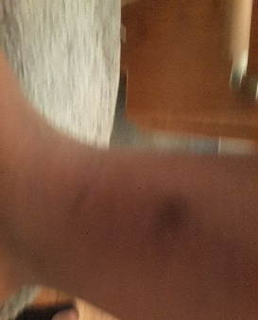

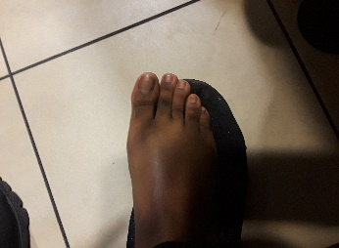

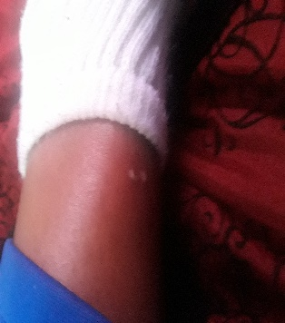

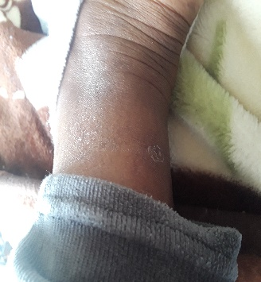

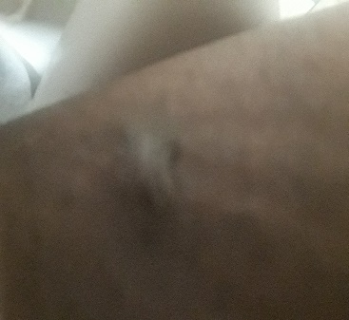
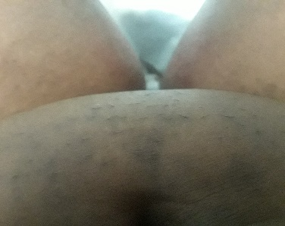
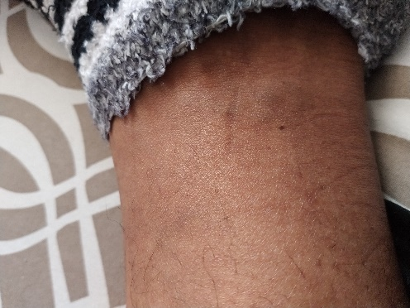
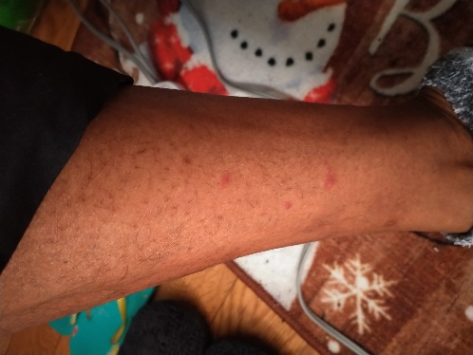
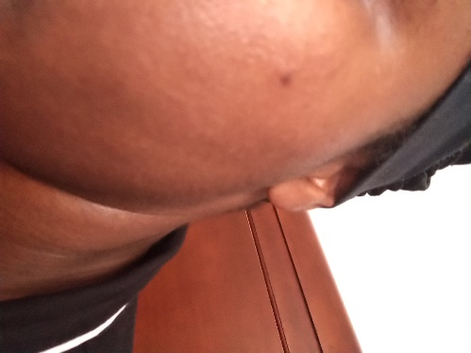
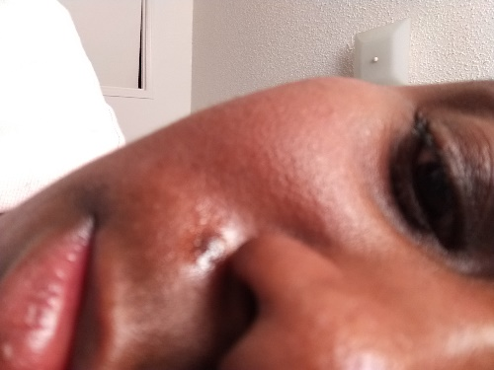

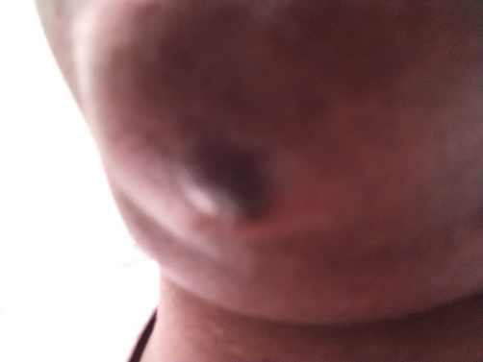
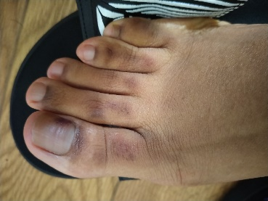

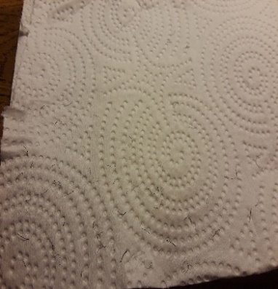
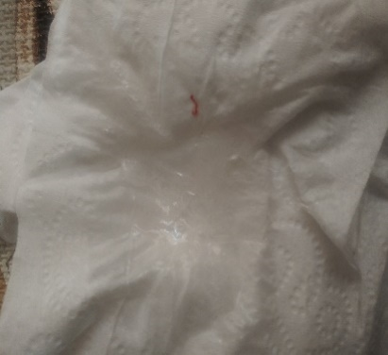

Pictures Of Hostel [Universal Symbol To Do Not Touch, Engaging The Universal Languages We All Understand Indeed Of See & Touch Respectively]
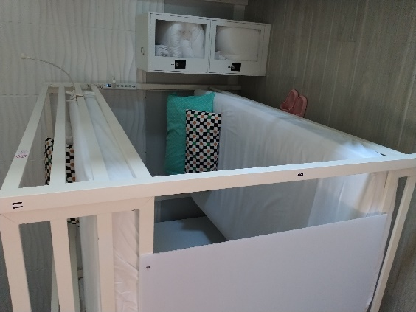
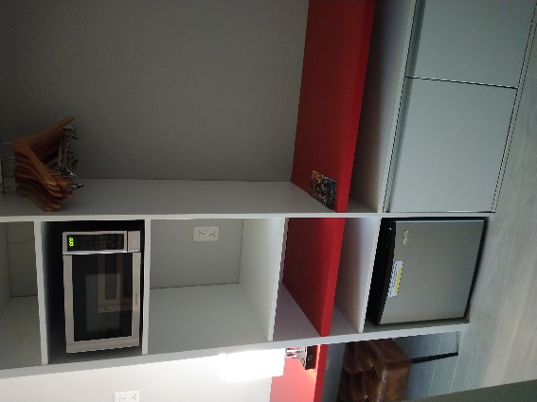
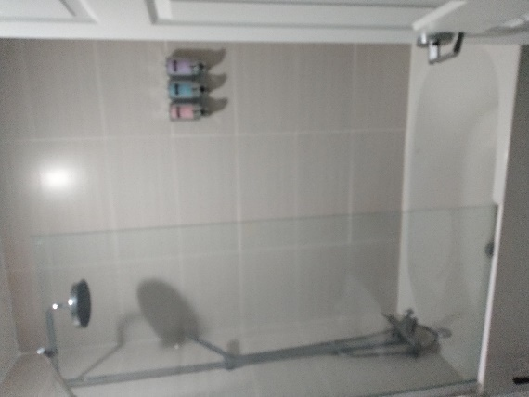

Pictures Of Criminal Harm

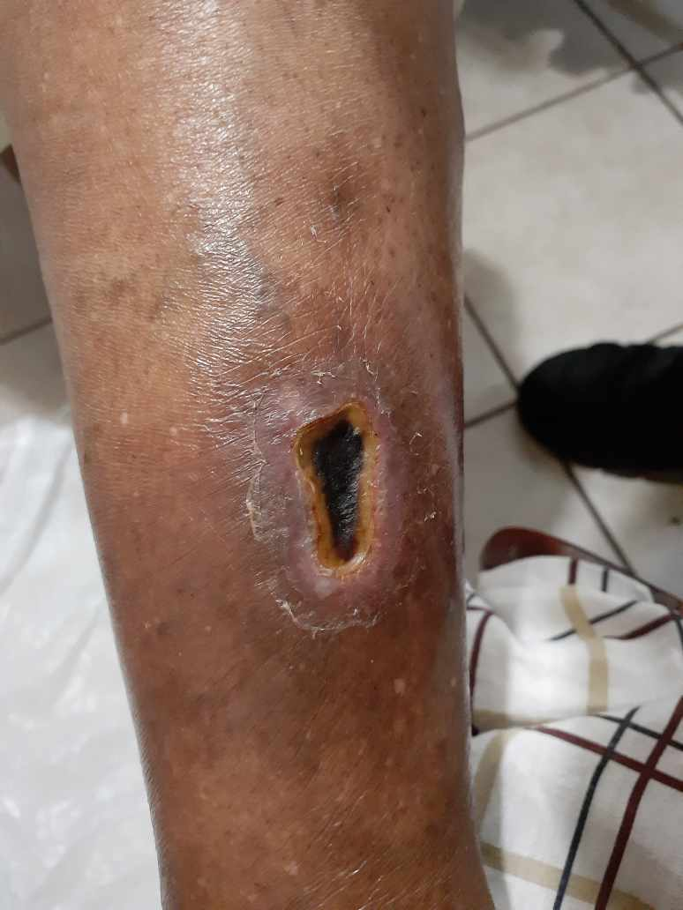

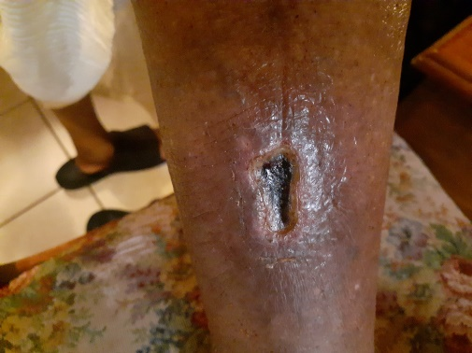

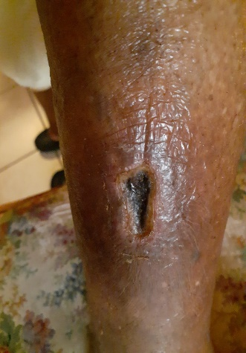

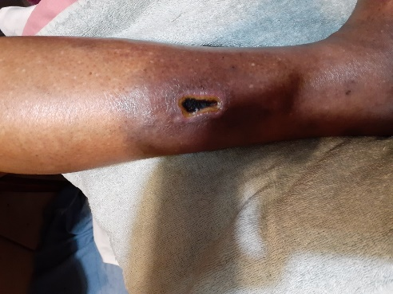

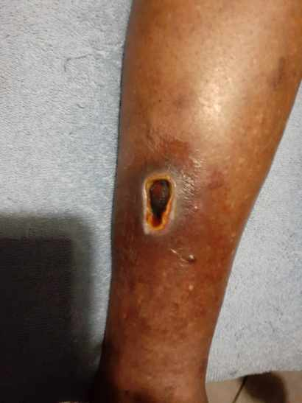

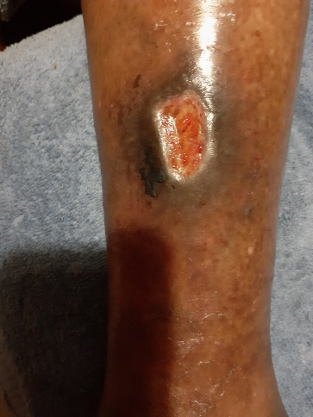

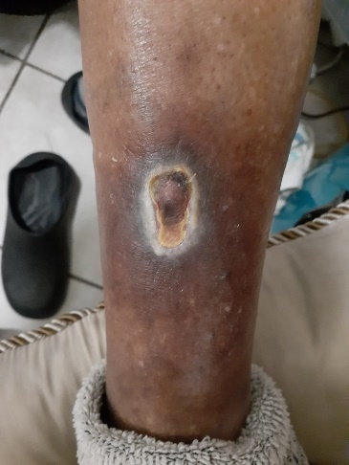

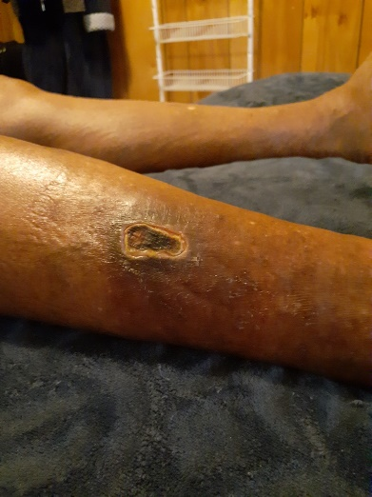

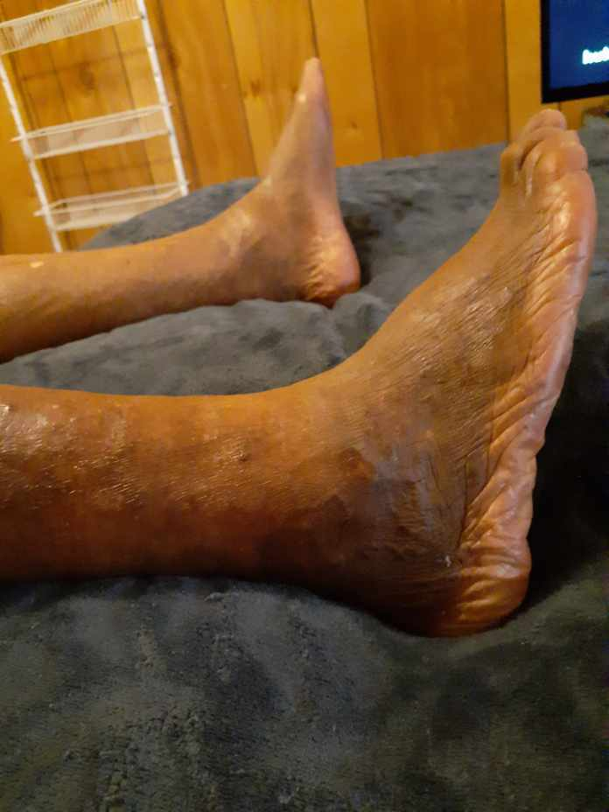

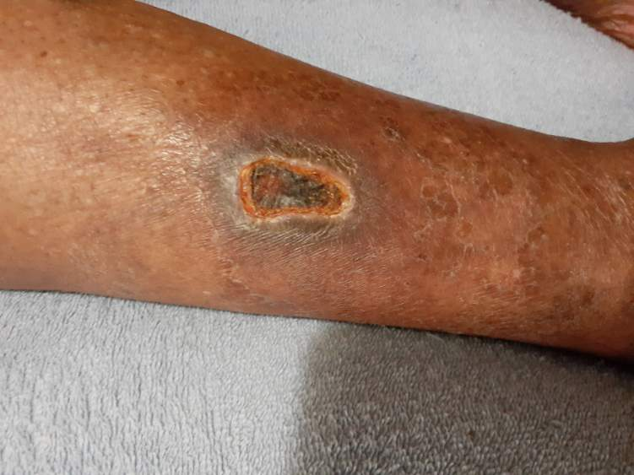

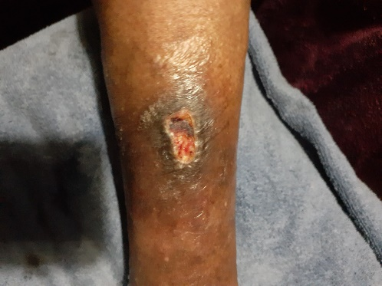

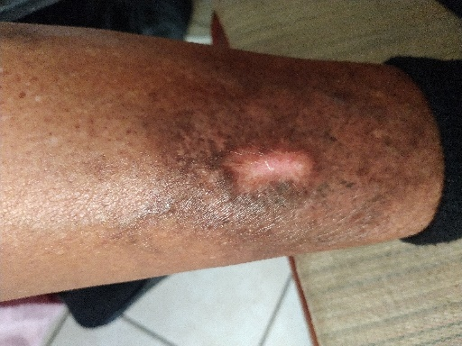
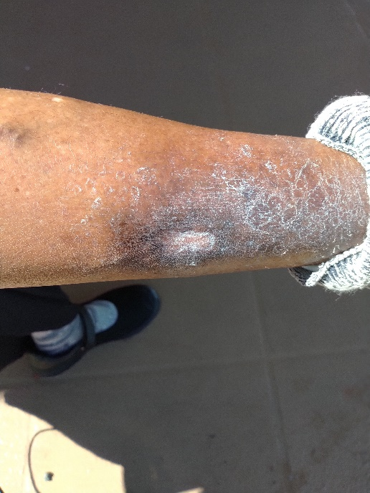

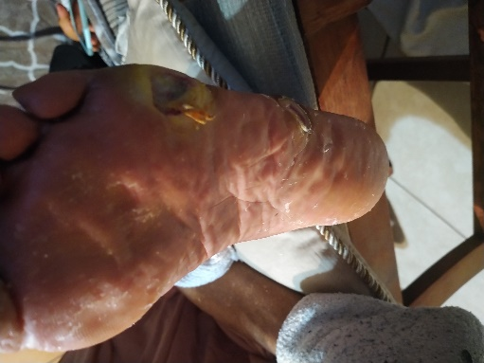

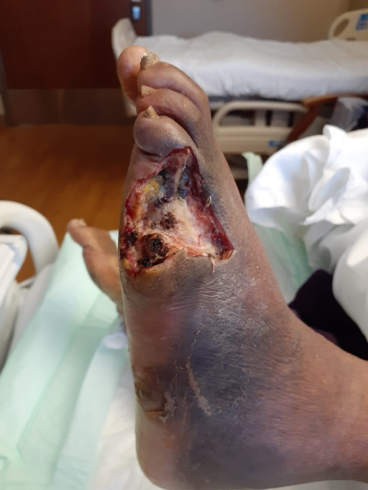

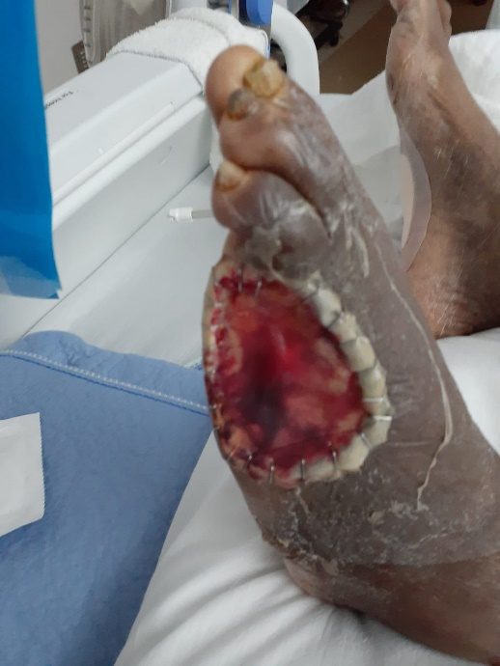

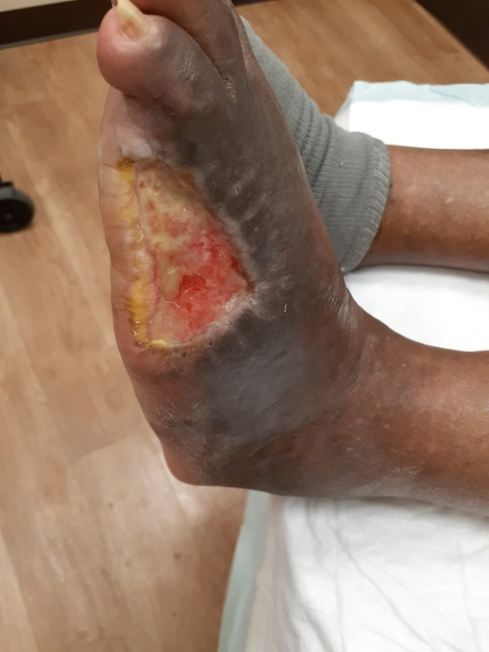

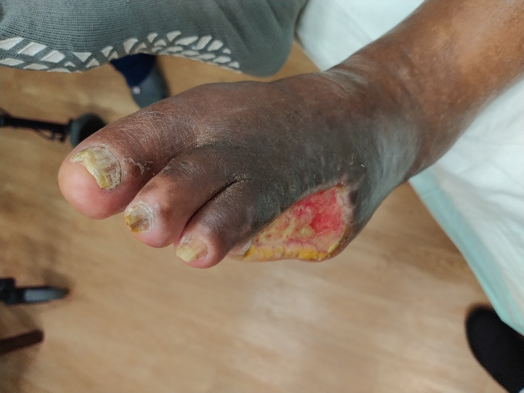

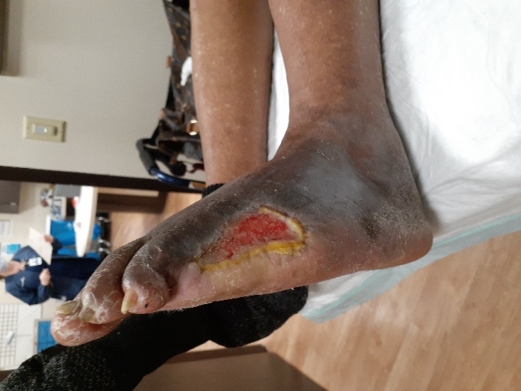

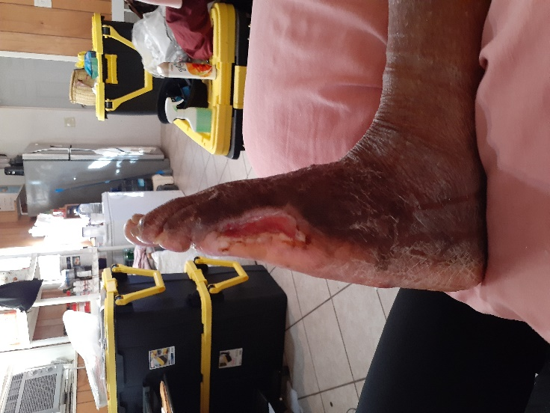

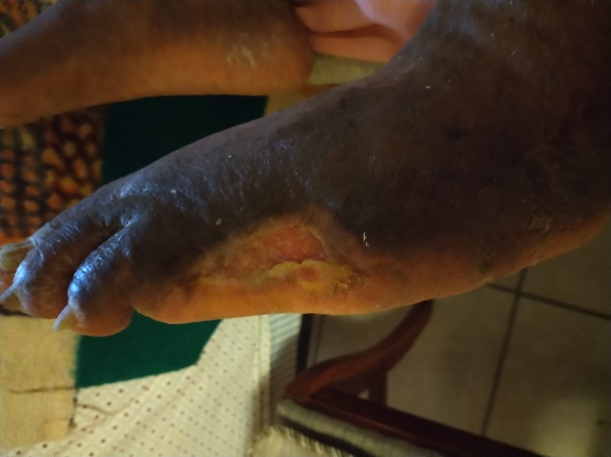

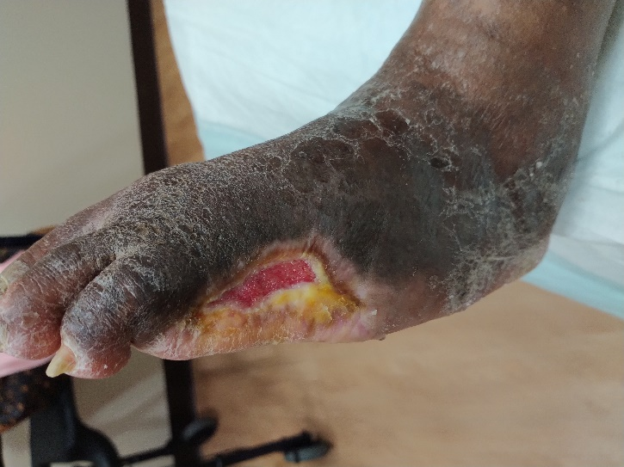

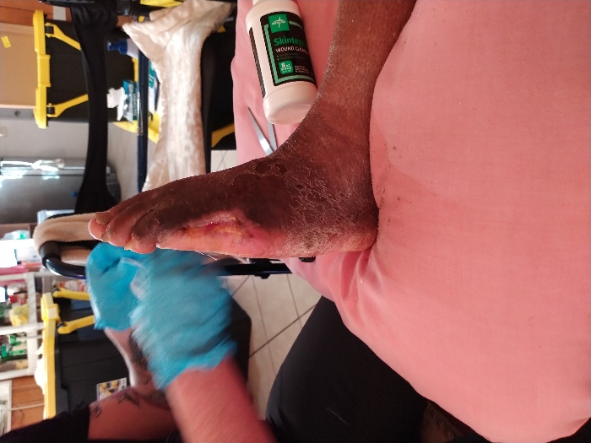

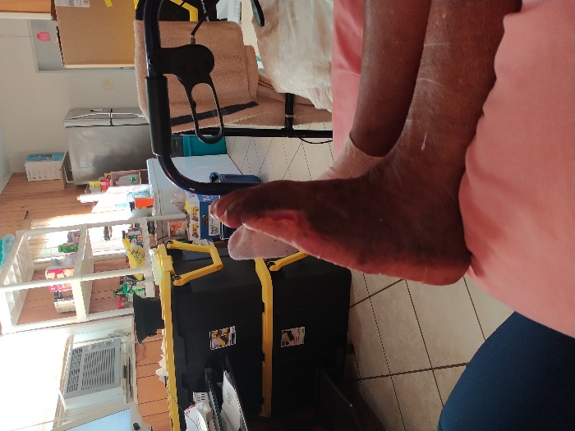

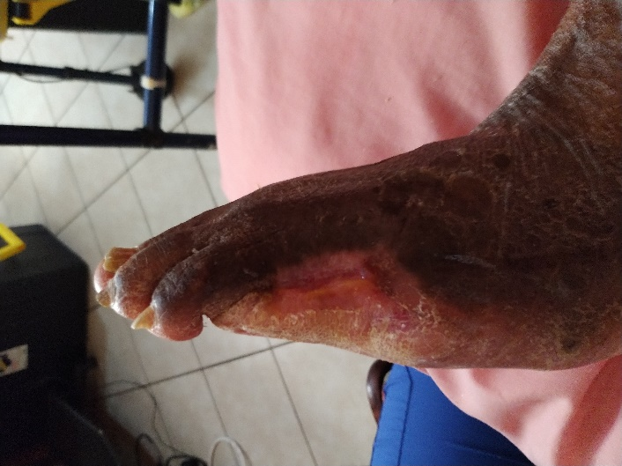

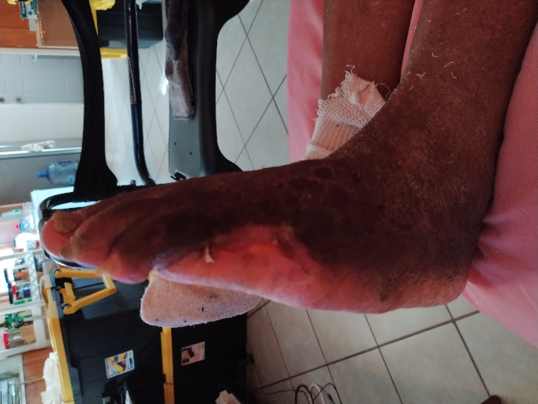

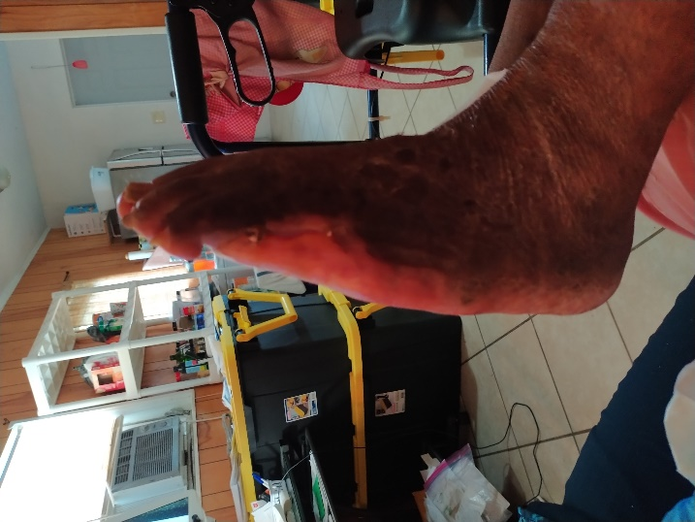

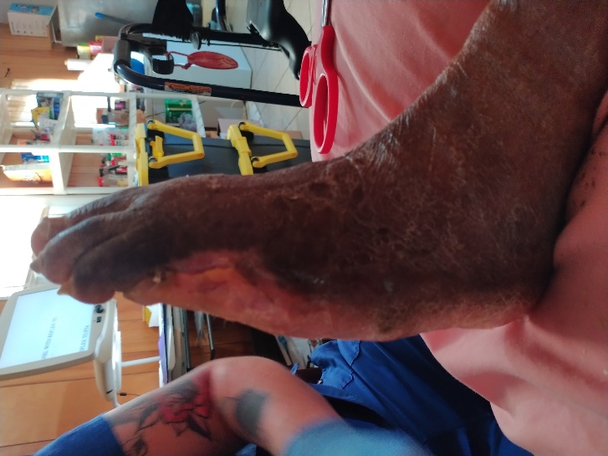

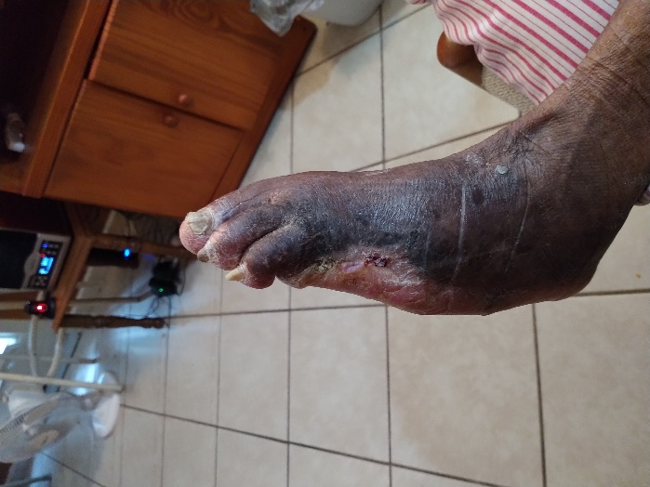

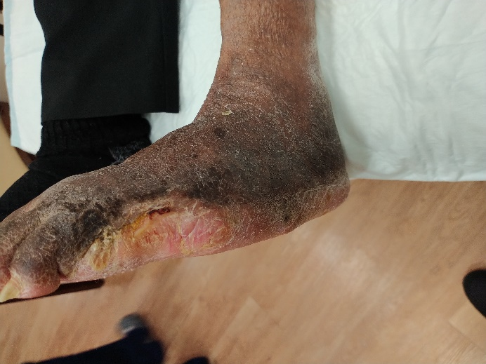

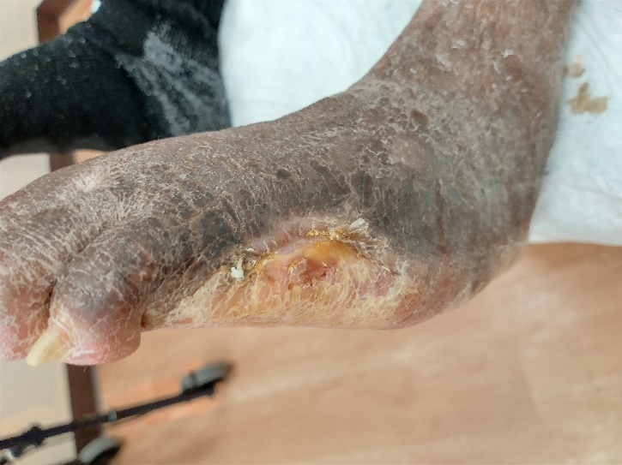

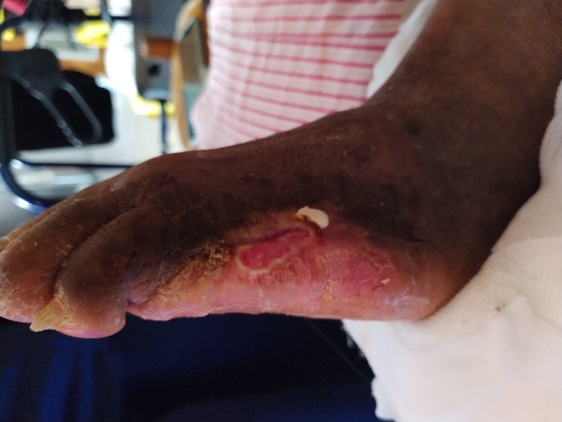

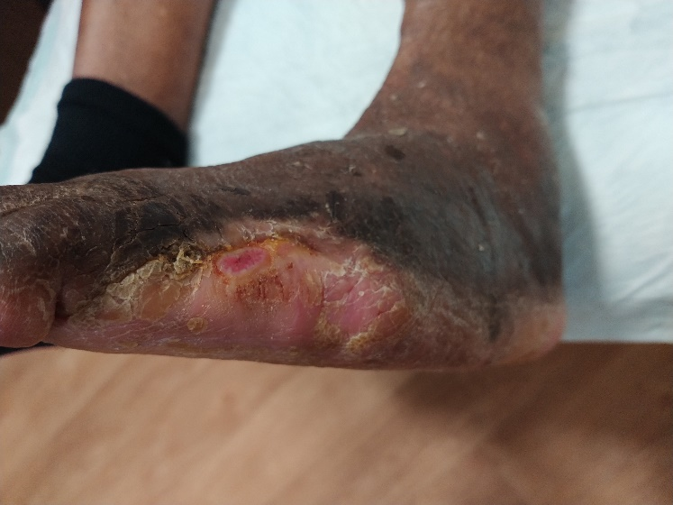

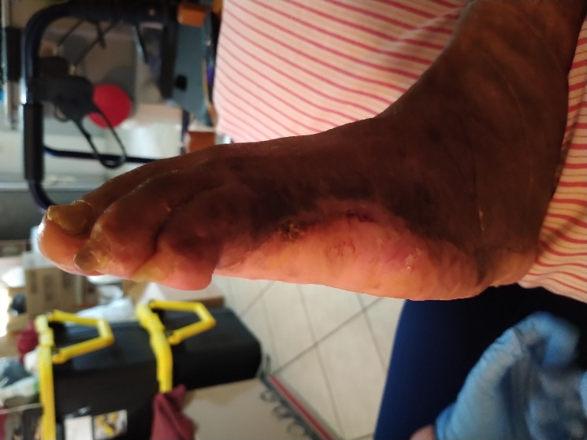

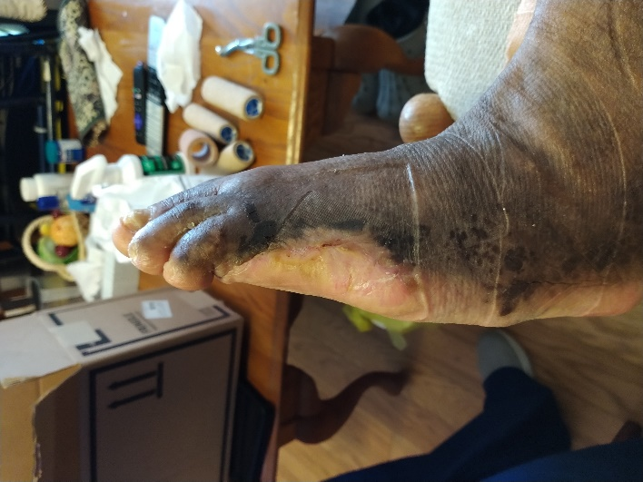

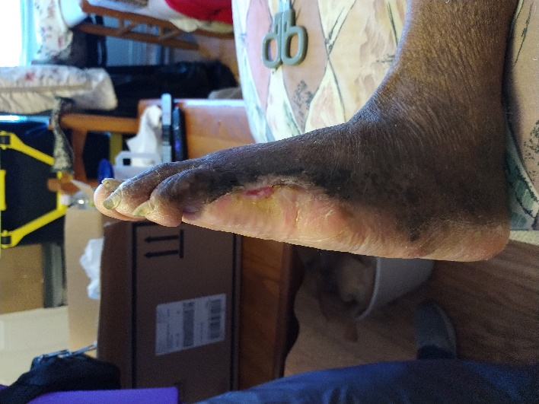

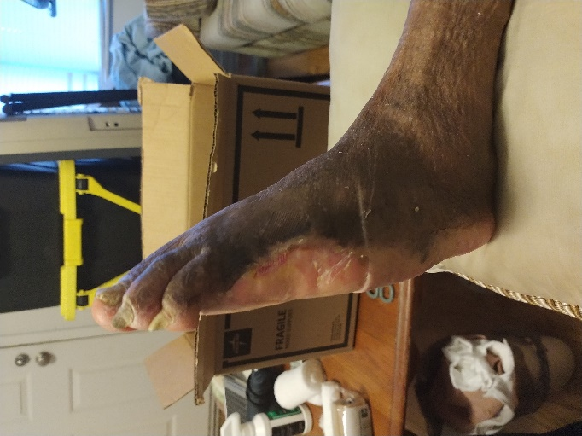

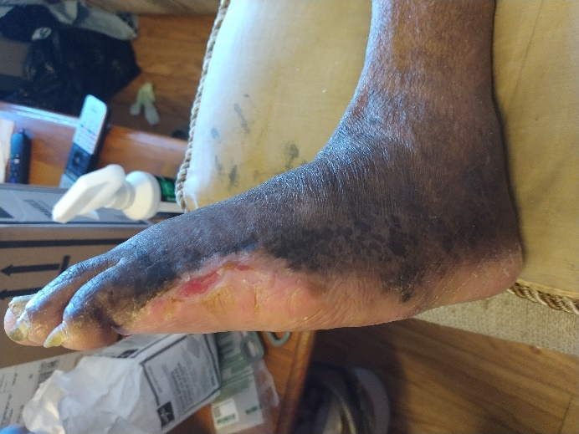

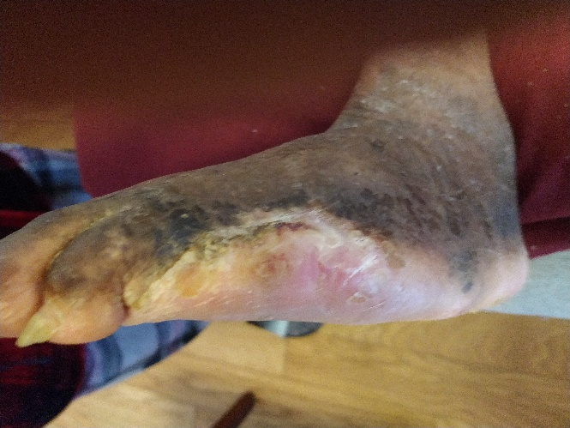

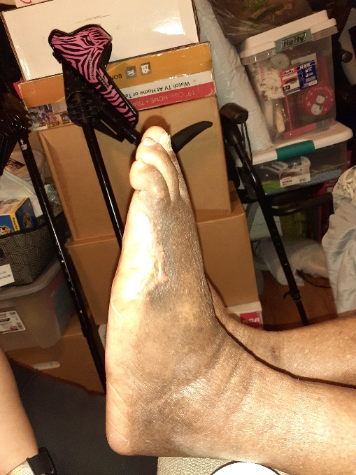

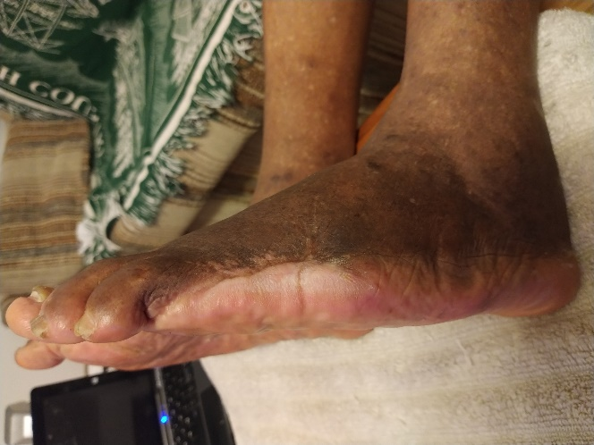

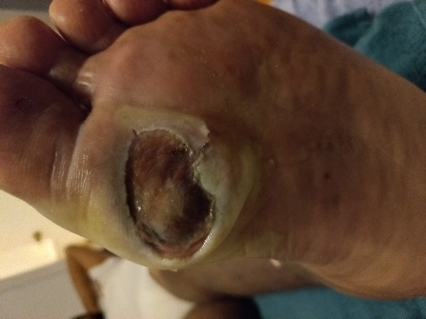

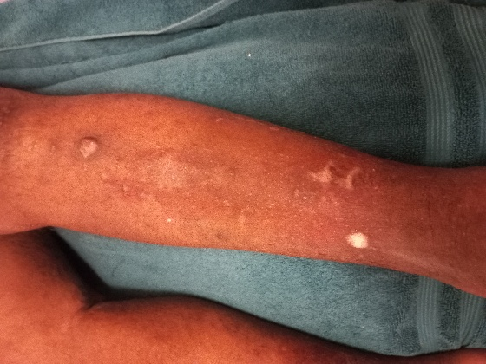

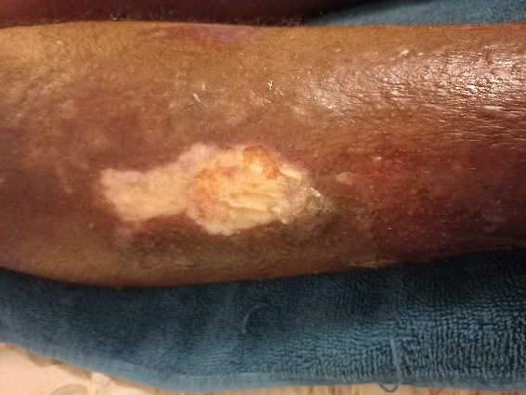

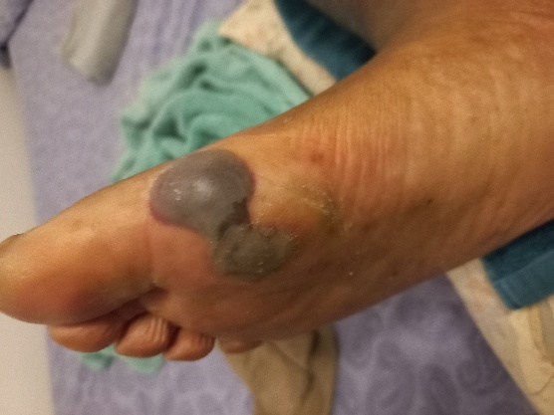

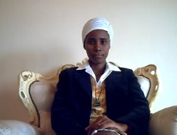
Queen Laura Gardner

